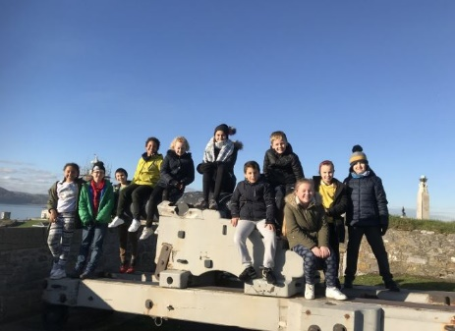
Class 4 Newsletter – Spring 2020

Happy New Year!
Dear Parents

Welcome back and Happy New Year to you all. I hope that you had a wonderful festive season. The spring term is always one of preparation and excitement in the class as we build up towards the exam season and the summer activities beyond. The children have already got off to a flying start!

The Year 5 children have attended their first Widening Horizons event of the year, exploring the many jobs offered at the National Marine Aquarium. We are very much looking forward to our next experiences at Brittany Ferries and Plymouth Citybus. The Year 6 children haven’t been left out! They will be taking part in an Indoor Rowing day in partnership with the PSSP working along-side the PE department of Notre Dame Secondary School as well as enjoying coaching from Plymouth Argyle for the next six weeks! A very busy start to the term!

This term, I am hoping once again to invite as many parents in to school as possible to view their children’s work and hold informal conversations around how learning can be consolidated and progress improved. My thanks to those who came along to the exhibition last term, it is lovely to see the children so excited to share their learning with you. If you are unable to make future exhibitions but would like to come and see your child’s work, please get in touch and we can sort a suitable time out for you as I would hate for you to miss out. In the meantime as always, if you have any questions or would like to discuss your child’s work or progress then please get in touch via the office or my new email address;

tdriscoll@csosm.org.uk

Learning outside the classroom

My thanks to all those who have taken the time to support the children with learning outside of the classroom through additional reading, homework and educational experiences. The impact that these opportunities have on the children’s learning is substantial and makes all the difference with regards to confidence and accelerated learning within the classroom.

The Year 6 children will soon be receiving their SATS Revision pack. Please ensure that as much of this is completed as possible and that the children are given the time and resources needed to complete it to a high standard. If the children find any aspect of the homework overly challenging and you do not feel comfortable supporting them with this then there is a homework club on Tuesdays from 12:15—12:30 where I will point them in the right direction. Please ensure that all homework is completed and in school by the Friday of each week. Thank you for you support with this.

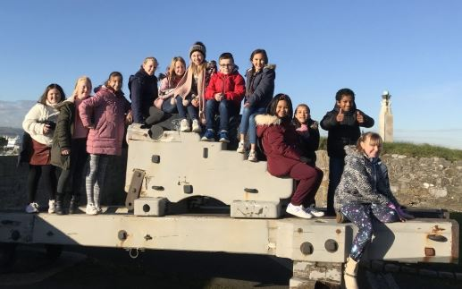

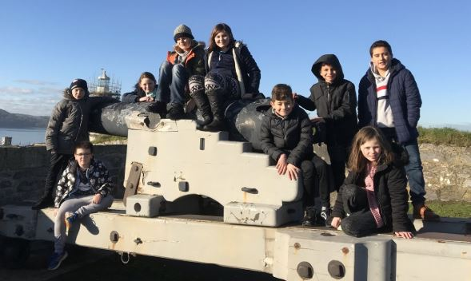

Great time exploring Plymouth Citadel!

Residential Update:
As you are aware, the residential on the 18th May is fast
approaching. My thanks to those who have already paid for their child’s place.
For those yet to pay, please en- sure that the £150 fee is paid either directly on ParentPay or to the school office as soon as possible. This can be done in instalments if you prefer.

The deadline for payment is Monday 4th May.

Learning this term
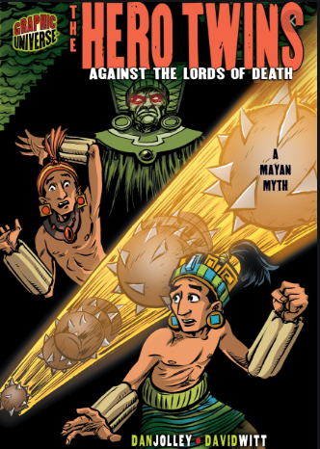
Our topic this term is ‘The Rise and Fall of the Mayan Civilisation’, focusing specifically the lifestyles and culture of the ancient Maya. We will be looking at how the expansion of the Mayan empire has shaped and helped create the world that we see around us today. We will be using archaeological skills to uncover secrets of the past and analyzing sites of archeological interest that can shed light on how these early settlers lived.
The topic theme is carried through our English lessons as we read Dan Jolley’s take on the Mayan Myth; The Hero Twins. A story of two brothers’ fight with the ancient gods.
In mathematics this term, the Year 5 children will be focusing on developing their understanding of multiplication, division and fractions whilst the Year 6 children will be focused on decimal, percentages and ratio.
In science, we will be further expanding our understanding of the Ancient Mayan landscape by exploring living things and their habitats.

Finally, in RE we will explore the Christmas story and how this we learn that Jesus is the fulfilment of God’s promise as through Matthew’s Gospel. We will then learn about Judaism before finishing the term with Revelation.
If you have any resources or feel that you can in some way contribute to any of the learning this term, please get in touch.

Learning after half term
After half term, we continue with our Mayan themed learning. The children will be exploring a Mayan themed novel – The Rain Player. An illustrative story based on the adventures of a boy’s desperate attempts to save his family through a ball game.
In mathematics Year 6 will be focusing further on ratio, before starting work on shape and measure. Year 5 will be consolidating their learning about fractions, decimals and percentages. The children will move between groups dependent on how their needs.

Our science focus will be Evolution and inheritance, once again using the incredible biomes of Central and Southern America to aid the children’s learning.

Our aim is to share this learning with you in the final week of term. The children will be aiming to produce a Mayan settlement throughout the term which will grow as their learning develops and will act as a focal point for the exhibition.

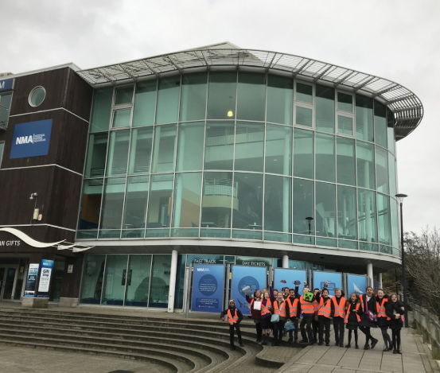

Key Dates

17.01.2020 – Library Visit
24.01.2020 – Class 4 Assembly
13.02.2020 – Widening Horizons (at school)
14.02.2020 – Term 3 ends
24.02.2020 – Non-Pupil Day
25.02.2020 – Term 4 begins

