

Autumn Term 2019

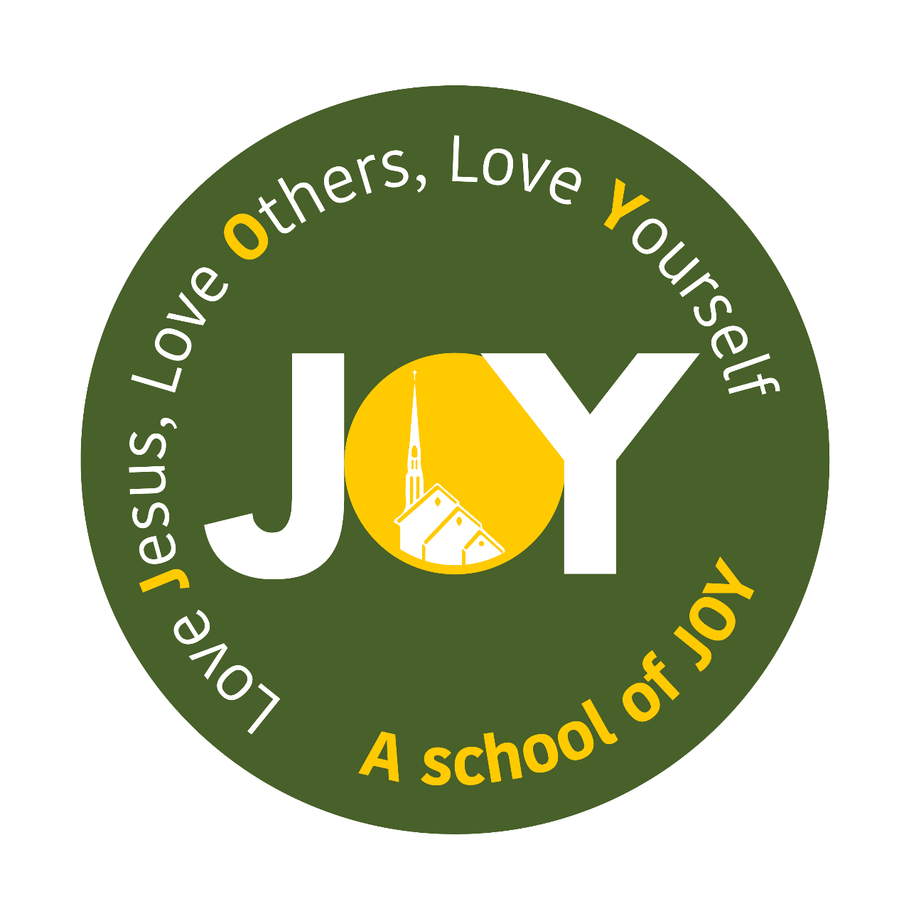

**Dear Parents**

**Welcome back for another year!**

I hope that you have enjoyed the extended break with your lovely children and appreciated the sunshine!

This newsletter is designed to help you settle as quickly as possible into life in Class 4.

**Organisation**

Upper Key Stage 2 is an important time where we develop many of the skills that will be essential for your next big journey – secondary school!

With this in mind we place a strong emphasis on the children taking ownership of their own learning, including making sure they are prepared for school every day. I would ask that they are responsible for their own homework, letters, jumpers and PE kits. They need to ensure they bring in and take home their reading books daily and that they have the correct PE kit in school at all times. Children need to ensure they have their homework on the stated days. If there are exceptional circumstances meaning that homework is not completed, please send a note in with your child so I can be clear about the reasons.

**Homework**

This year, after consultation with staff, parents and children, homework in years 5 and 6 will run differently. We will be using a range of different approaches to help ensure all children have the opportunity to participate in homework should they wish. This way we can clarify any misconceptions that the children may have. We are still in the process of sorting the logins for some of the tasks so please keep an eye on the ClassDojo page. Whilst homework is not compulsory, it is recommended. Reading at home is a requirement of our home – school agreement. It is compulsory that your child reads at least three times a week and this is recorded and signed for in their reading record.

**PE/Games**

**PE sessions will be held weekly on Wednesday and Friday afternoons. All children will be expected to take part in all lessons. If your child is injured and cannot take part in PE then you will need to send in a note with your child.**

All PE kits need to be in school from the start of the term and then taken home at regular intervals to be washed. Please make sure that all kit is labelled so that missing kits are easily returned to their owners. We expect all kits to be in school at all times as there are occasions where PE days can change. As our sessions will mix indoor and outdoor activities a full kit is required.

**Trips**

We will be stimulating our learning with off- site activities. Watch this space for details of our Autumn term trip linked to our topic of ‘Marvellous Maps!’

**Working in partnership**

As a school, we believe passionately that your child’s learning best benefits from a positive relationship between us as a school and you as parents and guardians.

With this in mind, please take time to say hello or raise any issues at the end of the school day when the children exit school. I am also contactable through email or Class Dojo or, if you need to speak with me at greater length or in private, I will naturally be happy to arrange a time to do that.

*A*ny support is always welcomed so please do not hesitate to catchme if you are interested in coming into the classroom to help any time throughout the week.



Our Learning This Term

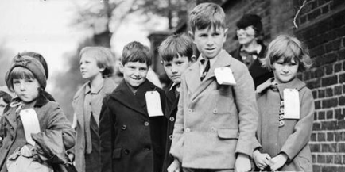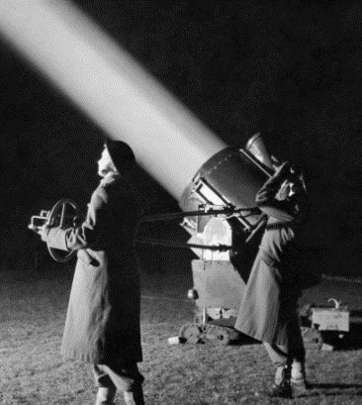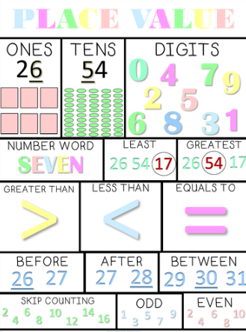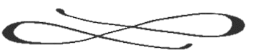

Mr Driscoll

Our **Science** investigations for the Autumn term will focus on ‘Light and Shadow’ where the children will explore how light behaves as well as looking at the role it plays in World War II through the creation of searchlights. After half term we will be exploring our Electricity with the aim of experimenting with circuits.

Our **Topic** this term is World War II, specifically the effect that the war had on every day people in Britain. With this in mind, we will be looking at the Battle of Britain, the D-Day landings and the life of an evacuee. The children will also get the chance to read real-life accounts of an evacuation as well as build their own gas masks.

All of our learning is underpinned by our **Social and** **Emotional Aspects of Learning** work the pupilsengage in.

I am really looking forward to getting to know you and your family over the year and am very much looking forward to a wonderful year of learning with the new ‘Year 5/6’.

With every good wish,

In **English** we will begin our term with an exciting historical fiction unit of work. We will be looking at the wonderful wartime story, Letters from the Lighthouse, by Emma Carroll and using this as a model for our own writing. We will have lots of research to do about life for an evacuee so keep an eye out for the homework task! Our unit will conclude with us looking at the role of poetry in wartime Britain which we hope to share with parents in a poetry afternoon. After half term, we remain with the World War II topic where we will explore writing biographical accounts from the eyes of a soldier.

Our **Maths** work will build on the work done last year. We will be developing further confidence in calculation using all four operations. In addition we will be working on understanding place value of whole numbers and decimals. . All this work will be put into practice in our problem solving and reasoning morning tasks and our mental arithmetic sessions.

Our **RE** work will begin with our Creation unit of work. We will be considering our roles as co-creators in our ‘Creation’ unit, moving on to ‘Sacraments’. Finally we will enter our ‘Advent’ unit as we move towards Christmas.