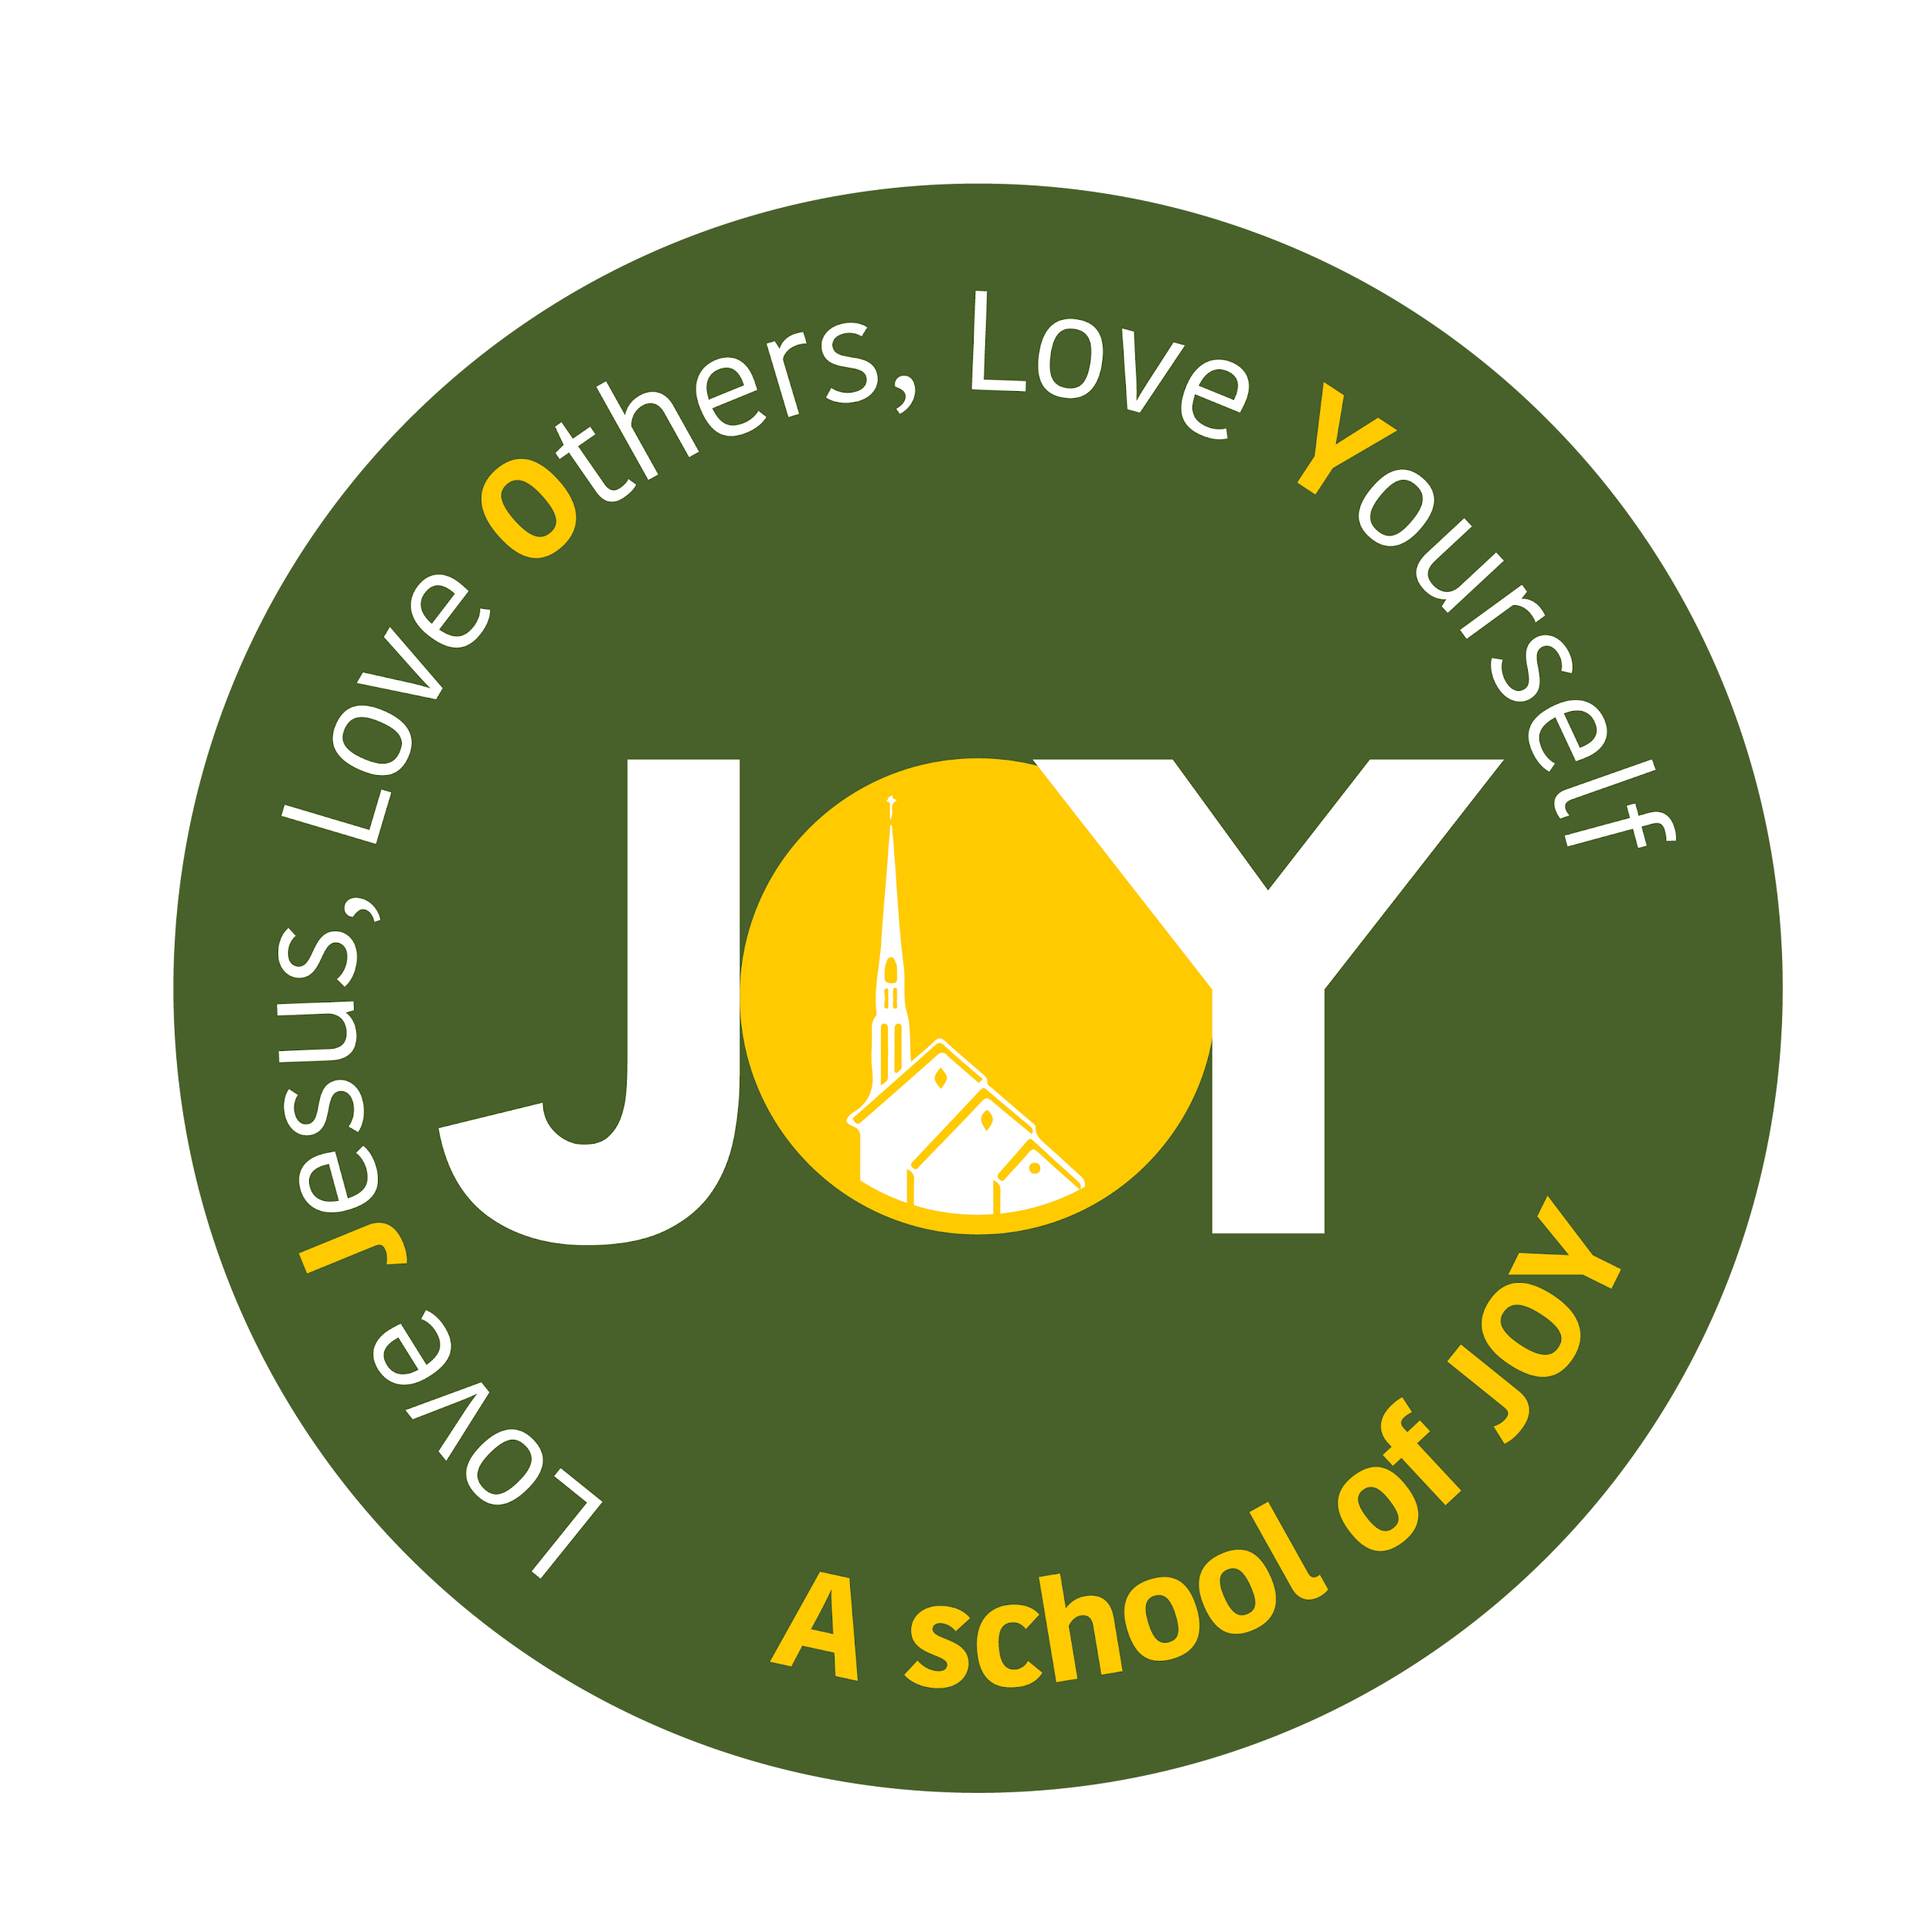

**The Cathedral School of St Mary**

**Religious Education Policy 2024**

**Mission Statement**

Together we will:

● promote a catholic ethos of caring and forgiveness;

● nurture the intellectual, spiritual, moral, social and physical development of each person;

● be free to express ourselves in a safe environment;

● share in the life of our family, school and community.

“Nurturing today’s minds for tomorrow’s future, always remembering that God made me as I am.” And never forgetting that: ‘God made me as I am’

**Rationale of Religious Education**

Teaching Religious Education is the main reason Catholic schools exist. The primary goal of Religious Education is to increase the knowledge and understanding of the Christian message for all pupils in Catholic schools. As such it will be planned, taught, assessed and monitored with the same rigor as other core curriculum subjects.

Education is integral to the Mission of the Church to proclaim the Good News.

‘Every Catholic School is a place of encounter with the living God, who in Jesus Christ, reveals his transforming love and truth’. 1

Religious Education in a Catholic school is an academic discipline with the same systematic demands and the same rigor as other disciplines. As such, it should be taught, developed and resourced with the same commitment as any other subject.

‘Classroom Religious Education complements and is enhanced by the catechetical and worshiping life of the whole school community but is distinct from each of them’. 2

‘Religious Education in Catholic schools is considered the core of the core curriculum. It is a discrete subject discipline as canonically and statutorily defined. The nature, purpose and scope of classroom Religious Education are defined in the Religious Education Curriculum Directory’. 3

The centrality of classroom Religious Education in the curriculum is reflected in several ways in Catholic schools, including parity with other core curriculum subjects. Bishops have mandated that pupils are entitled to receive RE that constitutes 10% of the taught week.

The outcome of classroom Religious Education is:

‘Religiously literate and engaged young people who have the knowledge, understanding and skills appropriate to their age and capacity-to reflect spiritually, and think ethically and theologically, and who are aware of the demands of religious commitment in everyday life’. 4

1 Pope Benedict

2 Circular letter on Religious Education in schools 2009

3 Religious Education Curriculum Directory, Department of Catholic Education and Formation, Bishops Conference of England and Wales 2012

4 Religious Education Curriculum Directory, Department of Catholic Education and Formation, Bishops Conference of England and Wales, 2012

**The aims of Religious Education as stated in the Religious Education Directory (2023) are:**

* To engage in a systematic study of the mystery of God, of the life and teaching of Jesus Christ, the teachings of the Church, the central beliefs that Catholics hold, the basis for them and the relationship between faith and life;
* To enable pupils continually to deepen their religious and theological understanding and be able to communicate this effectively;
* To present an authentic vision of the Church’s moral and social teaching to provide pupils with a sure guide for living and the tools to critically engage with contemporary culture and society;
* To give pupils an understanding of the religions and worldviews present in the world today and the skills to engage in respectful and fruitful dialogue with those whose worldviews differ from their own;
* To develop the critical faculties of pupils so to bring clarity to the relationship between faith and life, and between faith and culture;
* To stimulate pupils’ imagination and provoke a desire for personal meaning as revealed in the truth of the Catholic faith;
* To enable pupils to relate the knowledge gained through religious education to their understanding of other subjects in the curriculum

**The aims of Religious Education as stated in the Religious Education Curriculum Directory (2012) are:**

• To present engagingly a comprehensive content which is the basis of knowledge and understanding of the Catholic faith;

• To enable pupils continually to deepen their religious and theological understanding and be able to communicate this effectively;

• To present an authentic vision of the Church’s moral and social teaching so that pupils can make a critique of the underlying trends in contemporary society;

• To raise pupils’ awareness of the faith and traditions of other religious communities in order to respect and understand them;

• To develop the critical faculties of pupils so that they can relate their Catholic faith to daily life;

• To stimulate pupils’ imagination and provoke a desire for personal meaning as revealed in the truth of the Catholic faith;

• To enable pupils to relate to the knowledge gained through Religious Education to their understanding of other subjects in the curriculum;

• To bring clarity to the relationship between faith and life, and between faith and culture.

*Religious Education Curriculum Directory, Department of Catholic Education and Formation, Bishops Conference of England and Wales 2012*

**Religious Education – Curriculum Time Allocation**

10% of curriculum time is allocated to Religious Education. This does not include Collective Worship or the teaching of RSE (please refer to separate RSE Policy).

**Programme of Study**

To fulfill the aims of the Religious Education Directory and the four areas of study outlined in this document: Revelation, Church, Celebration and Life in Christ, Religious Education in UKS2 is taught through the ‘Come and See’ programme of work. Our EYFS, KS1 and LKS2 classes follow the Religious Education Directory - To Know You More Clearly - in preparation for the statutory delivery by September 2025.

**Process**

Religious Education, in the Diocese of Plymouth, is taught through the process of Explore, Reveal and Respond for UKS2 and through the knowledge lenses of Hear, Believe, Celebrate and Live in EYFS, KS1 and LKS2. As outlined in both the RECD and Catechism of the Catholic Church; **Explore** follows the pattern of the human **search** for meaning, God’s initiative in **Revelation** and the **response** in faith. The RED recognises the need to **understand, discern** and **respond** as **Ways of Knowing.** The content of the curriculum is explored through the six knowledge lenses of hear, believe, celebrate, and live (the study of the Catholic religion), dialogue, and encounter (the study of other religions and worldviews).

“The special character of the Catholic school, the underlying reason for it, the reason why Catholic parents should prefer it, is precisely the quality of the religious instruction integrated into the education of the pupils.” RECD 2012

**Methodology**

A variety of teaching and learning strategies and resources will be used by teachers, from across the curriculum, and adapted appropriately to the needs and learning styles of the pupils.

“The outcome of excellent religious education is religiously literate and consciously engaged young people who have the knowledge, understanding, and skills – appropriate to their age and capacity – to reflect spiritually, and think ethically and theologically, and who recognise the demands of religious commitment in everyday life.” To Know You More Clearly 2023

**Inclusion and Equality**

All pupils in our school, regardless of ability, faith and background, will have appropriate differentiated access to the Religious Education programme. We strive to do the best for all our pupils, irrespective of disability, educational needs, race, nationality, ethnic or national origin, sex, gender, religion or sexual orientation or those who are disadvantaged.

‘Children of all abilities benefit from ways of learning and knowing which are not necessarily reliant on cognitive ability, in particular, the learning of the heart’. RECD

‘Through the educational plan it is possible to create the conditions for a person to develop a gift for searching and to be guided in discovering the mystery of his being and of the reality that surrounds him, until he reaches the threshold of the faith. To those who then decide to cross this threshold the necessary means are offered for continuing to deepen their experience of faith.’ Congregation for Catholic Education, 2002

**Right of Withdrawal from Religious Education**

Parents have the right of withdrawal from RE for their children.

**Other Religions**

In UKS2, we dedicate one week per term to the teaching of other world religions including Judaism, Islam and Hinduism.

In EYFS, KS1 and LKS2, pupils are also expected to engage in a discrete study of other faiths, religions, and worldviews.

This is partly because of the Church’s own commitment to dialogue, partly also because to love our neighbour is also to respect and esteem his or her culture, and finally because to enter into dialogue is a means of learning how to live peaceably with difference.

Therefore, as they progress through school, pupils will study:

• Other Christian denominations

• Judaism

• Islam

• Dharmic religions and pathways

• Other religions and worldviews, including non-religious worldviews

**Assessment, Monitoring, Recording and Reporting**

• Assessment of standards is carried out using the interim ‘Age-Related Standards in Religious Education (3- 19) document agreed by the Bishops’ Conference for UKS2 and the Expected end of age-phase outcomes for those in EYFS, KS1 and LKS2. Each child will be individually assessed against these standards on INSIGHT.

• Each teacher keeps a class record of pupils’ progress across time and evidence of informal/formal assessment in line with their school’s assessment policy.

• Feedback, in line with the school’s assessment policy, will be personalized and tailored to challenge individual children to make at least expected progress.

• An in-school moderation of pupils’ books and work, against the interim standards, is held at least once a term and appropriate CPD provided at all levels.

• Annually, usually in the summer term, a range of annotated pupils’ books/work are presented for Diocesan Moderation at RE Leaders moderation meetings, as directed by the Diocesan RE Adviser. The moderation will be against the interim standards.

• Monitoring of teaching and learning work is in line with other core subject areas, so will include activities such as pupil voice, lesson observations and book scrutiny.

• The RE Lead will collect and collate termly data, use this for analysis and school development planning and send data annually to the Diocesan Education Service through the DDR ( Diocesan Data return).

• Progress and achievement in Religious Education is reported to parents/carers in a written report at the end of the academic year.

• Progress and achievement in Religious Education is reported to Governors/Local Governing Body Governors at each Full Governing Body throughout the year.

**Management of the Subject**

The RE Lead has the responsibility for leading, managing and supporting the delivery and training in Religious Education in line with other core subject areas. This role is carried out in line with the RE Leaders Job Description, based on the model provided by Plymouth Diocese.

**Policy Monitoring and Review**

This policy will be monitored, evaluated and reviewed by the governor with responsibility for RE and Catholic Life, the RE Lead and the Local Governing Body on an annual basis.

Review date: September 2025