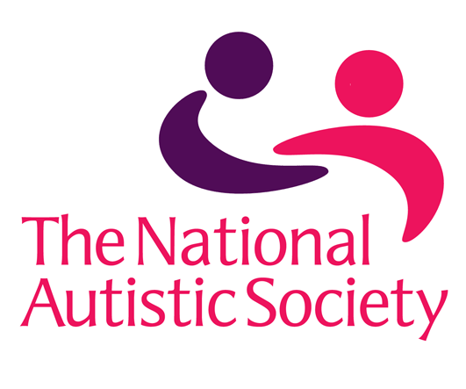

Plymouth Autism Parents' Support Group monthly meetings
Is your child on the autism spectrum?
Why not come and join our new free support group?
Share your ups and downs, and maybe find out how other parents are doing it. Sleep, school, behaviour, and eating can all be challenges.
Join us on Thursday September 28, 10.15am to noon at the Welcome Hall, Fore Street, Devonport PL1 4DN.
If you are busy during the day, there are also evening meetings starting Wednesday 27 September from 7.15-8.45pm at Pomphlett Church Hall, Pomphlett Road PL9 7RA opposite Plymstock Morrisons.
Contact: Ellie Scott Email: paab@nas.org
Supported by the National Autistic Society, Plymouth Branch.

