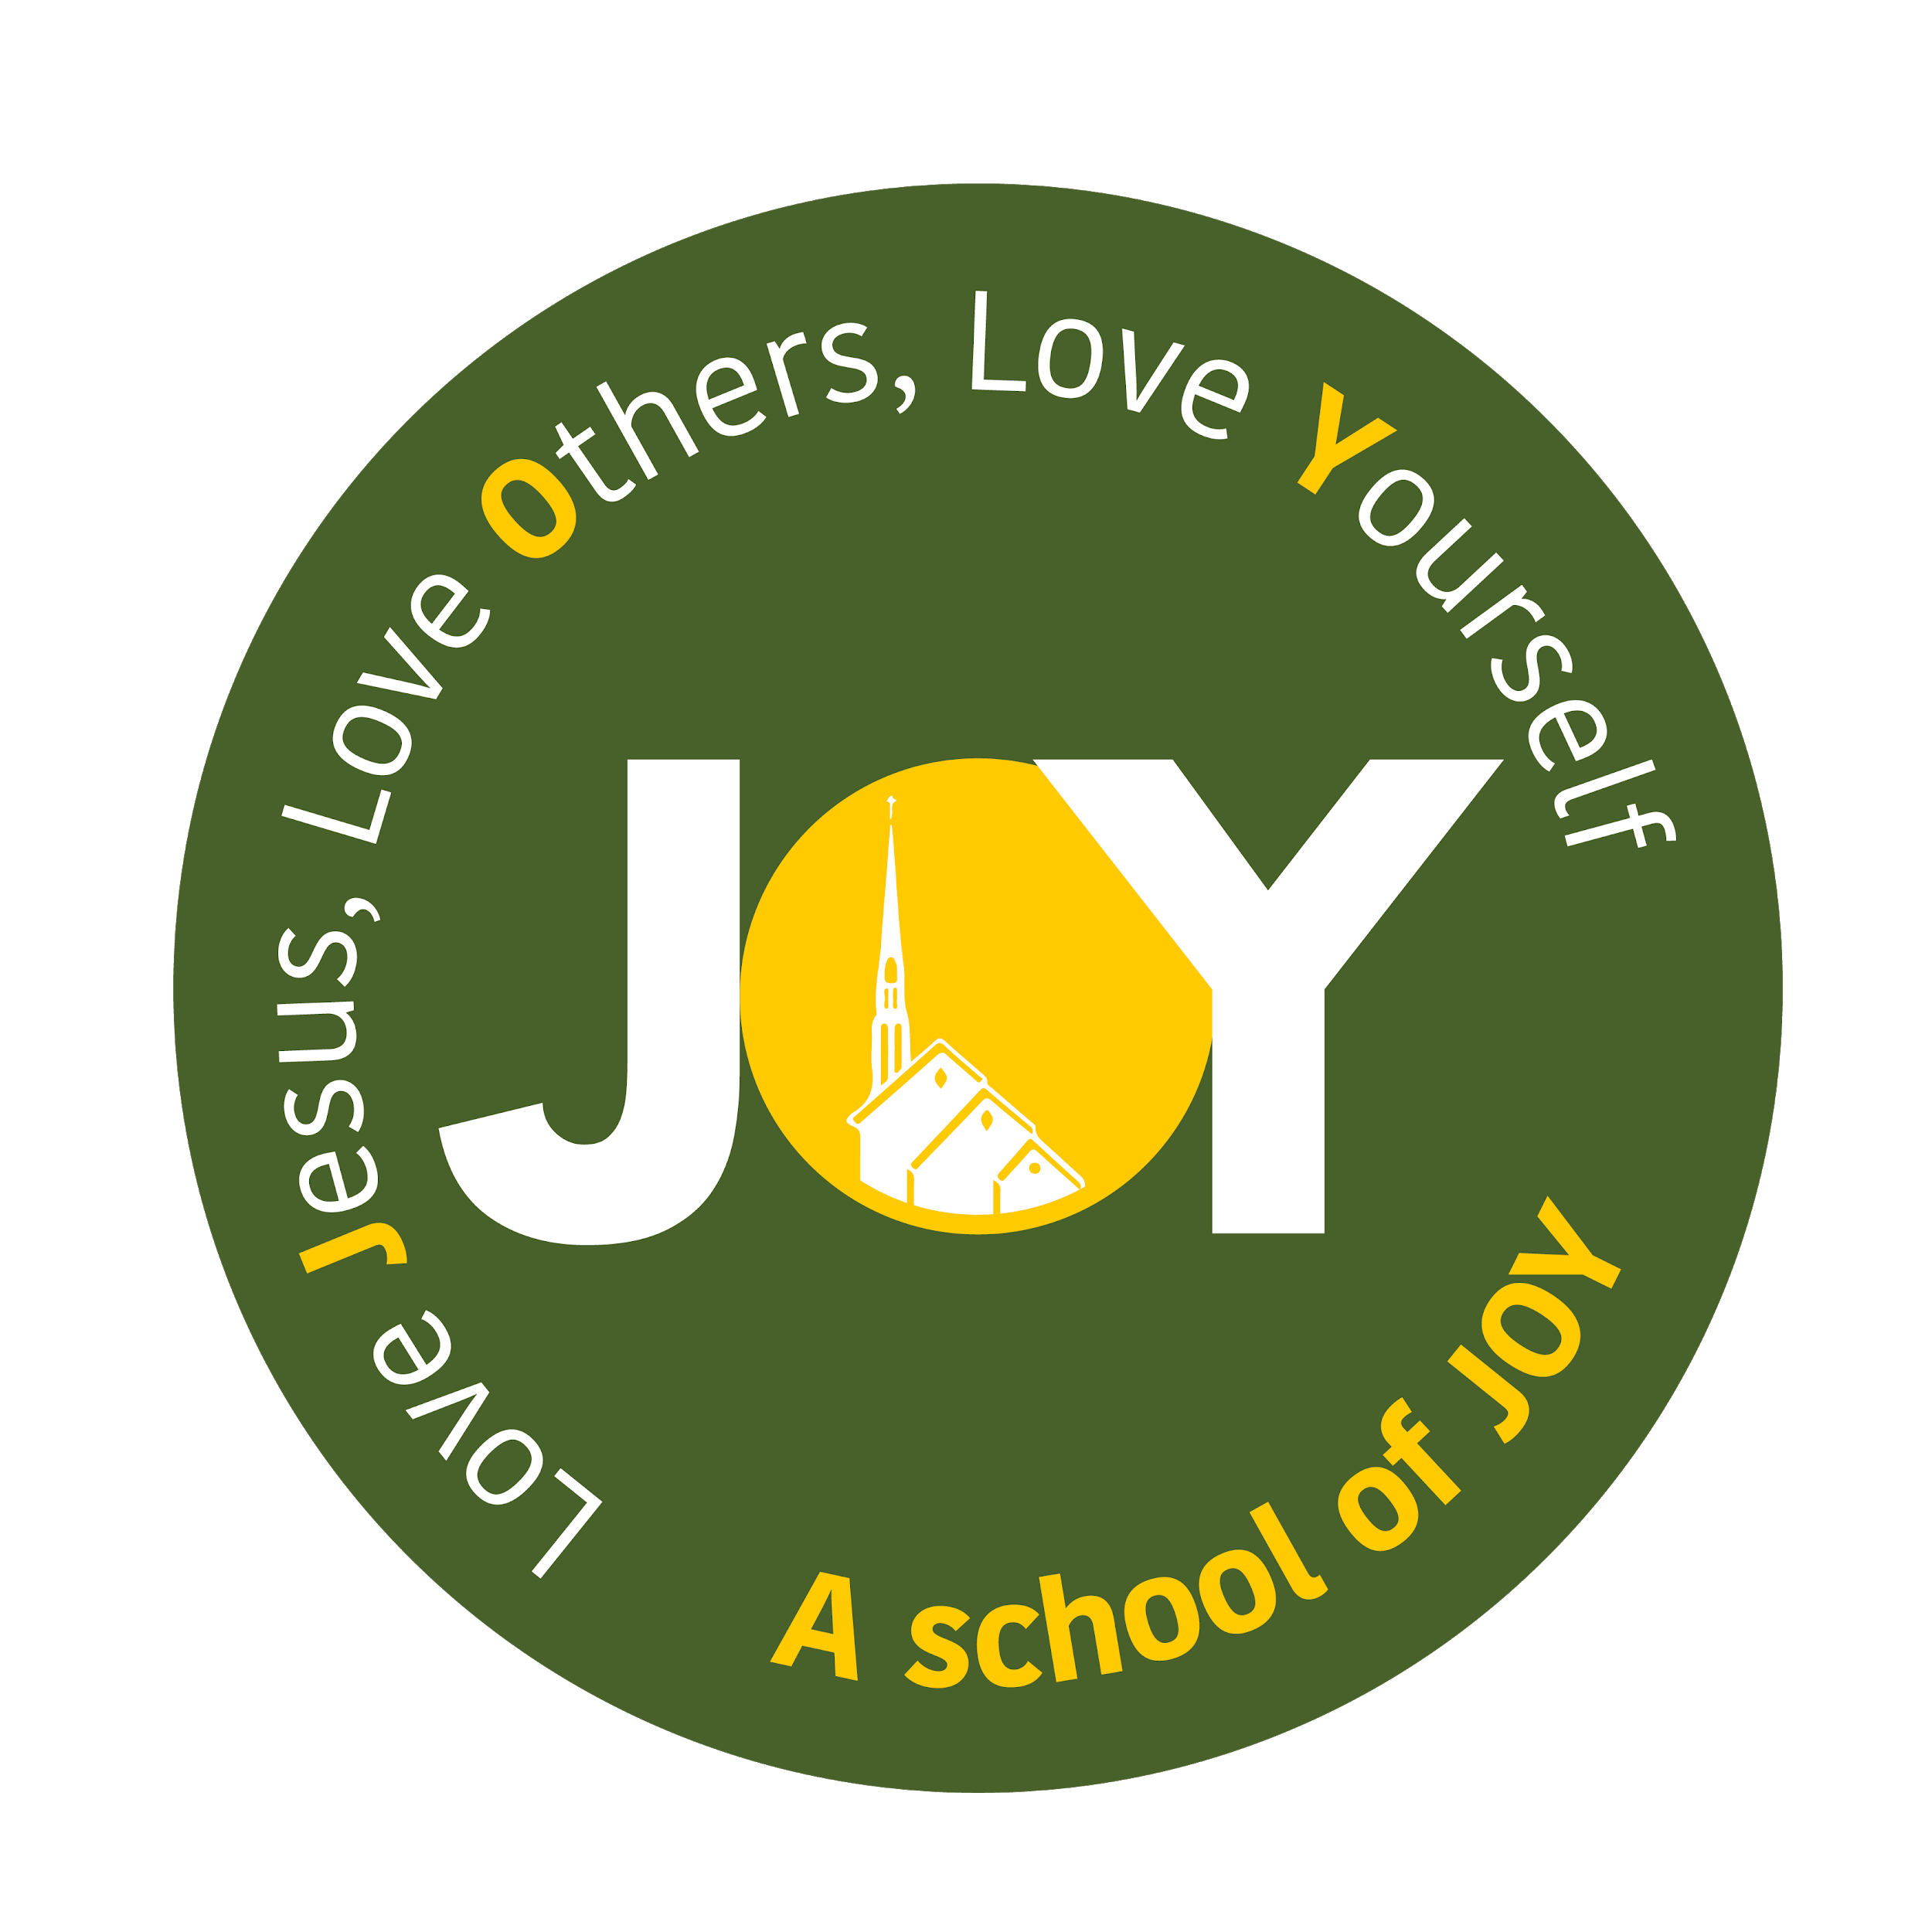

**St Joseph's and The Cathedral School of St Mary**

**Foundation - Autumn Term 1 2024**

**All About Me! and The Seaside!**

| **Foundation** | Week 1  WB: 02.09.2024 | Week 2  WB: 09.09.2024 | Week 3  WB: 16.09.2024 | Week 4  WB: 23.09.2024 | Week 5  WB: 30.09.2024 | Week 6  WB: 07.10.2024 | Week 7  WB 14.10.2024 | Week 8  WB 21.10.2024 |
| --- | --- | --- | --- | --- | --- | --- | --- | --- |
| **Key Dates/Info** | 02.09.24 - No school  03.09.24 - Non-pupil day  04.09.24 -1-3pm  05.09.24 - 9-11:30am  06.09.24 - 12-3pm | Begin RWInc |  |  |  |  |  |  |
| **Educational Visits/**  **Experiences** | SETTLING IN /BASELINE | SETTLING IN /BASELINE | SETTLING IN /BASELINE | SETTLING IN /BASELINE | SETTLING IN /BASELINE  02.10.24 - Foundation children’s Teddy Bears Picnic | SETTLING IN /BASELINE | SETTLING IN /BASELINE  Local area walk to Victoria Park | SETTLING IN /BASELINE |
| **Weekly Theme** | **Starting school** | **Starting school** | **Who is in my family?** | **Where do we live?** | **What can I see in my city?** | **What do we use maps for?** | **Let’s make a map** | **Let’s use a map** |
| **Vocabulary** | School, home, sad, happy, worried, scared, excited, names of children, adults and areas | School, home, sad, happy, worried, scared, excited, names of children, adults and areas | Family, mum, dad, sister,brother, auntie, uncle, grandma/grandpa, cousin (also special words the children might use for these people), member | Plymouth, City, home, town, street, island, sea, land, coast, beach, cliff. | Physical features, Human features, city, coast, pier, lighthouse, promenade, sea, | Map, house, home, shop, park, street, road | Map, key, north, south, east, west, next to, behind, under, in front of, over | Map, key, north, south, east, west, next to, behind, under, in front of, over |
| **Key Text** | The Colour Monster - Anna Llenas  The Colour Monster Starts School - Anna Llenas | The Colour Monster - Anna Llenas  The Colour Monster Starts School - Anna Llenas | Families, families, families - Suzanne and Max Lang | When The Dragons Came - Naomi Kefford and Lynne Moore | We’re going on a Bear Hunt by Michael Rosen | The Troll - Julia Donaldson | Mouse’s House by John Burningham | You Choose by Nick Sharratt and Pippa Goodhart |
| **Literacy** | Baseline  Understand the key concepts about print  Begin writing and identifying their first name with and then without a reference.  Answer ‘what’ questions related to a story.  Read individual letters by saying the sounds for them. | Baseline  Understand the key concepts about print  Begin writing and identifying their first name with and then without a reference.  Answer ‘what’ questions related to a story.  Read individual letters by saying the sounds for them. | Baseline  Understand the key concepts about print  Begin writing and identifying their first name with and then without a reference.  Answer ‘what’ questions related to a story.  Read individual letters by saying the sounds for them. | Baseline  Understand the key concepts about print  Begin writing and identifying their first name with and then without a reference.  Answer ‘what’ questions related to a story.  Read individual letters by saying the sounds for them. | Baseline  Understand the key concepts about print  Begin writing and identifying their first name with and then without a reference.  Answer ‘what’ questions related to a story.  Read individual letters by saying the sounds for them. | Baseline  Understand the key concepts about print  Begin writing and identifying their first name with and then without a reference.  Answer ‘what’ questions related to a story.  Read individual letters by saying the sounds for them. | Baseline  Understand the key concepts about print  Begin writing and identifying their first name with and then without a reference.  Answer ‘what’ questions related to a story.  Read individual letters by saying the sounds for them. | Baseline  Understand the key concepts about print  Begin writing and identifying their first name with and then without a reference.  Answer ‘what’ questions related to a story.  Read individual letters by saying the sounds for them. |
| **Maths**  **EYFS** | Baseline Unit 1: Numbers to 5 | Baseline Unit 1: Numbers to 5 | Baseline Unit 1: Numbers to 5 | Baseline Unit 1: Numbers to 5 | Baseline  Unit 2: Comparing groups within 5 | Unit 2: Comparing groups within 5 | Unit 3: 2D and 3D shape | Unit 3: 2D and 3D shape |
| **Maths**  **Year 1** | Unit 1: Numbers to 10 | Unit 1: Numbers to 10 | Unit 1: Numbers to 10 | Unit 1: Numbers to 10 | Unit 2: Part Whole Within 10 | Unit 2: Part Whole Within 10 | Unit 2: Part Whole Within 10 | Unit 2: Part Whole Within 10 |
| **RE**  **EYFS** | Introducing the 3 school prayers  Morning, grace and afternoon | Introducing the 3 school prayers  Morning, grace and afternoon | Creation and Covenant:  I know that God made me. | Creation and Covenant:  I know God loves me and I am part of a family. | Creation and Covenant:  I know we should look after ourselves and others | Creation and Covenant:  I know that God made our world. | Creation and Covenant:  I know we should look after God’s world. | Creation and Covenant:  I know that we are all invited to be part of God’s family |
| **RE**  **Year 1** |  |  |  | Creation and Covenant:  I know the story of how God made the world and that everything comes from God | Creation and Covenant:  I kkow that God shows His love for us through Creation | Creation and Covenant:  I know we can draw closer to God through prayer | Creation and Covenant:  I know we should care for God’s world | Creation and Covenant:  I know about some of the ways people care for God’s world. |
| **PSED/ Gospel Values** | Belonging/  Relationships  Tenten - Religious Understanding  ‘Handmade with Love’ | Belonging/  Relationships  Tenten - Religious Understanding  ‘Handmade with Love’ | Belonging/  Relationships  Tenten - Religious Understanding  ‘Handmade with Love’ | Belonging/  Relationships  Tenten - Me, my body, my health  ‘I am me’ | Belonging/  Relationships  Tenten - Me, my body, my health  ‘I am me’ | Belonging/  Relationships  Tenten - Me, my body, my health  ‘Heads, shoulders, knees and toes’ | Belonging/  Relationships  Tenten - Me, my body, my health  ‘Heads, shoulders, knees and toes’ | Belonging/  Relationships  Tenten - Me, my body, my health  ‘Ready Teddy’ |
| **Communication & Language** | Listen and take turns in speaking  Explore feelings using the colour monster book | Listen and take turns in speaking  Explore feelings using the colour monster book | Choose a member of their family to talk about. Questioning | Talk about ‘What is an Island?’ Have a look at a picture of an Island and talk about the features that make it an Island. | Share photos from around Plymouth. Can they guess where they might be? Have the children been to any of these places and can they describe them? | Share different examples of maps including OS maps, atlas and maps to places like the zoo. Give them all the same map of a zoo and see if they can find the different things. | Visit Victoria Park. Identify the different things they can see around the park. Usng photos of the different parts of the park, can they put them on a map in the right place. Can they recall the different uses for a map from previous lessons? Why might this map be helpful? | Recall the different uses for a map from previous lesson. Can they remember where we made a map? Look again at maps we made last week, can they remember the different features? |
| **Understanding the World** | Starting school - Explore the way they got to school and what they passed on the way | Starting school - Explore the way they got to school and what they passed on the way | Look at family timelines (baby to old person) - exploring and then creating their own from baby to starting school | Look at the different photos and identify what they can see.  Where might they find these places? Do you recognise them, are they familiar? | Decide if different features are natural (physical geography) or whether they are man made (human geography) Can they explain why. | Talk about why we might use a map. Link to pirate maps - why might a pirate need a map. X marks the spot to find their treasure! | Share a map of the playground. Can they add detail and then use the map to direct eachother to find some treasure. |
| **Year 1 Understanding the world outcome.** |  |  |  | Sorting photos into coastal and city pictures. Can they explain the similarities and differences? (scribed) | Identify some features of the seaside, and be able to name them. Attempt to label the pictures if appropriate | Create their own pirate map. | Draw features on to a map of Victoria Park - what did they see and can they put the right features in the right place. | Their map of the playground and photos of them following each others maps to find the treasure. |
| **Expressive Arts and Design** | Explore colours using the colour monster - mixing up emotions (colours) and seeing what they get | Explore colours using the colour monster - mixing up emotions (colours) and seeing what they get | Recreate a family photo using media of their choice e.g. crayons, pens, paint.  How easy was it to recreate the photo? | Explore colour mixing and adding white and black to change the shade. | Join the texture hunt, feeling and exploring different textures. | Staining paper to make it look old.  Can they make a pirate map like the one that the pirates followed in our story. | Create collages using different textured papers. What might the different papers be/represent? | Can the children add detail to their collages to make it look like a coastal scene. Can the children identify what they might add? |
| **Art**  **Year 1** |  |  |  | Colour Magic - Revisit the colour mixing we did at the beginning of term, talking about primary and secondary colours as well as shade. | Texture hunt -  Explore the different textures in the world around us. Can we describe them? Are the rough, smooth, bumpy, etc. | Making textures - Using the textures we discovered, can we recreate those textures in paint, or even use them as prints. | Collage creation - Using different textured papers, can we make a collage with a coastal focus - land, sea, sky and sand. | Developing Detail - Add details to our collages from the previous week - what would they need to add? |
| **Music**  **Year 1** |  |  |  | Friendship Song |  |  |  |  |
| **Computing / Technology** |  |  | Explore how families communicate with one another and keep in touch, especially with those members they don’t live with eg email, text, etc. | Using a keyboard - Learning what a keyboard is and how to locate the relevant keys | Logging in and out - Learning how to log in and out of the chromebooks at school | Mouse control - Learning what a mouse is and what it does | Mouse skills -  Develop basic mouse skills using an online paint programme | Mouse control - further their mouse skills, including clicking on an item and moving it. |
| **Physical Development** | Fine and Gross motor skills | Fine and Gross motor skills | Fine and Gross motor skills  PE Passport - Fundamental Movement Skills  ‘I can run skillfully and negotiate space’ | Fine and Gross motor skills  PE Passport - Fundamental Movement Skills  ‘I can pick up, carry and put down with care’ | Fine and Gross motor skills  PE Passport - Fundamental Movement Skills  ‘I can show increasing control over an object’ | Fine and Gross motor skills  PE Passport - Fundamental Movement Skills  ‘I can balance and move through an obstacle course’ | Fine and Gross motor skills  PE Passport - Fundamental Movement Skills  ‘I can be excited about and confident in my role in a team’’ | Fine and Gross motor skills  PE Passport - Fundamental Movement Skills  ‘I an thread objects and play games fairly’ |