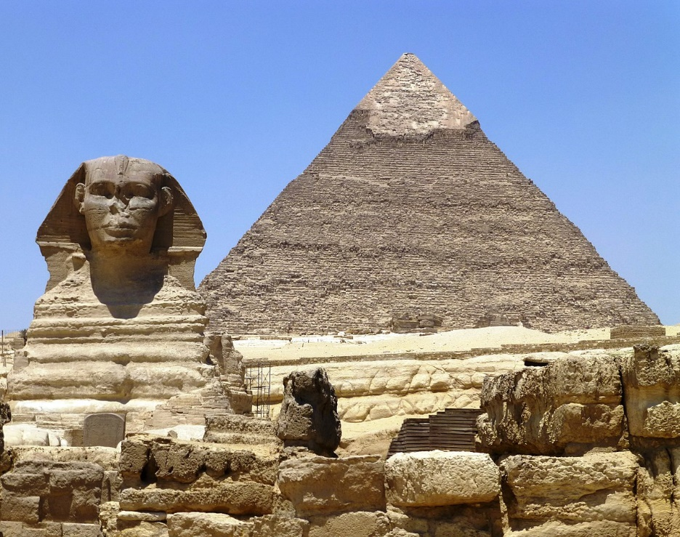

PE

Children will continue their lessons with Lucy and will be learning Handball this term. We will also be looking at the importance of exercise in maintaining a healthy lifestyle.

MFL

Children will continue their Spanish learning with Junior Jam who will also be teaching art.

Science

Our unit this term is Living Things and Their Habitats. We will be classifying animals and using classification keys to identify and name a variety of living things in their local and wider environments.

Maths

Our first topic of the term will be length, perimeter and Area. We will then begin our fractions unit.

Children will also have plenty of opportunities to practice their times tables to increase their knowledge and speed.

Computing

This term we will be using the Chromebooks to create presentations.

History

Our topic this term is Ancient Egypt. We will be looking at where Egypt is on a map and the chronology of Ancient Egypt. We will explore mummies, pyramids, diet, artefacts, Tutankhamun and Howard Carter.

Class 3: All Around the World

Religious Education

We will begin the term by exploring the importance of prayer in the Jewish faith.

We will then explore Lent as a time when we prepare for Easter. This unit allows pupils to explore how this preparation involves change.

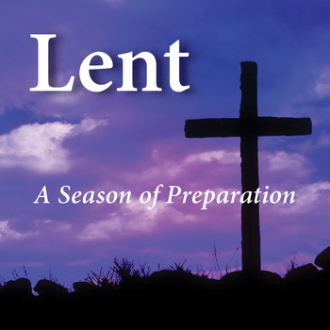

English

This term we will be starting with a creative writing unit before we write our own newspaper articles.

We will continue using Accelerated Reader to promote a love of reading and to ensure all children make progress by reading at the correct level.

Our new class book this term is The Abominables by Eva Ibbotson.