Class 2 Maths
– Year 2
Division

Tuesday
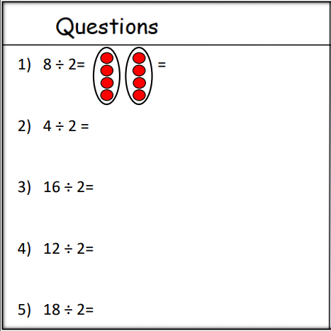
Can you fill in this table. Show me the array and then give me the answer. Than have a go at the challenge question. Use an array to help you.
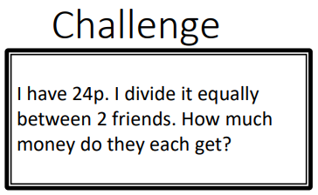

Wednesday
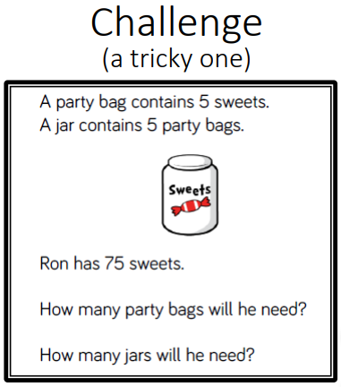
Have a go at these…we’ve moved to dividing by 5. Again, make sure you are drawing the array to help you. Then have a go at the challenge. With this challenge, remember to draw an array or use counters to help you.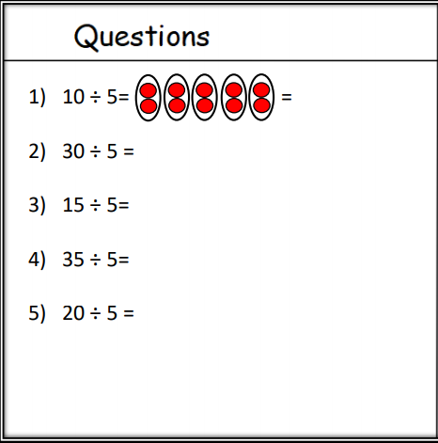
Thursday
Have a go at these…we’ve moved to dividing by 10. Again, make sure you are drawing the array to help you. Then have a go at the challenge.
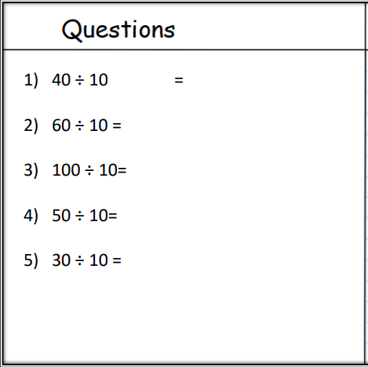
Challenge
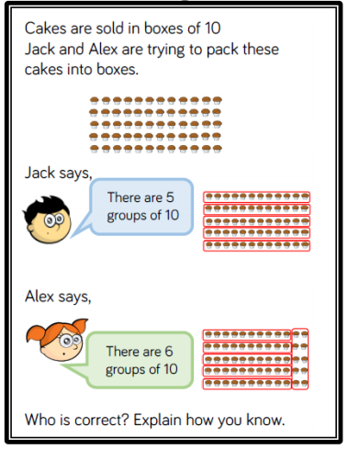

Friday
Have a go at these mixed division problems. Remember to draw your array and give me the answer. Then try the challenge.
