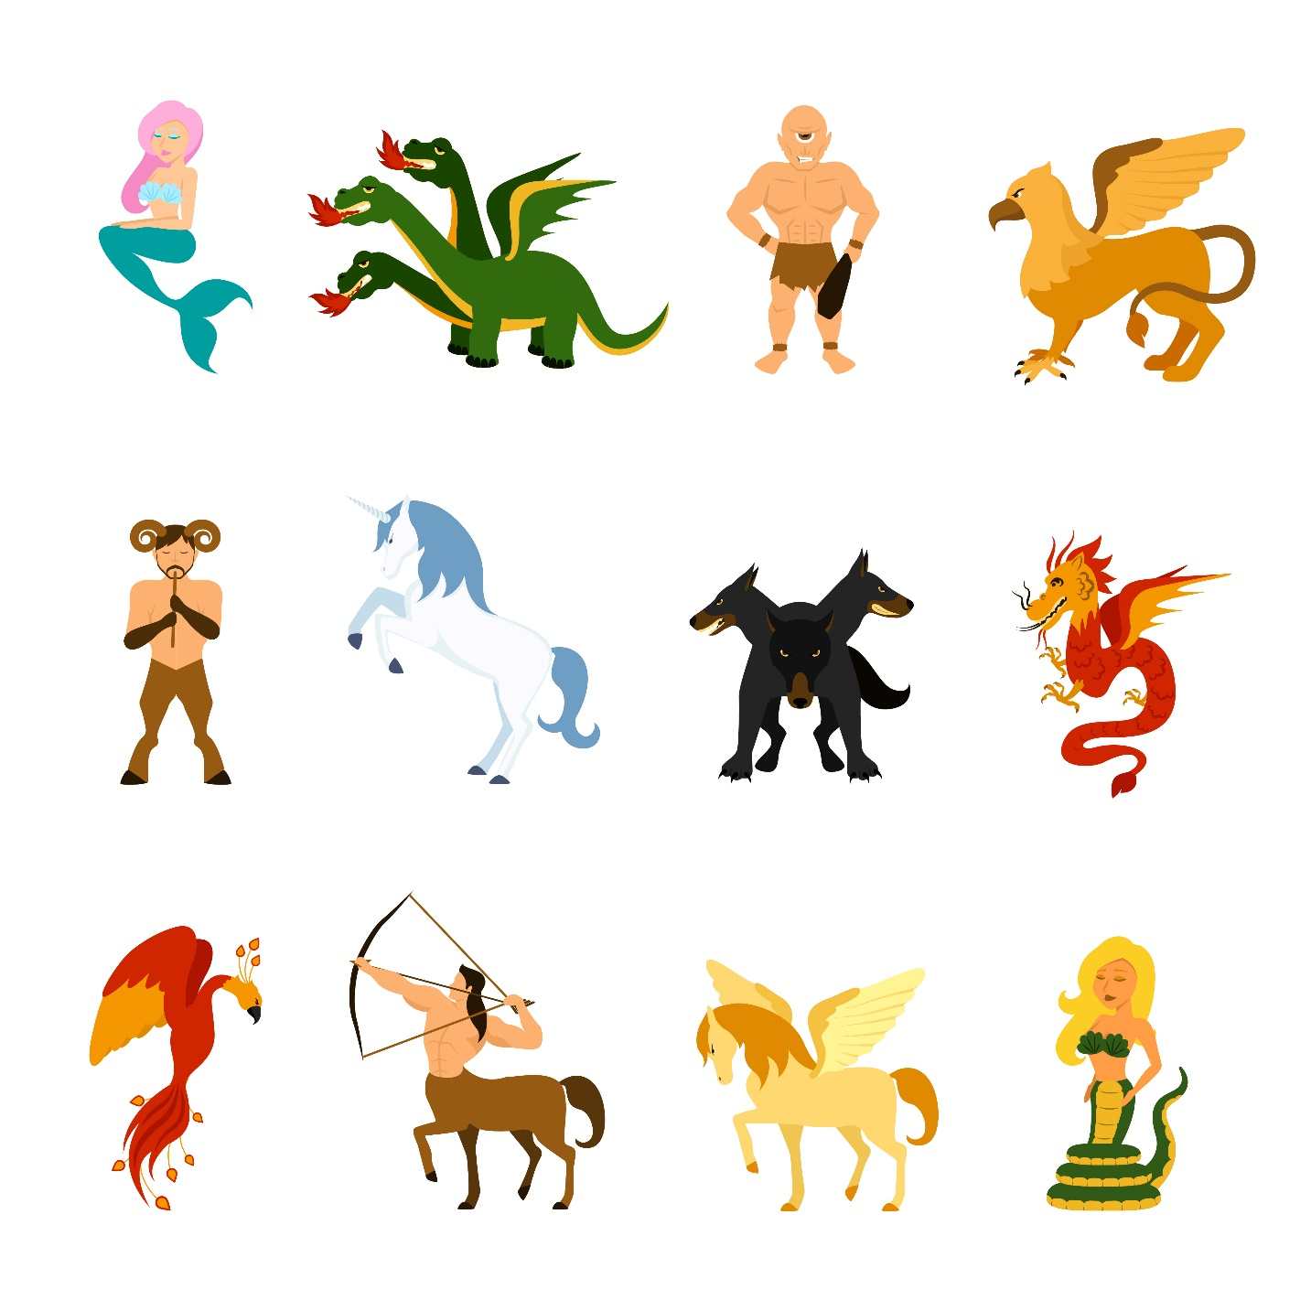

Class 2 English

Tuesday
The children in school have been enjoying researching and talking about mythical creatures, so we decided that we are going to spend this week looking at mythical creatures. Have a look at the powerpoint I have shared on Class Dojo. I would like you to have a go at drawing and describing one of the creatures. Use this online thesaurus to help you. https://www.thesaurus.com/
____________________________________________________________________________
____________________________________________________________________________
____________________________________________________________________________
____________________________________________________________________________
____________________________________________________________________________
____________________________________________________________________________

Wednesday
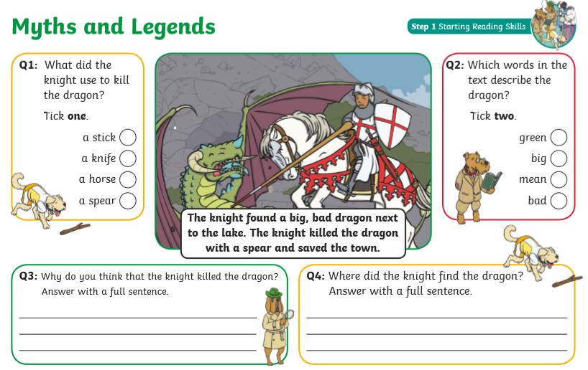
Here are 2 reading comprehensions. I would like you to have a go at both of them. They are all about developing different skills to help you understand what you are reading.

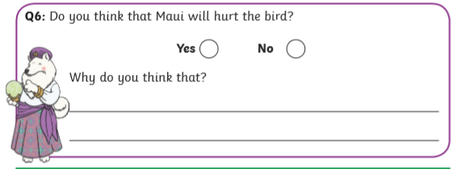
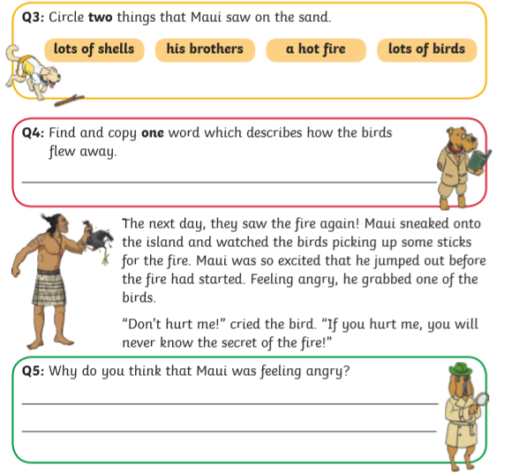
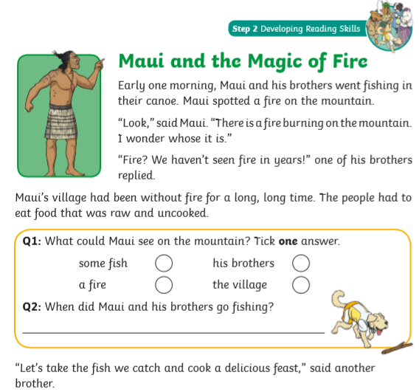

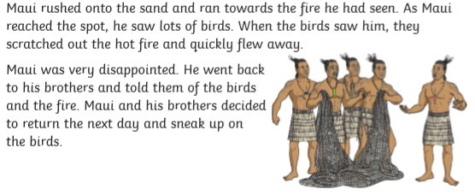

Thursday
Yesterday afternoon, you made your own mythical creature. Can you describe it for me? Can you tell me what magical features it has? Is it good or evil? Where does it live? What does it need to survive?
____________________________________________________________________________
____________________________________________________________________________
____________________________________________________________________________
____________________________________________________________________________
____________________________________________________________________________
____________________________________________________________________________
____________________________________________________________________________
____________________________________________________________________________
____________________________________________________________________________
____________________________________________________________________________
____________________________________________________________________________
____________________________________________________________________________
____________________________________________________________________________
Friday
Today, I would like you to imagine you are going on an expedition to find either the mythical creature you made up, or one of the ones we have talked about. Can you draw part of your journey? What did you need to take with you? Did anything exciting/scary happen? Did you meet the mythical creature?

