Plymouth Marjon  Ability Football Club | 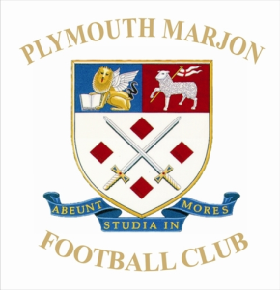
Football Skills and Coaching for Children with Special Needs and Disabilities age 6-12
All Abilities Welcome!!
Learn new skills – Work at your own pace
The club is for children with learning, sensory and physical disabilities and all playing abilities - beginners, improvers and more advanced football players are all welcome. The club will be supportive to all children and everyone can work at their own pace to try new football skills.

THURSDAY
(Starts on Thursday 1st October 2015)
6.00pm – 7.00pm
Marjons Sports Centre
(Sports Hall), Derriford Road, Plymouth, Devon, PL6 8BH
Cost £2 per player
Plymouth Marjon FC is a Charter Standard Club and all coaches are FA Level 1 qualified as a minimum.

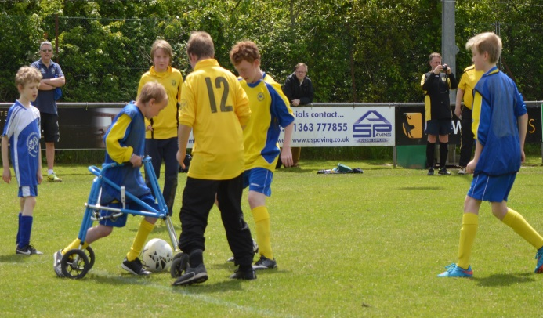

Supported by Devon County FA: Developing Football for Everyone

For more information please contact:
Andy Baum, Telephone 07717137459 / Email baum600@hotmail.com or Chris Smietenka, Telephone 07805177101 / Email csmietanka@marjon.ac.uk

Plymouth Marjon FC
Player Registration Form
Player Registration Form

Full Name of Player ……………………………………………………………….. Date of Birth ………………………………

Address …………………………………………………………..………………………………………………

……………………………………………………………………………………..Post Code………
Telephone Number …………………………………………

Email Address ……………………………………………………

Please Select:
I agree / Do not agree to photographs being taken of my child’s participation in the activity by your club or Devon FA. (These images may be used in printed/video/website format for the purposes of illustrating or promoting the Football Coaching Sessions)

Emergency Contact (If different from above):

Name ………………………………………………………… Tel: ............................ Relationship: ………………………….

Disability
Please give any additional info (include any communication or medical needs) that you consider relevant:
…………………………………………………………………………..
…………………………………………………………………………..
…………………………………………………………………………..
Amputee
Autism
Cerebral Palsy
Hearing impairment
Learning Disability
Behavioural Issues
Visual impairment

Ethnicity
Please choose one category from A to E and then please mark X in the appropriate box to indicate your ethnic background

A White B Mixed C Asian or Asian British
English |  | White & black Caribbean |  | Indian
Irish |  | White & black African |  | Pakistani
Scottish |  | White & Asian |  | Bangladeshi
Welsh |  | Other |  | Other
Other

D Black or Black British E Chinese or Other Ethnic Group
Caribbean |  |  | Chinese
African |  |  | Other
Other

Print Name _____________________________(Player)

Date ________________________

