Mrs Wright’s Update!

As we approach the Christmas break, we are delighted to share the latest happenings and updates from our vibrant Catholic school community. In this special edition, we focus on the spirit of Christmas, celebrating the values of love, kindness, and togetherness that define this festive season.
The spirit of Christmas surrounds us with its magic, and it is a privilege to share this special time with each and every one of you. This December, with the warmth of this Christmas season, I am filled with joy and gratitude for the blessing of being part of such a caring school community and I thank you all for making my first term here as Headteacher so welcoming.

Our school has been alive with the spirit of Christmas! My first Nativity service at The Cathedral School of St Mary was so special, magical and holy. I will never forget it. I would like to thank our dedicated staff for preparing the pupils for the service. Their tireless efforts do not go unnoticed, and I am grateful for the impact they have on our children’s lives every day.
It was lovely to see so many parents/ carers and families at the service. Our partnership in the education and spiritual growth of our children is invaluable. The strong bond between home and school is a partnership that is crucial in nurturing the whole development of our young people.
Our incredible pupils that evening, brought the first Christmas story to life, showing that our school is truly a school of joy and I was so proud of everyone.

We had a wonderful afternoon over at St Joseph’s School (our sister school) for a Pantomime. A special thank you to Plymouth College and Stoke Damerel for transporting us as the weather was awful that afternoon, thanks to one of the various storms we have had this half term!
This week our choir sang beautifully at the residents of Woodlands Villa Care home and they brought the spirit of Christmas to the whole community.

Earlier this year in November, the whole school walked to the memorial of No Place Memorial Gardens to commemorate Remembrance Day. We discussed the significance of Remembrance Day and the children were shocked to read the ages of the fallen on the grave stones. The children placed wreaths that they had made at school as a mark of respect.
Year 3/4 thoroughly enjoyed their residential at Start Bay Centre and I did not enjoy my first experience of Devon lanes driving a minibus following Mr Moore!

We were honoured and surprised to be part of the historical announcement of the new Bishop of Plymouth. Adventurers class asked Bishop Christopher questions both confidently and eloquently, whilst being filmed and photographed by the local media.
I would like to take this opportunity to say a HUGE thank you to Lesley, our MDS, who has worked at this school for 30 years. She has cared for and entertained so many pupils both past and present and she is loved by all. We will miss her soooooo much! We wish her all the best in this next phase of her life and hope she comes back to visit!

As we anticipate the New Year, we are excited about the possibilities and opportunities that lie ahead. Our commitment to providing a nurturing and faith-filled learning environment remains unwavering, and we look forward to continuing our journey together in the coming year.

Finally, may the blessings of Christmas fill your hearts with peace and joy. From my family to yours, and on behalf of the entire Cathedral School community, I wish you a Merry Christmas and a happy and holy New Year.

God bless.
Mrs R Wright
Catholic Life

Catholic Life  The Autumn term has been a very busy term for the Catholic Life of our school.  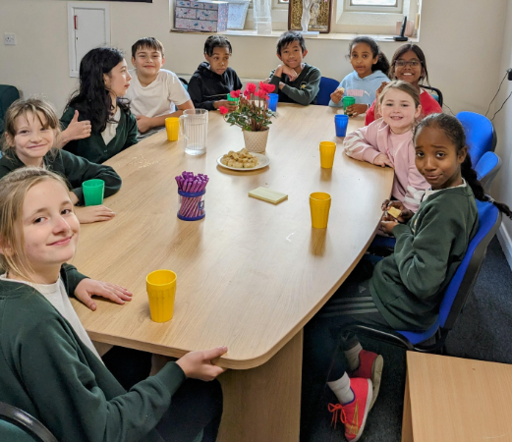  With the help of Canon Mark, we appointed a new GIFT Chaplaincy team. The chaplains first job was to help with the preparations for the Advent Carol Service, sending invites to special guests and welcoming visitors to the performance.  Our choir children visited Woodland Villa Care Home to sing carols and Christmas songs, spreading Christmas cheer and God’s love to our wider community.  We also worked with PC Deb Hart and the CLean our Patch Team to help show love and respect for our local area by going on a litter pick. The children shared the importance of looking after God’s creation with people we met along the way. 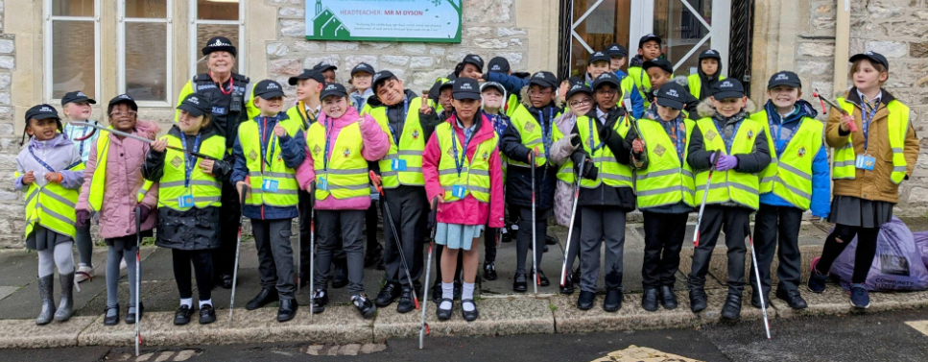  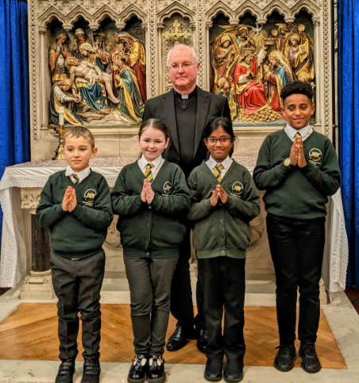  One of the major highlights of our Catholic Life this term was the privilege of meeting Bishop elect Christopher. We were thrilled to be able to ask him questions to find out more about him and his vision for our Diocese. |  | Collective Worship  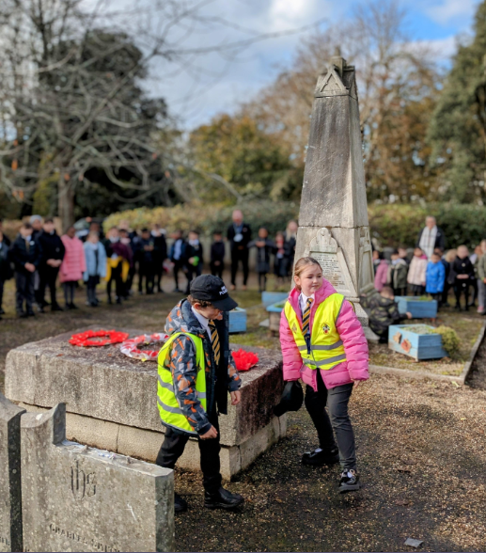  The children have all had fantastic experiences in our Collective Worships this term.  We celebrated a beautiful remembrance service at No Place Memorial Gardens for those who have lost their lives in service to our country.  Our youngest children have begun to attend their weekly masses at the Cathedral and we have celebrated lots of occasions. Our Harvest Festival raised nearly 85 kg of food for the foodbank.  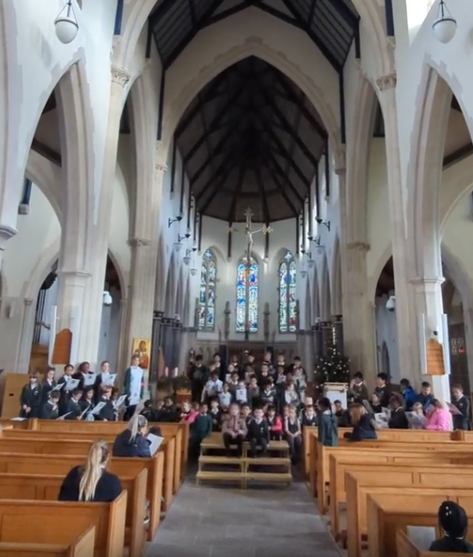  Our Advent Carol Service was very well attended and we received lots of comments about how lovely the evening was.  Our retiring collection made over £165 for the Catholic Children’s Society.  To end the term, we gathered as a school family to celebrate our end of term mass where some of our children have begun serving on the altar.  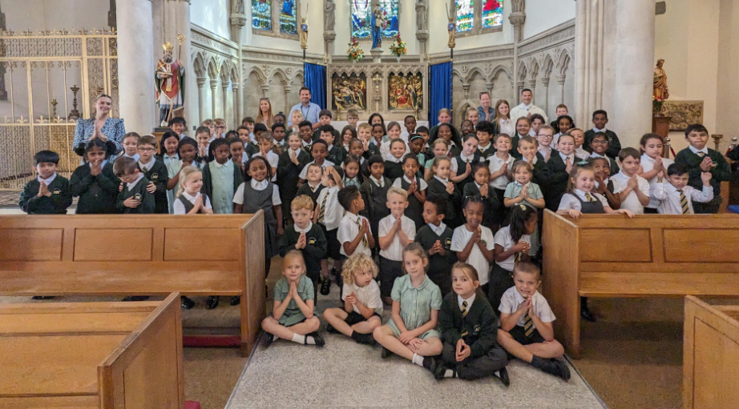

Congratulations!

We have high expectations for all of our pupils to arrive at school each day and on time. Thank you for your continued support.  Miss Grosch 87.51%  Miss Galloghly 85.47%  Miss Toms 87.11%  Mr Driscoll 94.75%  Mrs Berry 91.60%  The highest attendance this half term goes to…  Mr Driscoll’s Class  As a ‘well done’ for winning this half term’s attendance, your class have earnt an extra 20 minutes playtime- keep up the excellent work! |  | Heart of Gold Awards  Miss Grosch’s Class  My heart of gold award goes to Levi. Levi is getting this because he has been trying so hard in our lessons, joining in and making brilliant choices within our classroom, Well done Levi!  Miss Galloghly’s Class-  This week we are awarding Rosie with the Heart of Gold award. It is a sad day today, as we say a farewell to Rosie as she sets off in her new adventures! Rosie has demonstrated a heart of gold during her time at our school with continuous kindness and laughter. Well done Rosie!  Miss Toms’ Class-  The Heart of Gold award this week goes to JJ.  JJ is such a kind and caring member of our class and is always willing to help others. He will often check up on everyone, not only in our class but in the whole school. He is very compassionate when someone is sad and will always be the first person to support others.  Well done JJ.  Mr Driscoll’s class-  Jorcina has been awarded the Heart of Gold this term for her Love for the school. She is always happy to help others and greets them with a smile. Her love makes our day brighter and we are so grateful that she is part of our school family.  Mrs Berry’s Class-  Adam B consistently tries his best in all lessons. When faced with challenges, Adam works systematically and is able to successfully apply his knowledge to solve problems. Well done Adam. Keep up the good work!
News and Events

Meet our Governors!  Mrs Wilson-Town  I joined the Governors last year as a staff governor and am now a parent governor. I am the Year 6 teacher at our sister school, St Joseph’s. I am also a mum to two boys - one who is 5 years old and in Foundation at St Joseph’s and the other is 2 years old. They are both cheeky monkeys! This allows me to see things from different perspectives. I appreciate and see the benefit of our two schools working closely together. I lead maths across both schools and try to make sure I am at CSOSM every Tuesday afternoon. It has been lovely getting to know some of the children and talking to them about their maths learning! | Fundraising  We raised £35.25 for Children in need 2023. A huge thank you for all of your donations- every little helps and the money raised will help to make a huge difference to the lives of others, Well done everyone!  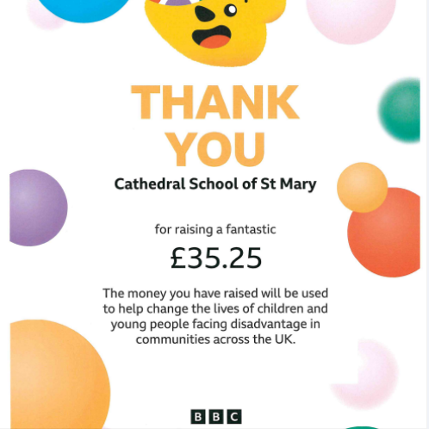
Let’s get talking at home
Things to talk about at home...
Share any prior knowledge you have about volcanoes.
How do you imagine the people of Grindavik feel about having to leave their homes, not knowing when they will be able to go back?

We Love Learning!

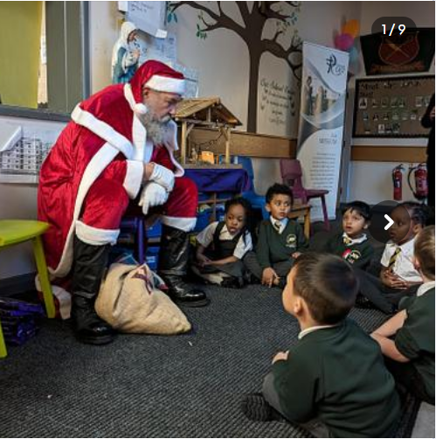 |  | 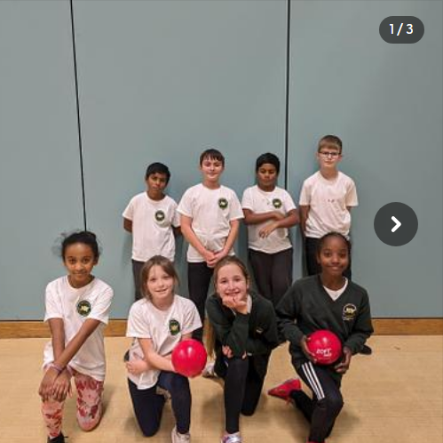
We had a visit from our special guest Santa during our film night. He told us that we were all on the good list!. |  | Great teamwork from our KS2 dodgeball team. Some fantastic performances and great motivation!
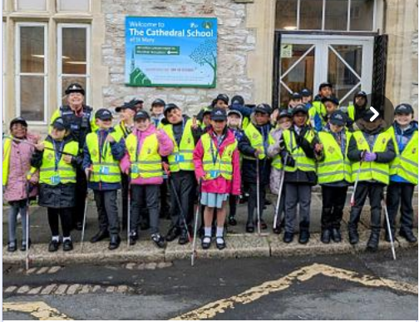 |  | 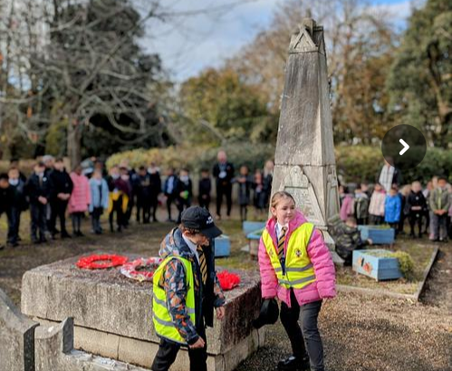
Our Mini Police team collecting litter from the local area as part of their Social Action Project. |  | As a whole school, we visited No Place Memorial to pay out respects to our fallen soldiers laying wreaths.
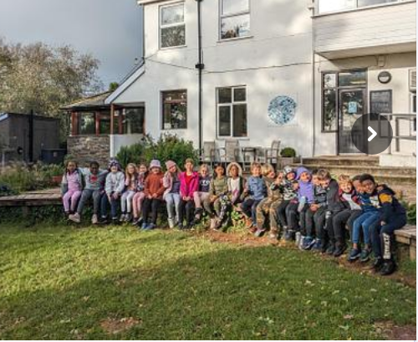 |  | 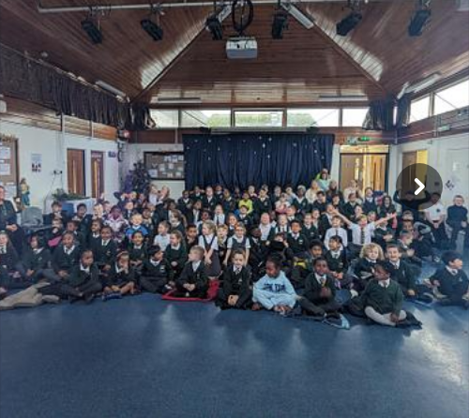
We took some children from Mr Driscoll’s class on a residential for 2 nights. The children had a wonderful tome and all of them grew in confidence and self belief. |  | The whole school had a great time watching the panto at St Joseph’s Primary school- luckily we had some transport as they would have become very wet had they walked!
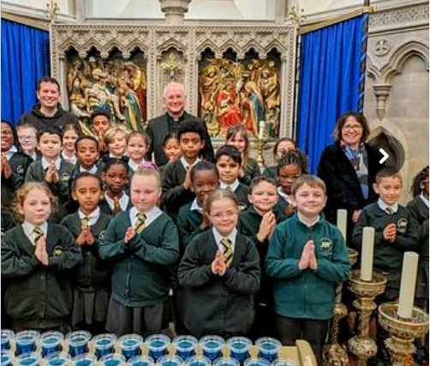 |  | 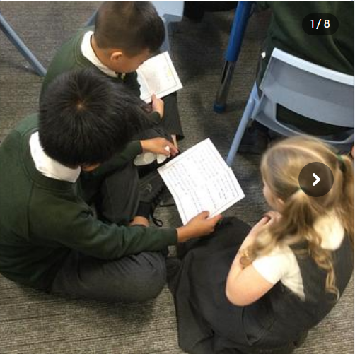
We have the honour of welcoming Bishop Elect Christopher Whitehead last week- soon to be the 10th Bishop of Plymouth. |  | Years 5 and 6 visited year 1 to share Christmas stories that they had been writing about in English.

Christmas Events

Help and support

We are Readers
Help us win £1,000 for our school library!

Our school needs you! Please help us to win £1,000 of National Book Tokens and a membership to the School Library Association to help develop our library and encourage reading for pleasure - plus you could win £100 for yourself!
Enter here: http://www.nationalbooktokens.com/schools

Do you know an adult who can't read?

Read Easy is a completely free one-to-one service designed to help adults learn to read at their own pace, without pressure. If you know someone who would benefit from this service, please get in touch with Mrs Foster or Mrs Low and we will provide you with some further information. https://readeasy.org.uk/

Happy reading!

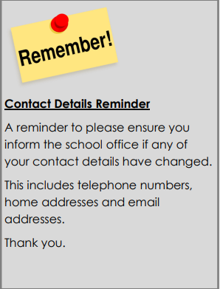
Attendance update

I was fortunate to be able to attend an Attendance Conference held by the Local Authority last week. This was a fantastic opportunity to learn how other schools are working with families to support children’s attendance and gave me the opportunity to reflect on the strategies and initiatives we currently use.

I am incredibly proud of the steps we are taking as a community to improve our attendance and I will share further steps we are taking after Christmas.

Thank you to all of our families and the wider community for ensuring that our children are in school and on time regularly and I wish you all a Merry Christmas.

Mr Moore

MYCLOTHING
Get great value school uniforms, complete with embroidered emblem.
• Extensive size and colour choices
• Outstanding products ethically sourced
• Embroidered in the UK
• FREE DELIVERY on all orders over £50
www.myclothing.com 0800 059 0594
Help and support

Dates for your diary  3rd January- First day back  5-9th February- Children’s mental health week  12-16th February- Half term  19th February- Non-Pupil day  20th February- Children return to school.  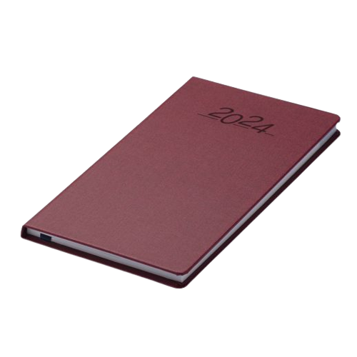 |  | The uniform store Plymouth is a free service for families to kit out their children for school.  Through donations of good quality school uniform, we give the items to those in need, free of charge.  Our service is open to anyone to use- no referral is needed.  We are located at;  93 New George Street, Plymouth City Centre, PL1 1RQ  Opening hours:  Tuesday, Wednesday and Friday 10am-1pm.  Plymouth Uniform store

Is your child eligible for free school meals?

If you receive certain benefits then your child may be entitled to a free school meal and if so, their school receives extra funding. This means it’s important to apply, even if your child is in reception, year 1 or year 2 and already receives a free lunch.

Check the criteria and apply online: Free School Meals Plymouth

