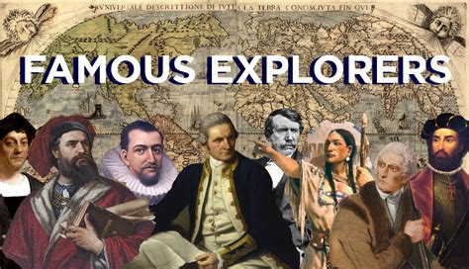

Class 2 English

Monday
Look at the powerpoint I have shared on Class Dojo about the explorers who went to the South Pole. Can you answer the questions at the end of the powerpoint? How do you think expeditions to Antarctica might be different today? What do we have in the world that would help modern explorers? Please answer in full sentences.
____________________________________________________________________________
____________________________________________________________________________
____________________________________________________________________________
____________________________________________________________________________
____________________________________________________________________________
____________________________________________________________________________
____________________________________________________________________________
____________________________________________________________________________
____________________________________________________________________________
____________________________________________________________________________

Tuesday
Look at the powerpoint I have shared on Class Dojo about the South Pole/Antarctica. How is it different from where we live? What is the difference in climate? What about the different animals that live there? Can you write me a list of the differences.
____________________________________________________________________________
____________________________________________________________________________
____________________________________________________________________________
____________________________________________________________________________
____________________________________________________________________________
____________________________________________________________________________
____________________________________________________________________________
____________________________________________________________________________
____________________________________________________________________________
____________________________________________________________________________

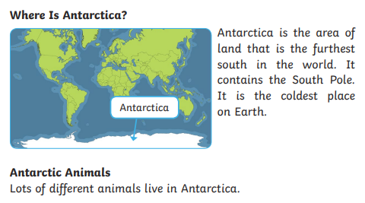
Wednesday Have a go at these reading comprehensions
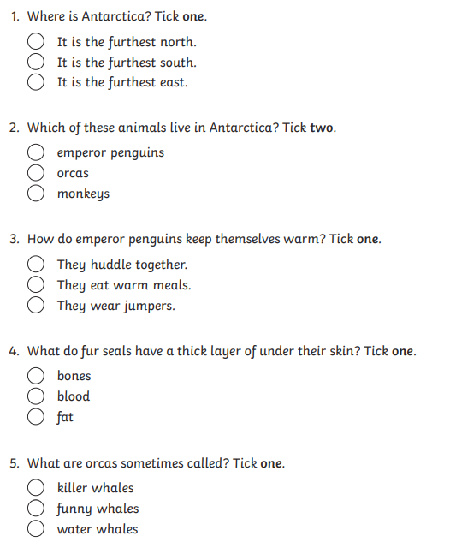

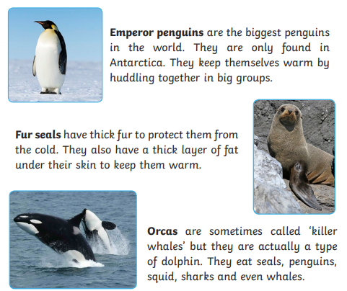

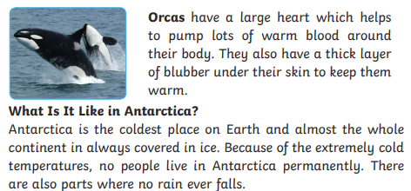
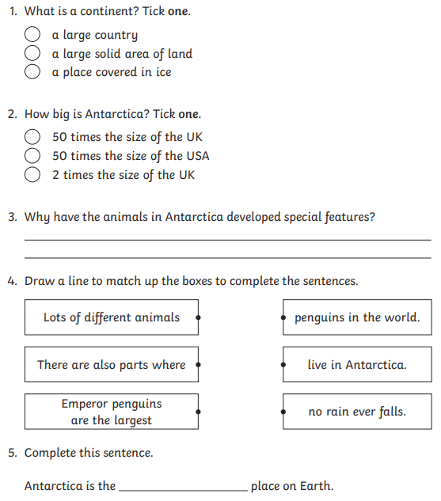
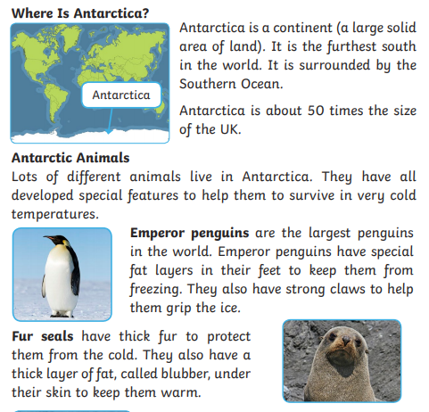
Thursday
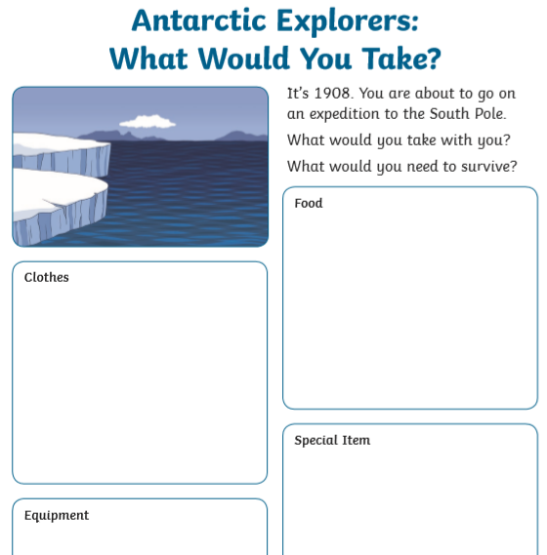
Have a think about what you would need to take on an Antarctic adventure. Can you pack a bag?

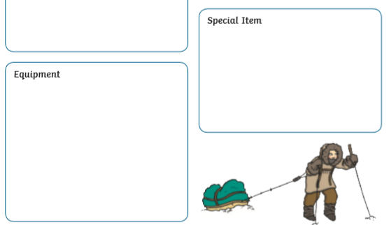

Friday
Have a listen to some of the extracts I’ve read on class dojo of the diaries that explorers have kept. Can you imagine that you’re an explorer in the Antarctic? What would you write in a diary? Maybe you can draw some pictures too.

