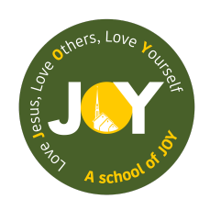
Uniform Policy

Policy agreed by governors October 2023
Review ed September 2023
Executive Head Teacher: Mrs Roisin Wright
Chair of Governors: Canon Mark O’Keeffe

School Uniform Policy

It is our school policy that all children wear school uniform when attending school, or when participating in a school-organised event outside normal school hours. We provide a complete list of the items needed for school uniform on our school website.

Our policy on school uniform is based on the notion that school uniform:

- promotes a sense of pride in the school

- engenders a sense of community and belonging towards the school

- is smart

- identifies the children with the school

- makes children feel equal to their peers in terms of appearance

- is regarded as suitable wear for school and good value for money by most parents

- is designed with health and safety in mind

We ask all parents who send their children to our school to support the school uniform policy. All parents sign an agreement on entry to our school stating that they will support all school policies including supporting the uniform policy. We believe that parents have a duty to send their children to school correctly dressed and ready for their day. One of the responsibilities of parents is to ensure that their child has the correct uniform at all times.
There may be times throughout the year where children’s shoes are damaged or the child has outgrown their uniform. In this case, we expect the parent to explain the circumstances to the school and that the parent will replace the uniform within a week.
This is to ensure the high expectations for uniform are adhered to.

Uniform List

Boys (winter) | Girls (winter)
Dark grey trousers | Dark grey skirt, pinafore or trousers
White collared shirt | White blouse/collared shirt
School tie - elastic tie for EYFS/KS1 neck tie for KS2 | School tie - elastic tie for EYFS/KS1 neck tie for KS2
Dark green v-neck jumper (preferably with school badge) | Dark green cardigan or v-neck jumper (preferably with school badge)
Plain dark socks | White/ grey socks or grey/black/navy/ white tights
Sensible black school shoes or trainer style | Sensible black school shoes or trainer style

Boys (summer) | Girls (summer)
Dark grey shorts (or trousers) | Green and white checked dress or dark grey shorts
White collared shirt | White blouse/collared shirt
School tie (either next tie or elastic) | School tie (either neck tie or elastic)
Dark green v-neck jumper (preferably with school badge) | Dark green cardigan or v-neck jumper (preferably with school badge)
Plain socks | White/ grey socks
Plain, sensible black school shoes or trainer style. | Plain, sensible black school shoes or trainer style.

PE for Boys and Girls
School PE T-shirt or plain white t-shirt/ polo shirt
Plain black/navy/ dark green shorts and tracksuit bottoms or leggings. Plain black/ navy/ dark green tracksuit jumper (no logos, patterns or images)
Black plimsolls/ Trainers- not colourful and not expensive.

Additional Information

Tracksuits- children need these for activities taking place outside during cold weather. Tracksuits need to be plain black, dark green or navy without logos, patterns or images.

Watches may be worn at the discretion of parents, but the school cannot accept responsibility for damage or loss incurred. Alarms or bleepers are not permitted. NO SMART WATCHES permitted.

All items of clothing (including shoes, socks, and trainers) must be clearly labelled with your child’s name.

The school is aware of the cost of uniform and acknowledges the guidance from the DFE to ensure uniform is affordable for all. Any parents needing support with sourcing uniform can make an appointment to meet with our PSA who will be able to help.
https://www.gov.uk/government/publications/cost-of-school-uniforms/cost-of-school-uniforms#the-importance-of-the-cost-of-school-uniform

Jewellery, Hair Ornaments, Make-up and Nail Varnish
For many reasons, including safety, we do not allow children to wear jewellery. The exceptions to this rule are ear-ring studs in pierced ears. Children are required to remove any items during P.E. lessons to prevent them from causing injury.
Please note: School staff are not permitted to remove earrings.

Make up and nail varnish should not be worn to school.

All long hair should be tied back and hair accessories should be plain and either green, brown or black to match our uniform. Hair bands should not have large flowers or other decorations attached.

Extreme hairstyles are not appropriate for school. The use of styling products should be kept to a minimum and children should not have decorative patterns cut into their hair or have hair coloured or dyed.

We are passionate in securing the highest standards for our school. By adhering to a clear uniform policy will promote pride and high expectations across the school.
Parents who refuse to follow the uniform/hairstyle policy will be asked to meet and discuss the issue with the Headteacher and representatives from the Governing Body.

Appendix 1

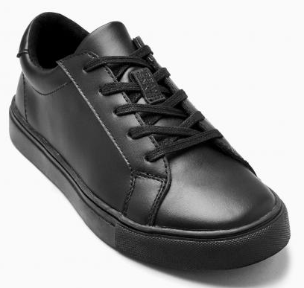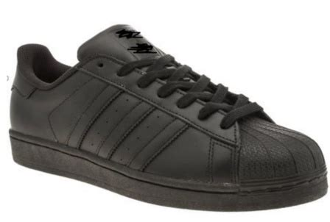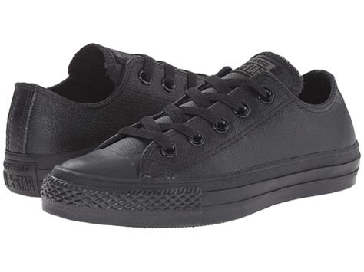

The above footwear are acceptable as they are a close mimic to normal shoes. They are entirely black with no colours.

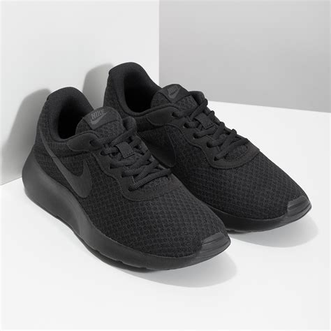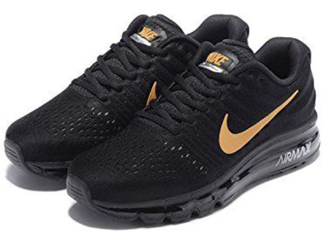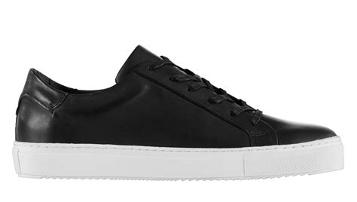

The above footwear are NOT acceptable.

The first two trainers are obviously trainers and do not give the smart look that we expect at our school.

The last image, whereas they look similar to those that are acceptable, have a white base and are not ALL black.

