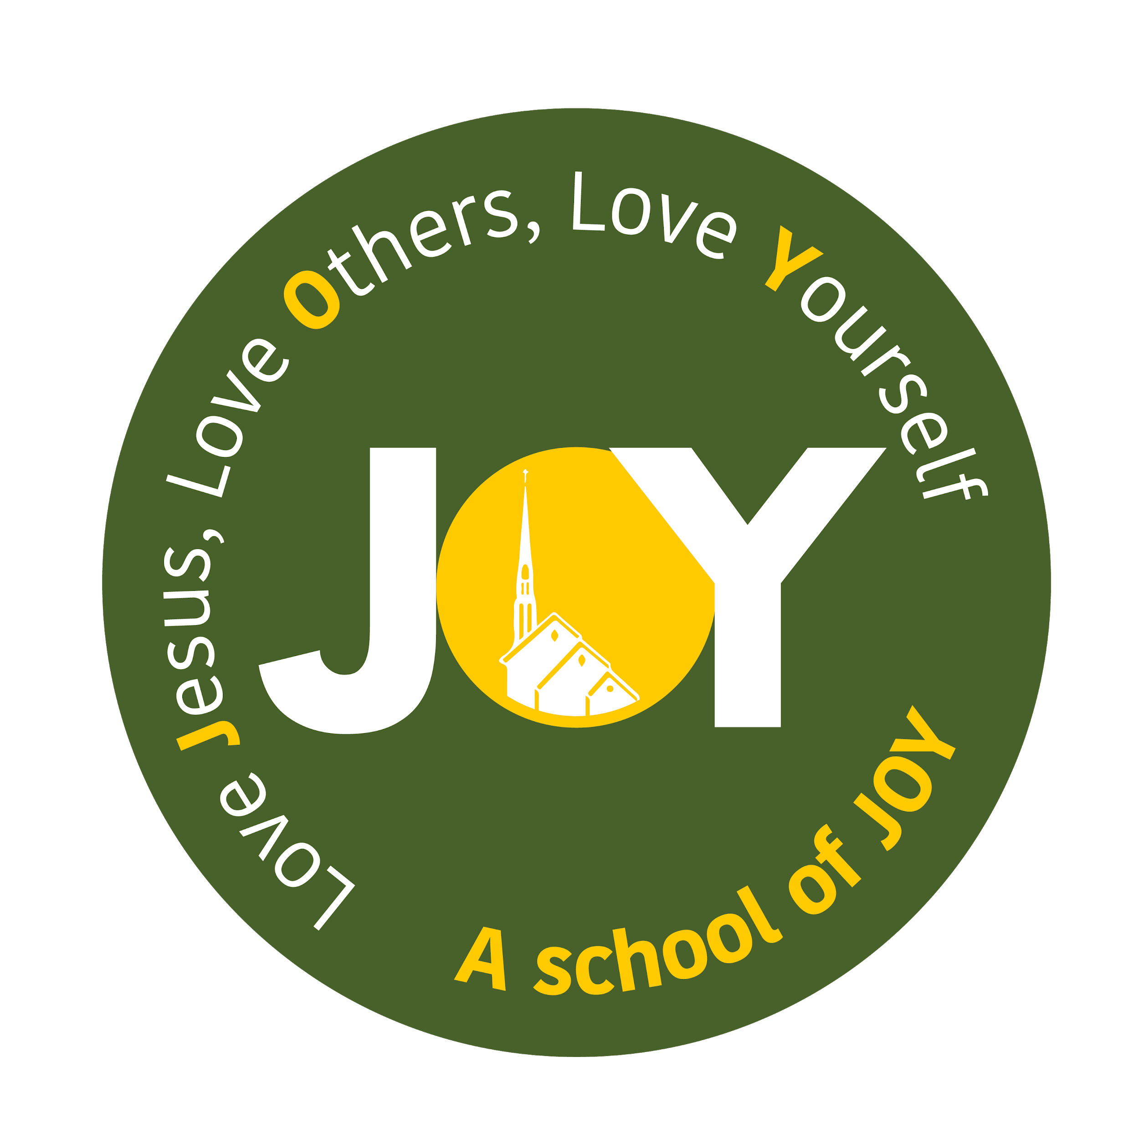

**St Joseph's and The Cathedral School of St Mary**

**Foundation - Autumn Term 2 2024**

**Fire, Fire!**

| **Foundation** | Week 1  WB: 04.11.2024 | Week 2  WB: 11.11.2024 | Week 3  WB: 18.11.2024 | Week 4  WB: 25.11.2024 | Week 5  WB: 02.12.2024 | Week 6  WB: 09.12.2024 | Week 7  WB 16.12.2024 |
| --- | --- | --- | --- | --- | --- | --- | --- |
| **Key Dates/Info** | 04.11.24 - Non-pupil day |  |  |  |  |  | 20.12.24 - Last day of school |
| **Educational Visits/**  **Experiences** |  |  |  |  |  | Advent Afternoon |  |
| **Weekly Theme** | Crime Scene Investigation - The Great Fire! | Who’s in charge?  King Charles II | I’m a survivor! Surviving the Great Fire of London | Fire, fire!  People who help then and now | How do we know?  Samuel Pepys and his diaries | Christmas Preparation | Christmas Celebration |
| **Vocabulary** | The Great Fire of London, River Thames, Bakery, Pudding Lane | Thomas Farriner, Sir Christopher Wren, King Charles II, Architecture, Declaration | Questions, Answers, Survivors, Rebuild, Destruction, Blaze |  | Samuel Pepys, Diary, Account, True, False, Historical fact | Elf, door, Father Christmas, RE vocab | Mary, Joseph, Jesus, Bethlehem, donkey, wisemen, angels |
| **Key Text**  **For Drawing Club** | Oi Frog! By Kes Grey | Owl Babies by Martin Waddell | Goldilocks and the 3 bears | Weather by Steffi Cavell-Clarke | Tree by Patricia Heggarty and Britta Teckentrup | Harvey Slumpfenburger’s Christmas Present | Jesus’ Christmas Party |
| **Key Text**  **For Bookwrites** | Oi Frog! By Kes Grey | Oi Frog! By Kes Grey | Oi Frog! By Kes Grey | Weather by Steffi Cavell-Clarke | Weather by Steffi Cavell-Clarke | Weather by Steffi Cavell-Clarke | Jesus’ Christmas Party |
| **Literacy** | I know how to spot and suggest rhymes.  I know the individual letters taught so far.  I can orally blend and segment simple words.  I know how to read simple words with sounds that I am familiar with.  I know how to write simple words using sounds that I am familiar with. | I know the individual letters taught so far.  I can orally blend and segment simple words.  I know how to read simple words with sounds that I am familiar with.  I know how to write simple words using sounds that I am familiar with. | I know the individual letters taught so far.  I can orally blend and segment simple words.  I know how to read simple words with sounds that I am familiar with.  I know how to write simple words using sounds that I am familiar with. | I know the individual letters taught so far.  I can orally b;lend and segment simple words.  I know how to read simple words with sounds that I am familiar with.  I know how to write simple words using sounds that I am familiar with. | I know the individual letters taught so far.  I can orally blend and segment simple words.  I know how to read simple words with sounds that I am familiar with.  I know how to write simple words using sounds that I am familiar with. | I know the individual letters taught so far.  I can orally blend and segment simple words.  I know how to read simple words with sounds that I am familiar with.  I know how to write simple words using sounds that I am familiar with. | I know the individual letters taught so far.  I can orally blend and segment simple words.  I know how to read simple words with sounds that I am familiar with.  I know how to write simple words using sounds that I am familiar with. |
| **Maths**  **EYFS** | Unit 2: Comparing groups within 5 | Unit 2: Comparing groups within 5 | Unit 3: 2D and 3D shape | Unit 3: 2D and 3D shape | Unit 4: Change within 5 | Unit 4: Change within 5 | Unit 5: Number bonds to 5 |
| **Maths**  **Year 1** | Unit 4: Subtraction within 10 | Unit 4: Subtraction within 10 | Unit 4: Subtraction within 10 | Unit 5: 2D and 3D shapes | Unit 5: 2D and 3D shapes | Unit 5: 2D and 3D shapes | Unit 5: 2D and 3D shapes |
| **RE** | Prophecy and Promise  I know that Mary was chosen by God to be Jesus’ mother. | Prophecy and Promise  I know that Mary and Joseph travelled to Bethlehem.  The Longest Wait-book | Prophecy and Promise  I know that Jesus was born in a stable and laid in a manger.  The Longest wait-book | Prophecy and Promise  I know that Shepherds visited Jesus in the stable. | Prophecy and Promise  I know that Advent is a time to get ready for Christmas. | Prophecy and Promise  I know that Jesus came for the whole world.  Joy to the World!-book | Prophecy and Promise  Celebration of learning.  Joy to the world!-book |
| **PSED/ Gospel Values** | I know we are part of God’s family.  I know that Jesus loved and cared for people. | I know who special people are.  I know why it is important to trust special people to me and that I can talk to these people if I am worried. | I know how my behaviour affects others.  I know the characteristics of positive and negative relationships.  I know about different types of teasing and that bullying is wrong and not acceptable. | I know that when I have been unkind I can say sorry.  I know how to recognise when someone is being unkind to me and how I can respond.  I know that I can forgive others like Jesus did. | I know about safe and unsafe situations including online.  I know I can speak to a trusted adult if I feel unsafe. |  |  |
| **Communication & Language** | Set up a ‘crime scene’ with clues to hint to the fire of London (flour, singed paper, burnt loaf, etc) Can the children use the clues to figure out what happened. | Who is in charge? Play a game of Simon Says. Who is in charge - who do we need to listen to? Talk about what makes someone a good leader. | Read a bit of a made up diary - what does it tell us?  Share pictures of the Great Fire of London. What can you see - compare with pictures of London at the time. | How would you survive on a desert island? What would you need? What would you do?  Link to how people looked after themselves and each other during the Great Fire of London. | Share different scenarios eg if you are lost, if you fall over- who might help us?  Talk about a time when someone has helped you. | Talk about how we prepare for something like a new baby. Remember that through advent we have been preparing to celebrate Jesus’ birth. | What are you excited about over the Christmas period? Together, write a letter to Father Christmas and a prayer to Jesus. What shall we say in each of them? |
| **Understanding the World** | Look at the events of the Great Fire of London. Sequencing the events, making a timeline of what happened using the language, first, then and next | Look at King Charles the II. Who was he, what did he do to help during the Great Fire of London. Was he important? | Talk about how we know about things that we haven’t witnessed. Would there be pictures of the Great Fire of London? | Can the children make survival packs for if they were in an emergency situation? What would they want to take with them? | Act out different people who help us, using the dressing up to show how they might help. | Look at different ways people around the world celebrate Christmas, comparing it to our celebrations. | How do you think your celebration of Christmas will be different from the celebrations of that first Christmas? |
| **Year 1 Understanding the world outcome.** | Put together a timeline of the Great Fire of London. Discuss where this would sit in the wider context of history. | Character biography of Charles the II, focusing on what he did during the Great Fire of London. | Sort true and false statements about Samuel Pepys. | Oracy session looking at how people survived and how they might have felt during the Great Fire of London. | Look at the beginning of the fire service. Compare the different equipment used then and now. |  |  |
| **Expressive Arts and Design** | Autumn Art!  Printing with Autumn leaves, using Autumn colours. | Looking at the pictures of the Great Fire of London. Can they recreate their own. Stations cutting out silhouettes of houses and painting with ‘fire’ colours. |  |  |  |  |  |
| **Computing / Technology** |  |  | Children to use ipad to take pictures of themselves | Recognise and search a range of technology used in the home. | Explore how families communicate with one another and keep in touch, especially with those members they don’t live with eg email, text, etc. | Create a video performance of ‘All join in’ by Quentin Blake. | Talk to the pupils about technology that has been  developed to help people e.g.  dictation programs. |
| **Physical Development** | Fine and Gross motor skills  Dance: Nursery Rhymes | Fine and Gross motor skills  Dance: Nursery Rhymes | Fine and Gross motor skills  Dance: Nursery Rhymes | Fine and Gross motor skills  Dance: Nursery Rhymes | Fine and Gross motor skills  Dance: Nursery Rhymes | Fine and Gross motor skills  Dance: Nursery Rhymes | Fine and Gross motor skills  Dance: Nursery Rhymes |