Mrs Wright’s Update!

I hope this newsletter finds you well as we approach the joyous season of Easter. It's been a remarkable term filled with learning, growth and community spirit here at The Cathedral School of St Mary.

It has been a very busy term for our pupils.

Our school football team has represented us in two tournaments and they are growing in confidence and skill. A special shout out to Freya who played in the team and I’m hoping that more girls will be inspired to attend football club on Monday after school because of her.

The other clubs we offer are Dance, Table Tennis, Choir and Art. Our Art club is proving popular and we have a few spaces left: expect to use paints, pastels and your creativity. A huge thank you to all the staff that help run these free clubs, in their own time for the benefit of our children.

Foundation and Year 1 were lucky to have a trip to Plymouth Argyle Football Club. They had a tour of the school, went on the pitch, met players and were given their very own Argyle football shirt!

Last week Mr Driscoll and I became the proud Godparents to 6 pupils who were baptised at the Cathedral supported by the whole school and their families and friends. We were all honoured to be able to share their special day.

World Book Day was celebrated again in style at CSOSM and the children looked amazing. Thank you to our creative parents and carers.

I would like to thank the year 6 parents that were able to attend our recent SATs parents’ session where we discussed the tests, expectations and the best ways to support your year 6 children as they prepare for their SATs which start on 13th May. Please can I encourage all pupils to attend the booster classes that I am teaching every Monday and Tuesday at 8am until the tests begin.

A reminder for your photographs reading in unusual places. The 2 week holiday will provide lots of opportunities for that. We only have 4 photos and we have over 100 pupils! Children nag your parents and carers, and please parents and carers, support us to create an inspiring reading display at our school reception. Please email photos to school.

Finally, can I remind everyone that we have a school focus on attendance and uniform. Our school attendance is still below expected and lower than other schools in Plymouth. We continue as a school to support our families with any barriers to attendance and we will continue to monitor this closely and address any concerns.

Please refer to the information I shared recently on our school uniform. I did this to give parents and carers time to ensure that their children have our school uniform and PE kit when they start back after Easter. We will monitor uniform closely, especially PE as we allow pupils to come to school in their kit on PE days. Parents and carers will be contacted if our school uniform is not followed. If there is an issue with our uniform policy please arrange an appointment with the school to discuss so we can see how we can support.

Thank you for your continued support for our School of Joy.
May this Easter season fill your hearts with hope, joy, and renewed faith. Wishing you and your loved ones a blessed Easter filled with peace and happiness.

God bless
Mrs R Wright

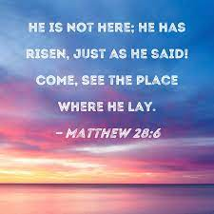

Catholic Life and Events

Catholic Life  We have spent the last few weeks of this term preparing for our ‘Sleep on the Floor for a Night’ sponsored sleepover, in support of the Catholic Children’s Society. We’re looking forward to seeing how much everyone has raised after the Easter break.  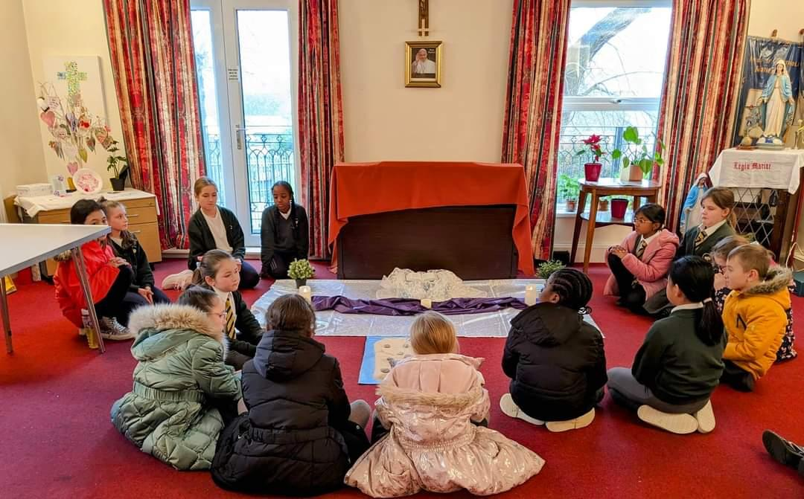  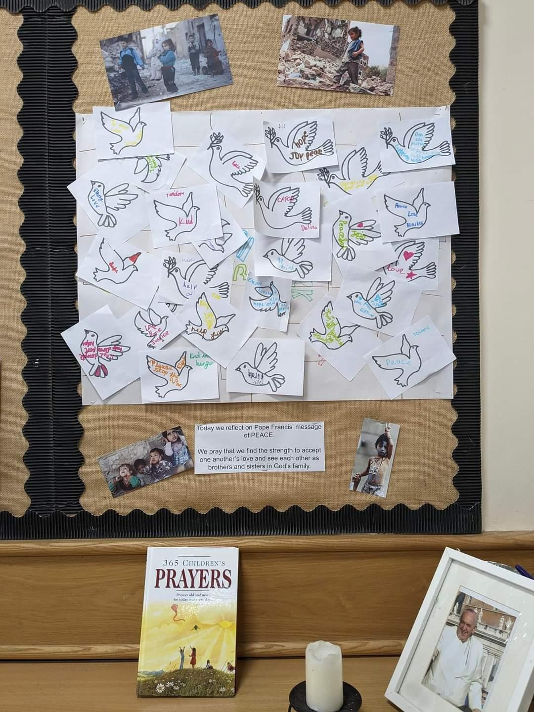  Our GIFT Team have led several prayer spaces this term all with the help of Sister Navya. The children have focused on Pope Francis’ message of peace and looking at how we can have a successful Lent.  Finally, we celebrated a beautiful end of term Mass. We were very honoured to welcome six children into the Catholic Faith through the Sacrament of Baptism.  Please keep our children who will be making their First Holy Communion next term in your prayers. |  | Regular events in The Cathedral Centre  Ecumenical Bible Study Group:  Thursdays -10.00am coffee/tea, 10.30-11.30am.  Legion of Mary:  Thursday, 6.00pm to 7.30pm  Union of Catholic Mothers:  Tuesdays 1.30pm-3.30pm.  St Pio Prayer Group:  On the first Friday of every month after 7.00pm Mass, all are welcome. Contact: Rev. Deacon Tony Irwin, Tel. 01548 853413.  Society for the Protection of Unborn Children:  Meet in the Cathedral Centre, third Wednesday of every month at 7.30pm. Contact Christine Hudson Tel. 01752 224018.  Knights of St Columba:  Every second Monday of the month at 6.30pm.  The Cathedral Centre Events

Congratulations!

We have high expectations for all of our pupils to arrive at school each day and on time. Thank you for your continued support.  Miss Grosch 98.21%  Miss Galloghly 93.33%  Miss Toms 80.88%  Mr Driscoll 90.91%  Mrs Berry 80.08%  The highest attendance this half term goes to…  Mrs Grosch’s Class  As a ‘well done’ for winning this half term’s attendance, your class have earnt an extra 20 minutes playtime- keep up the excellent work! |  | Heart of Gold Awards  Miss Grosch’s Class  The heart of gold this week goes to…the whole of Explorers Class! This week we went on a trip to Plymouth Argyle. I was so proud of their behaviour, the energy and joy they put into the football games and the gratitude they showed on receiving their football tops. Thank you for a lovely trip!  Miss Galloghly’s Class-  The Heart of Gold winner this week goes to Lacie. Lacie has massively improved to spread joy and love to others throughout this term. Lacie helps others with their learning and offers support to her peers.. Keep displaying your loving and caring side Lacie which we all adore!  Miss Toms’ Class-  The Heart of Gold award this week goes to Aiva.  She has been so kind and caring to her friends in class and has been especially helpful to the other children during PE. She has consistently been an extremely positive role model who has been encouraging and full of praise.  Well done Aiva.  Mr Driscoll’s class-  Rhys has been awarded the Heart of Gold this week for demonstrating resilience. He is becoming increasingly focused on his work and is starting to understand his capabilities and achieve his potential. Well done Rhys!  Mrs Berry’s Class-  Haneen is a conscientious member of the class who is motivated to do well. She listens well during lessons, engages in independent and group tasks and completes her learning to a good standard. Well done Haneen! Keep up the good work.
News and Events

Meet the Staff  Miss Cooper  I have worked as a TA for the past 19 years and I am delighted to have joined the team at The Cathedral School of St Mary. I have a passion for supporting all ages of children with different needs and I pride myself on encouraging children to achieve their best. I enjoy watching football and F1 and I am a huge argyle fan. I have a son, cat and a dog and in my spare time I enjoy listening to all types of music. | Meet the Staff  Mr Parker  I am excited to be joining the team at The Cathedral School of St Mary full time whilst I undertake my Sports Apprentice Level 2 qualification. I have always loved sport and have always been part of a team. I currently play hockey at Plymouth Marjons hockey club. I love the outdoors and everything that comes with it from hiking and camping all the way to climbing and kayaking.
Let’s get talking at home
Things to talk about at home...
• Share your experience of mobile phones and other portable devices. Do you use them at home or at school? Do you enjoy using them?
Do you agree that mobile devices should be banned in school? What are your thoughts on the new guidance?

We Love Learning!

 |  | 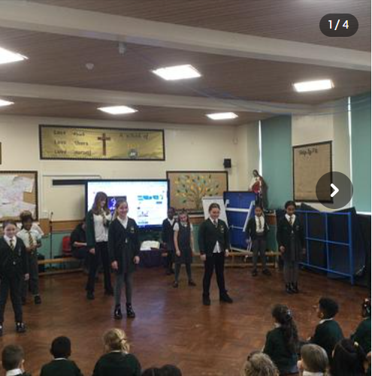
We sent a team to the UKS2 Indoor Rowing Festival. Well done to all of our athletes. |  | The dance club have been working particularly hard on a dance routine with Miss Kirk. They showcased their new dance during assembly.
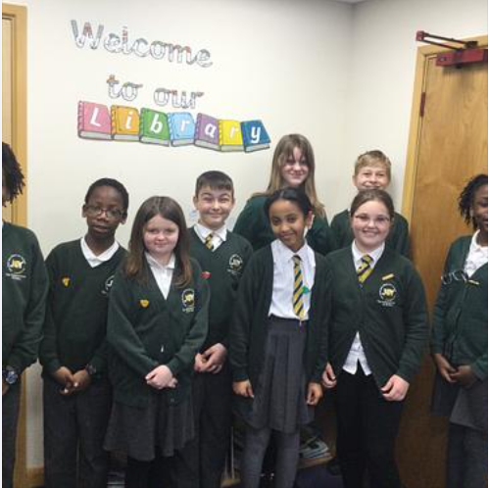 |  | 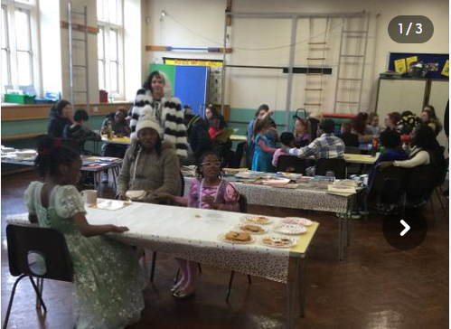
Well done to the all of our new house captains. |  | We had a wonderful time on World Book Day by holding our very first Reading Cafe which was well attended by parents.
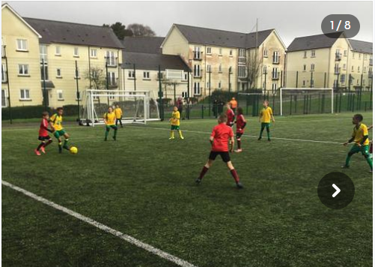 |  | 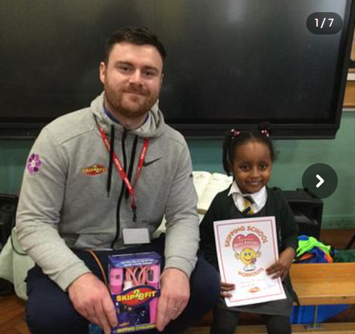
The football team have continued to represent the school in tournaments and have grown in confidence and togetherness. A special mention to Freya who represented the girls during the tournament. |  | This term we have launched the new ‘Skip to be fit’ programme. The children are now completing their daily skipping challenge and have all been provided with a skipping rope and drinks bottle.
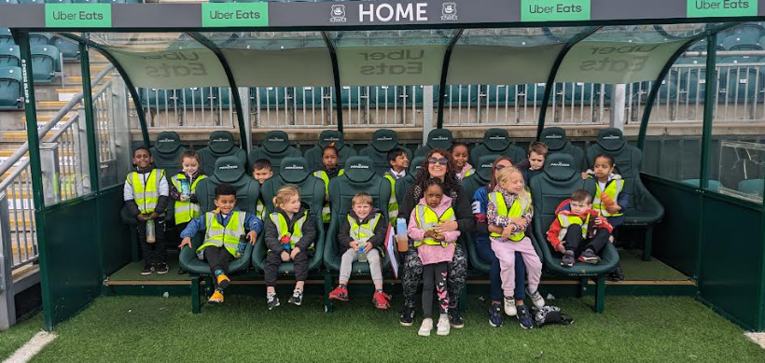 |  | 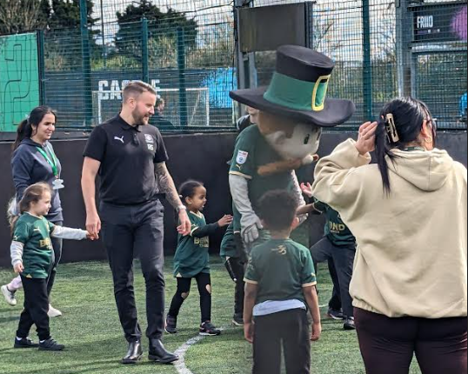
EYFS and Year 1 had were lucky enough to win a competition in which they were invited to PAFC for a stadium tour. |  | The children were fortunate enough to meet Pilgrim Pete and each child who attended the tour received a free PAFC home shirt. ,

Half Term Events

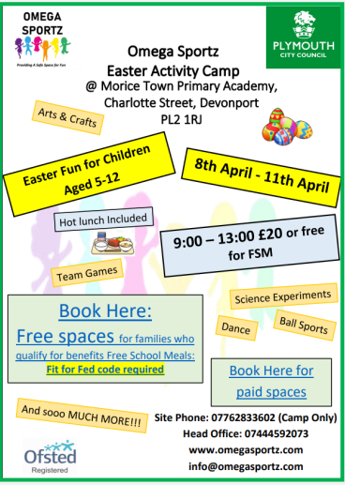
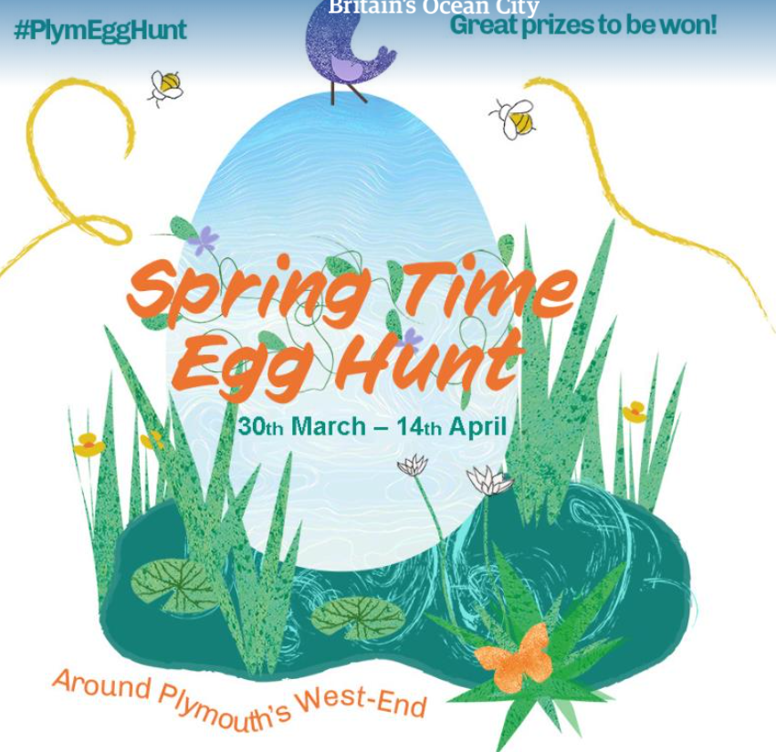
Advice and Support

We are Readers

Miss Tom's class have really enjoyed their latest fiction book “Don’t spill the milk”. The children loved listening to the journey that Penda went on, and they have created their own story following the structure of the book. They have been looking at using adjectives to make their writing more descriptive, and have produced some amazing stories. Whilst working on this unit, they have read about many different emotions that Penda experienced, which has linked nicely to our PSHE lessons too.
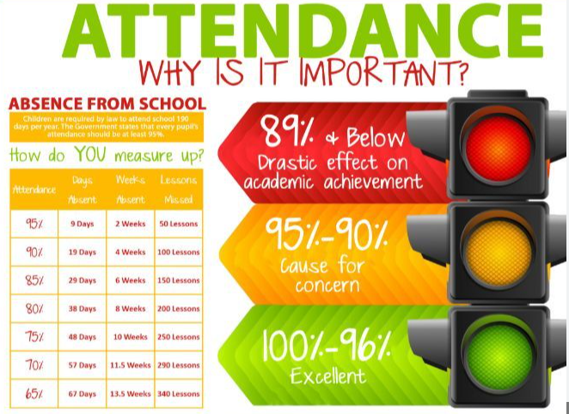
Attendance update

After half term, we will be sharing half termly letters with you regarding your children’s attendance. Children whose attendance falls below 96% will receive a letter which will outline the following information;

- Attendance percentage (year to date)
- Each session (if present)
- Sessions absent (with absent codes

The rationale behind this is to make attendance more transparent for parents so that you are fully aware of your child’s absence throughout the year.

As always, if you have any questions or queries about your child’s attendance, do not hesitate to contact me.
Mr Moore

Advice and Support

Dates for your diary  29th March- Monday 15th April Easter Holidays.  Monday 15th April - Friday 3rd May - Year 3 swimming lessons  Monday 6th May - Spring bank holiday  Tuesday 7th May - Friday 10th May- Bikeability  Monday 13th May - Thursday 16th May -  SATS  Monday 27th May - Tuesday 4th June - Half Term  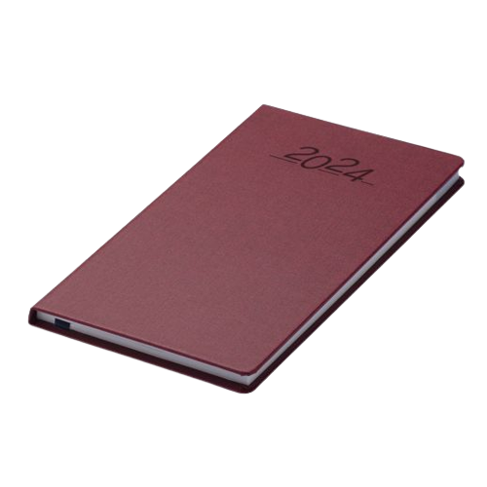 |  | The uniform store Plymouth is a free service for families to kit out their children for school.  Through donations of good quality school uniform, we give the items to those in need, free of charge.  Our service is open to anyone to use- no referral is needed.  We are located at;  93 New George Street, Plymouth City Centre, PL1 1RQ  Opening hours:  Tuesday, Wednesday and Friday 10am-1pm.  Plymouth Uniform store

Is your child eligible for free school meals?

If you receive certain benefits then your child may be entitled to a free school meal and if so, their school receives extra funding. This means it’s important to apply, even if your child is in reception, year 1 or year 2 and already receives a free lunch.

Check the criteria and apply online: Free School Meals Plymouth

FOOD REQUEST

The Cathedral School of St Mary

have teamed up with

Love in action group -

The Cathedral Church of St Mary and St Boniface
If you email Marianne our School PSA, by Tuesday 2pm of the week you require help with food, you will be able to collect from School on The Wednesday/Thursday

t.cook@plymouthcast.com#

Spaces Available For Foundation September 2024!

