Mrs Wright’s Update!

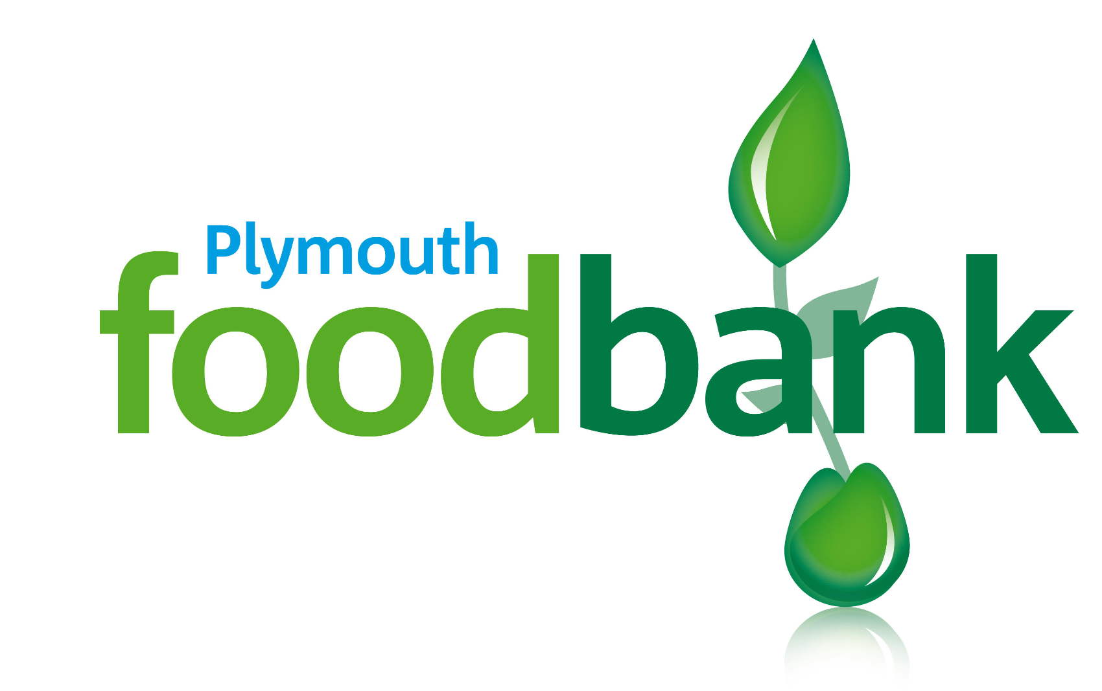
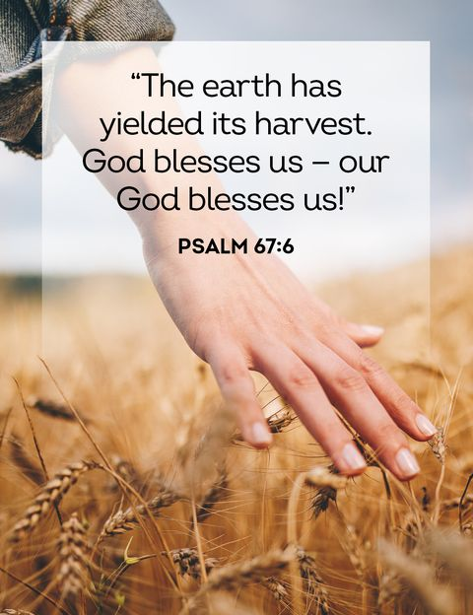
This first half term has just flown by and we have been so busy.  We started the term with our joint residential trip with St Joseph’s to Glanville House in  Brixham.The sun shone and they shared many new experiences. I shared an evening walk with  them with 2 of my sons.  Pupils in KS2 represented the school in Cross Country and I was proud of their determination as  this was not one of my favoured events when I was at school. A special mention to David in  year 4 who came in 18th place out of 100 and so qualified for the finals which unfortunately  were cancelled due to the stormy weather we had this week.  Our Boccia team was also successful at the tournament at Notre Dame this week and they  enjoyed experiencing a new sport for the first time.  Navigators visited Market Hall.  Explorers had a fantastically wet, but fun day at ‘Life on the Oceans Waves’ at Mountbatten.  To finish this half term together as a family we will be celebrating mass as a school with year 6  pupils from St Joseph’s (weather permitting).  Apart from myself, we have two new members of staff who we are delighted to welcome. Miss  Toms is our new year 1 teacher and Miss Galloghly is our new year 2 teacher. Both teachers  and pupils are enjoying their new smaller class sizes.  As we finish this half term celebrating the festival of Harvest I would like to leave you with a  scripture quote which I was inspired to choose for the newsletter by the KS2 Cross Country  runners. Many said, ‘It was tough, but we finished’. At times things can be difficult: friendships,  school work, brothers and sisters but this quote gives us strength to know that everyone of us  can achieve great things.  I wish you a peaceful, safe and relaxing half term.  God Bless. |  | Worship and Liturgy  This Sunday’s Gospel reminds us how we can live happier lives by giving God what is due to him - our gratitude! Being grateful to God puts us in the right frame of mind. It is good to him - our gratitude! Being grateful to God puts us in the right frame of mind. It is good for our well-being and helps us to be happy in life. for our well-being and helps us to be happy in life.  Saying ‘thank you’ to God (at anytime throughout the day) is a great way for us to show our gratitude. It is good for us to be grateful to God for the blessings of his love, for our lives, gratitude. It is good for us to be grateful to God for the blessings of his love, for our lives, our talents, our families, our school and for the love of those around us. our talents, our families, our school and for the love of those around us. How do we show God that we are grateful? Who else will you remember to show gratitude to in these coming weeks? Perhaps a parent or carer, a family member, a teacher or a friend. How will you do this (e.g. with kind words, a thank you note, a prayer, a gift, or by offering help)?  Catholic Life  To end our term, we came together in the Cathedral to celebrate our Harvest Mass. We are very grateful for all the donations we have received which will go in support of those most in need at the Plymouth Foodbank.
Congratulations!

We have high expectations for all of our pupils to arrive at school each day and on time. Thank you for your continued support.  Miss Grosch 79.29%  Miss Galloghly 87.74%  Miss Toms 84.71%  Mr Driscoll 93.33%  Mrs Berry 86.55%  The highest attendance this half term goes to…  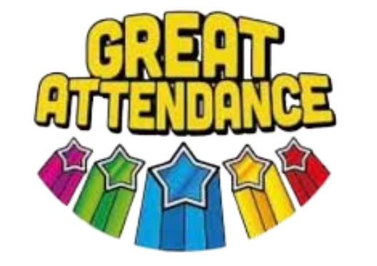  Mr Driscoll’s Class  As a ‘well done’ for winning this half term’s attendance, your class have earnt an extra 20 minutes playtime- keep up the excellent work! |  | Heart of Gold Awards  Miss Grosch’s Class  My first heart of gold award for the year will be for the whole foundation class. They have settled into life in our school really well. Well done foundation, what a brilliant first term!  Miss Galloghly’s Class-  Lacie demonstrates her heart of gold, through her continued kindness and support in the classroom to both her peers, and adults. Lacie is always keen to help the adults, tidying away resources and giving warmth and love every day. Well done, Lacie!  Miss Toms’ Class-  Dawid always has a smile on his face and is always there to support his classmates. He is always keen to get on with any task and is a joy to have in class. Well done Dawid.  Mr Driscoll’s class-  Tamilore has been awarded the Heart of Gold this week for love. She is a well-respected member of the class who always tries her best to fulfil her potential and share her knowledge with others. Well done Tamilore!  Mrs Berry’s Class-  Vance produced a beautiful poem this week as part of our English learning. He has engaged well throughout the unit, worked hard and taken responsibility for his own learning. Well done Vance! You should be very proud!

News and Events

Meet our Governors!  Mrs Peacock  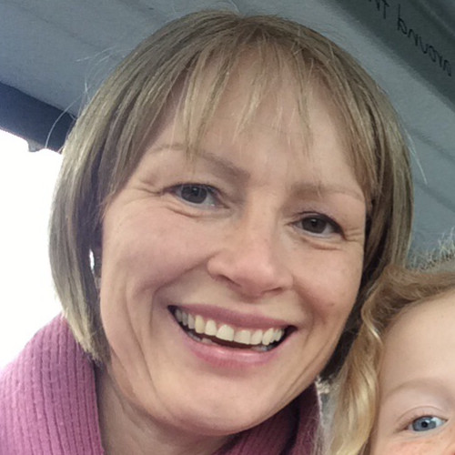  I am the nominated safeguarding and health and safety governor as well as being the vice chair for the governing board. I am responsible for monitoring and ensuring safeguarding and health and safety policies are in place and are effective. As vice chair, it is also my responsibility to cover when the chair is away. When I am not governing, I work part time as a registered nurse, I also lead ‘Messy Church’ at the Cathedral and am a mum of 3. |  | Meet Our New Y1 Teacher  Introducing Miss Toms  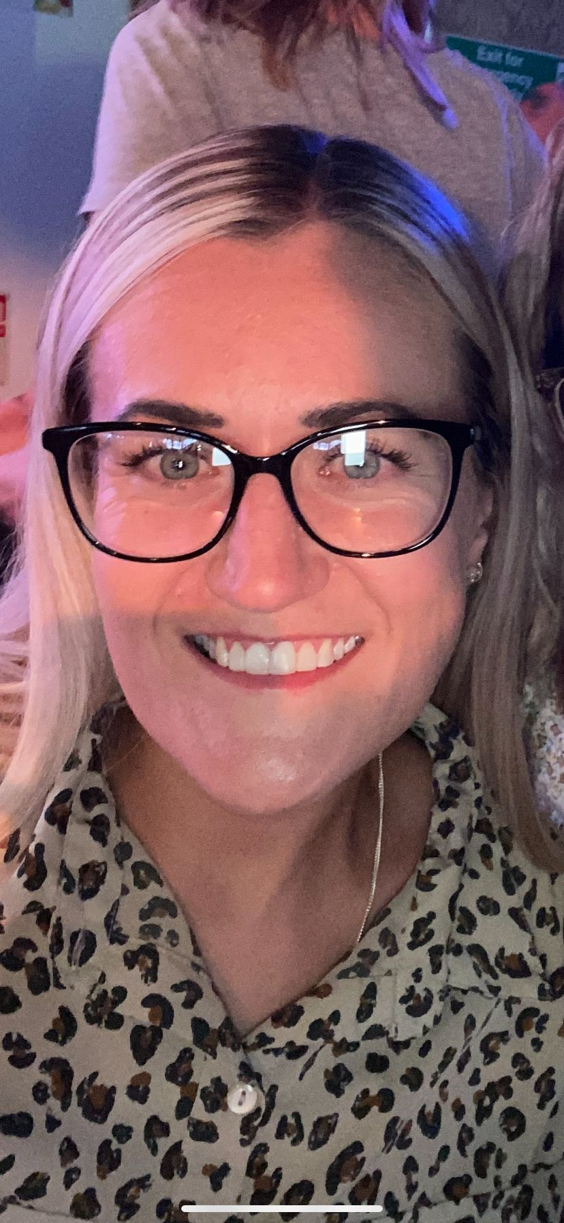  Hello, my name is Miss Toms. I am the new Year 1 teacher here at St Mary’s and I would like to tell you a bit about myself. I am a mum to 3 girls and in my spare time I like to go for long walks and spend time with my children. I have a huge passion for PE and I especially love football. I also play in a ladies 5-a-side team. My favourite food is pizza and I am a bit of a chocoholic but I also keep myself active! I look forward to meeting you all.
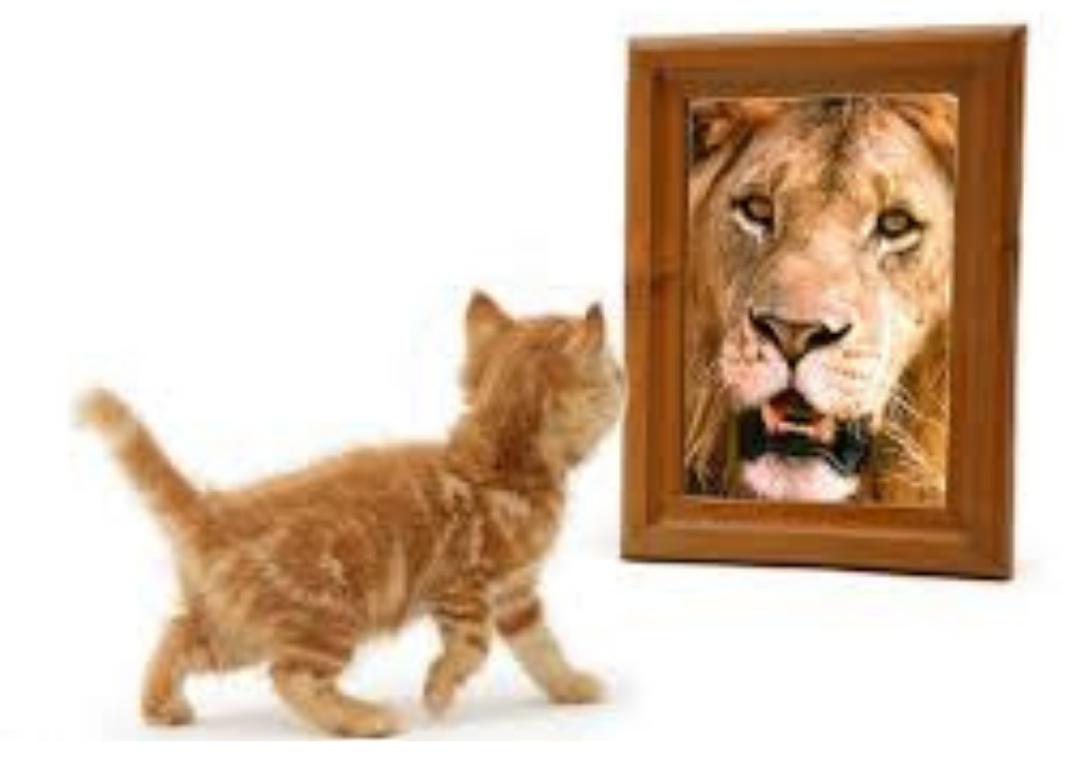
Let’s get talking at home
Things to talk about at home...
- Why does the cat see a lion in the mirror?
- How might the reflection change each day?
- What would others see when looking at the cat?
- Does it matter how we see ourselves?
- What do you see when you look in the mirror?
We Love To Learn!

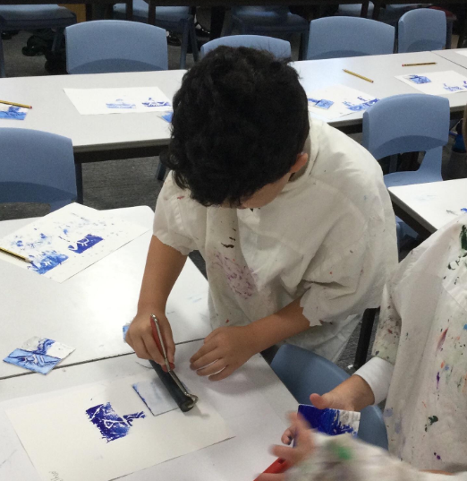
 |  | 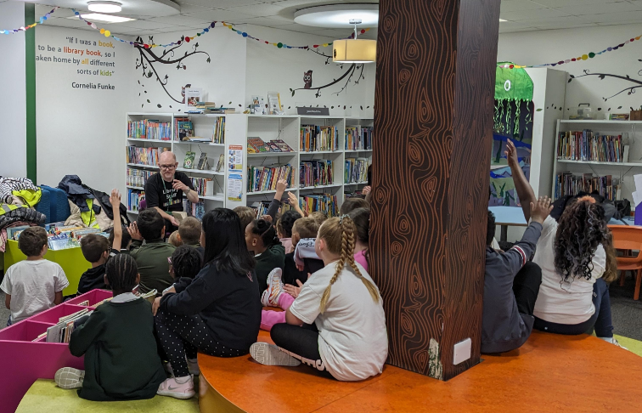
In Mr Driscoll’s class we learnt about printing. We used a range of techniques and colours in art to create our finished products. |  | Each class had a visit to the local library.
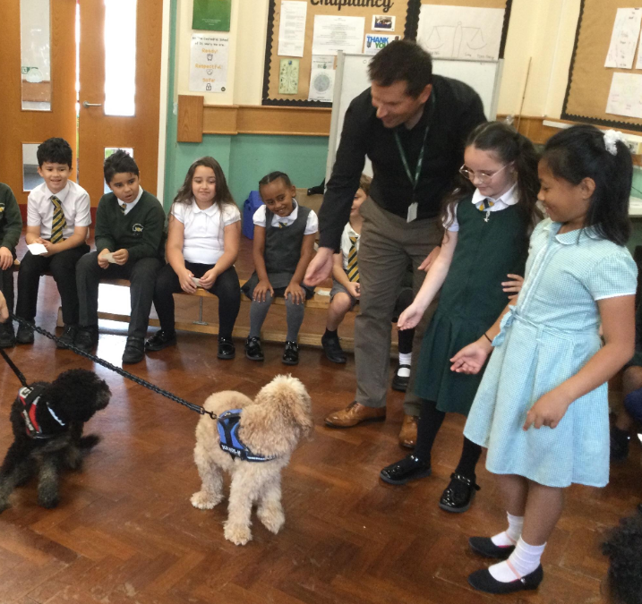 |  | 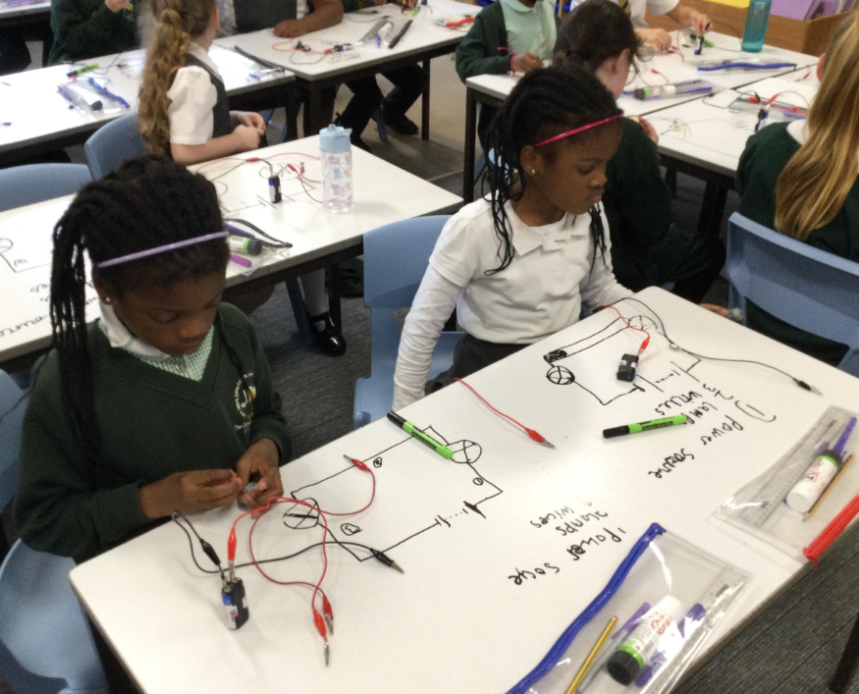
Mr Driscoll brought his 2 dogs in as part of our PSHE lesson. The dogs were very cute and cuddly! |  | In science we have been learning about electricity and we created our own circuits to make the lightbulbs light up!
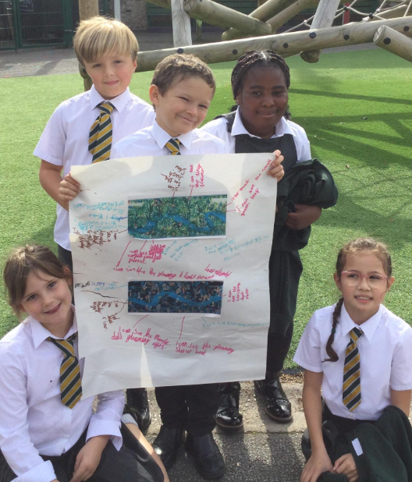 |  | 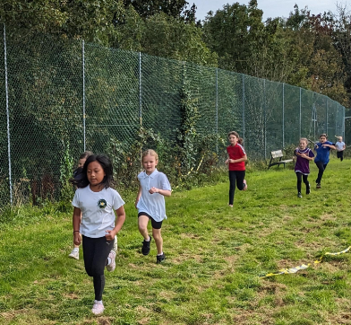
We have collaborated to complete some fantastic group work in which we all contributed. |  | Children in KS2 visited Central Park to take part in a cross-country event with many other schools from around Plymouth.
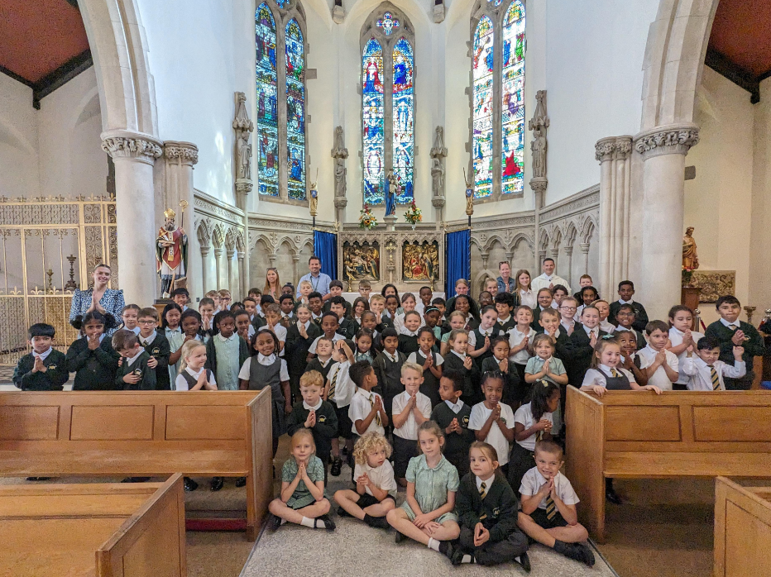 |  | 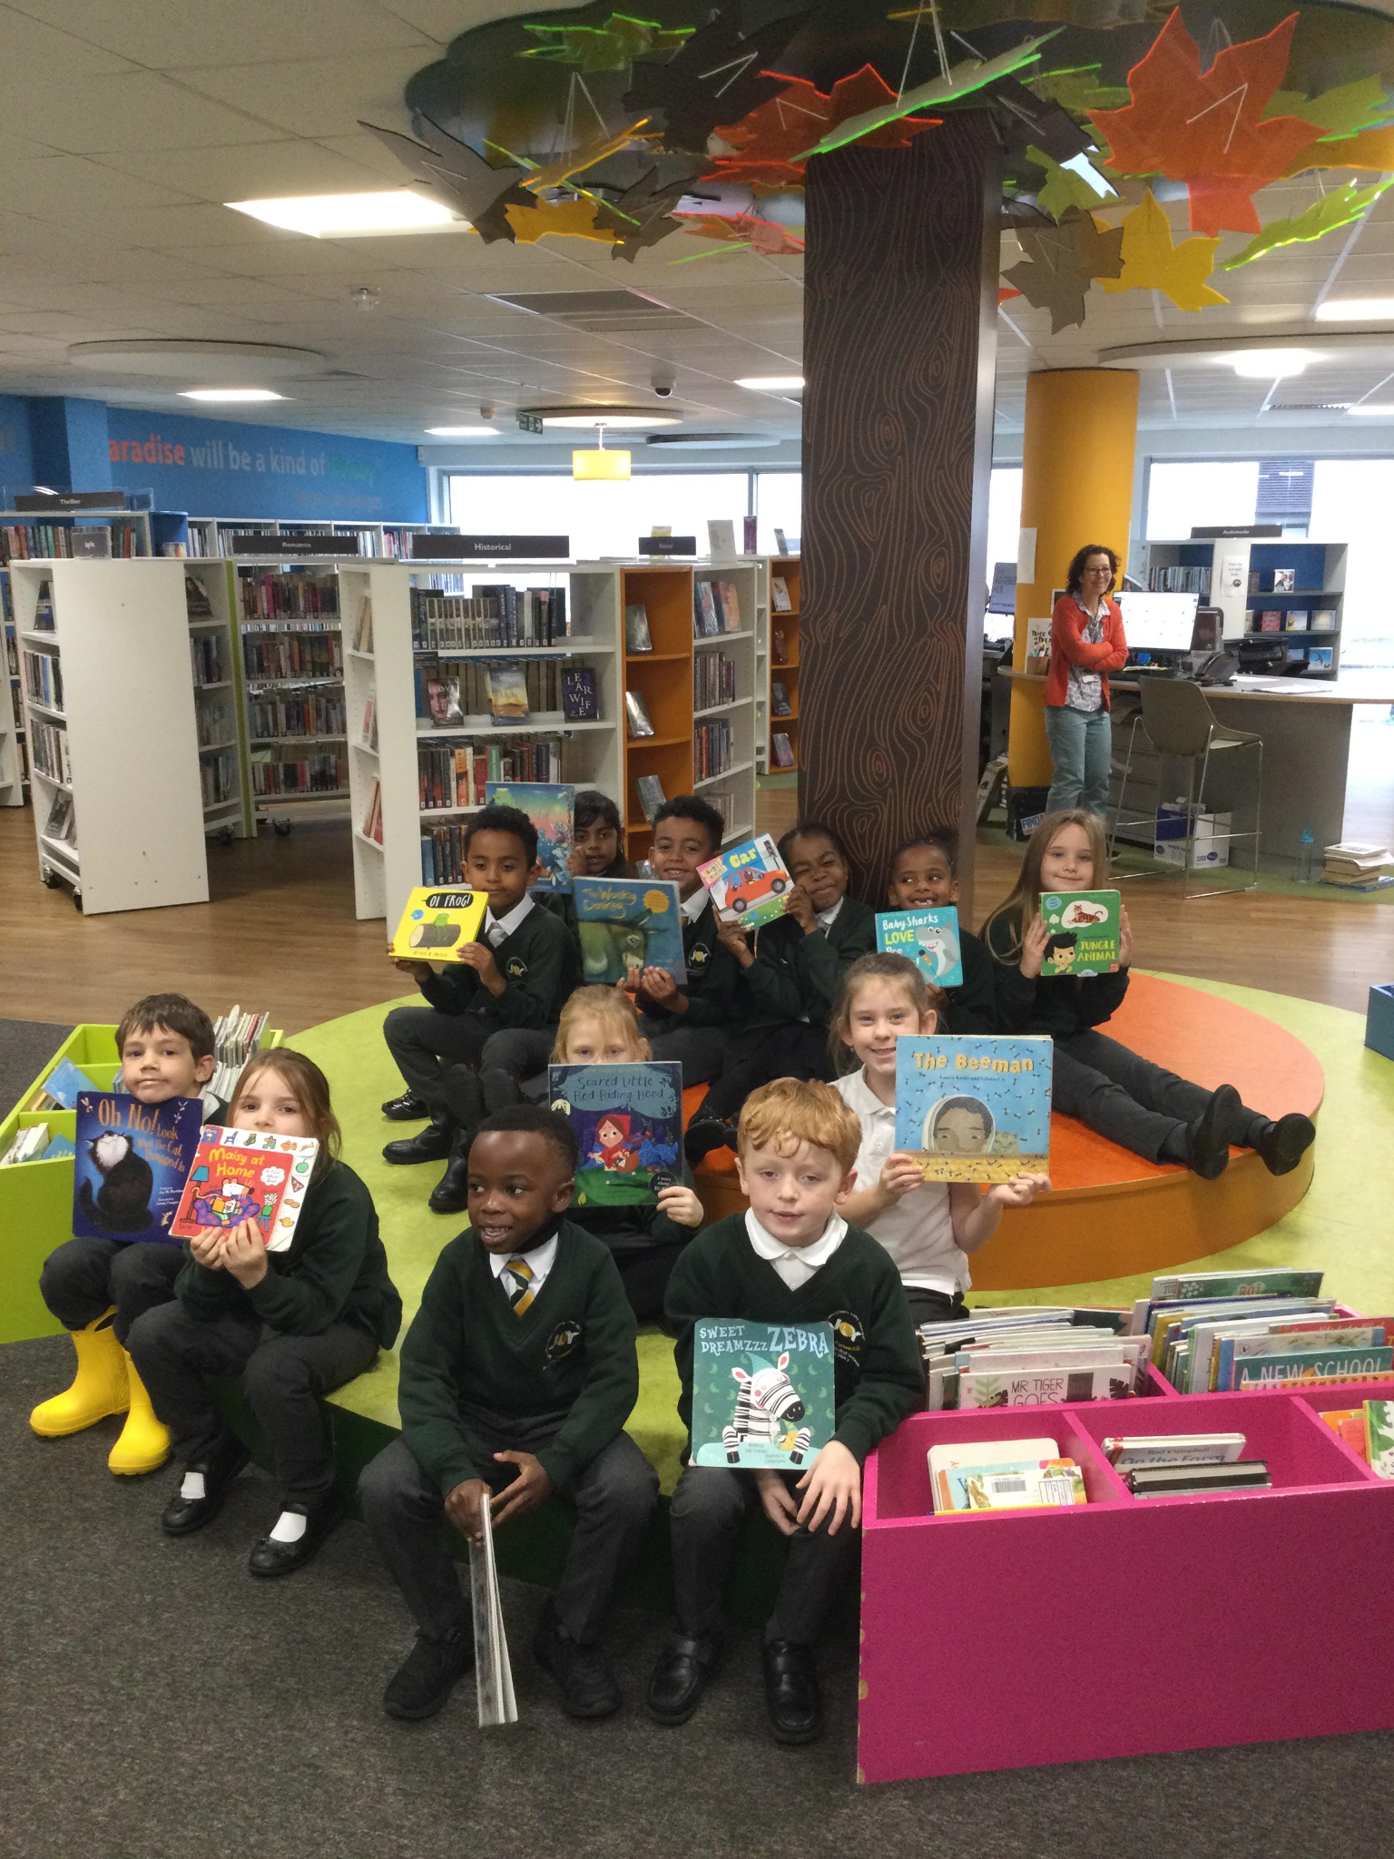
We have enjoyed the first Whole School mass of the year. |  | We were fortunate to visit the Library, where we had the opportunity to hear some more fairy tales and poems
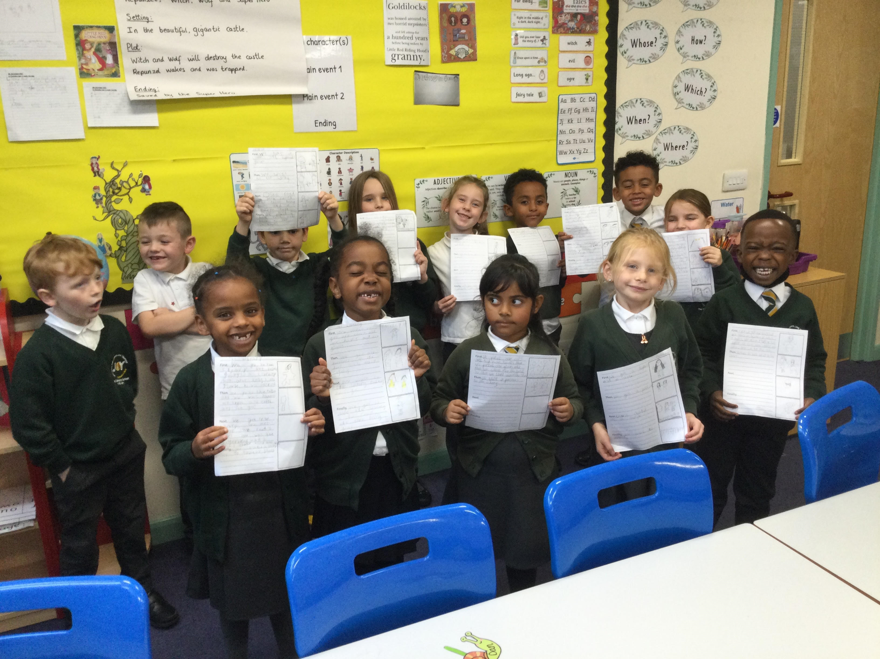 |  | 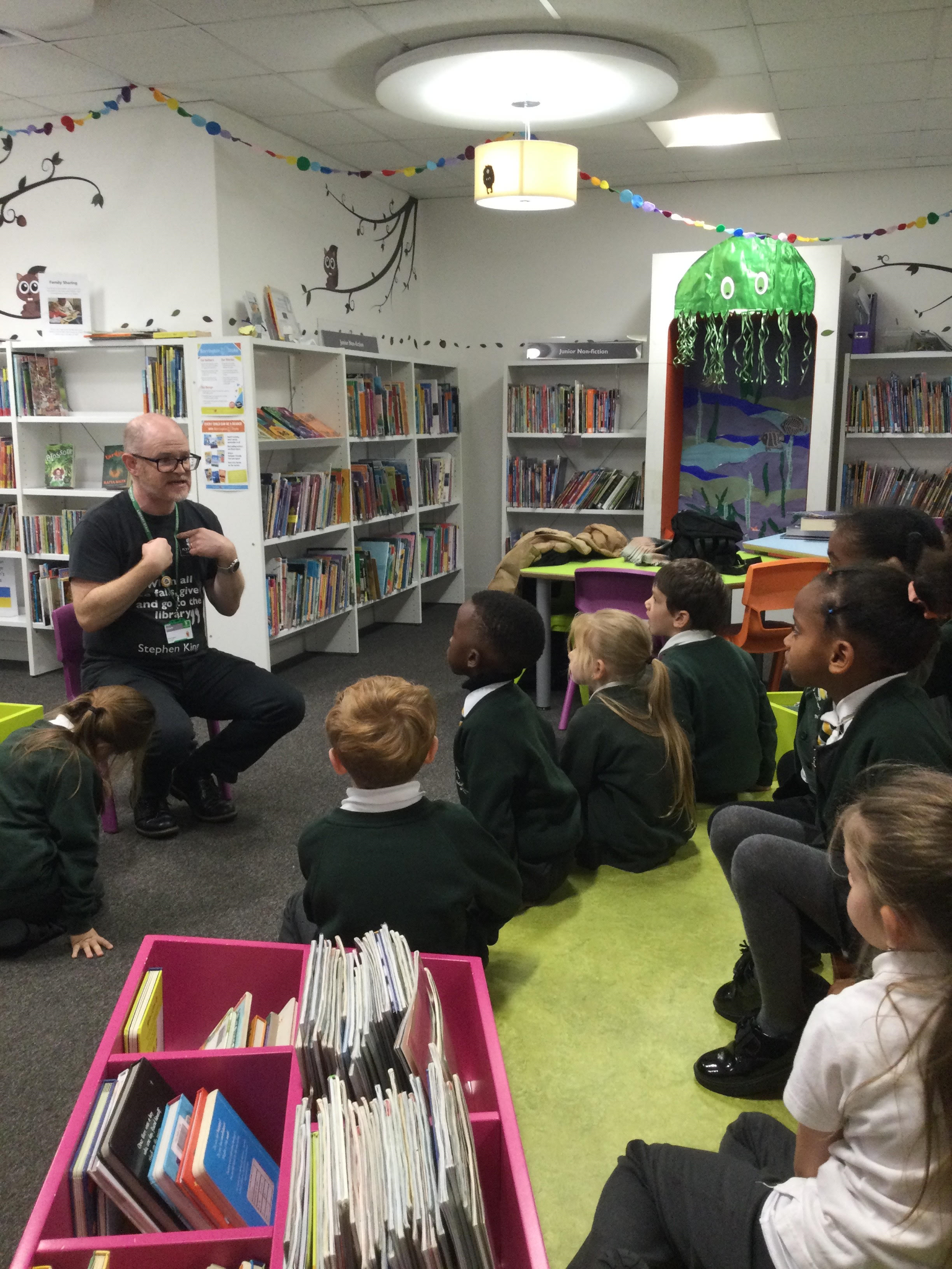
During this term, Year 2 have worked hard in their English unit all about fairytales. The children have explored a range of fairytales. |  | Year 2 were fortunate enough to bring back a book each to have in our class reading corner
Help and support

We are Readers
Help us win £1,000 for our school library!

Our school needs you! Please help us to win £1,000 of National Book Tokens and a membership to the School Library Association to help develop our library and encourage reading for pleasure - plus you could win £100 for yourself!
Enter here: http://www.nationalbooktokens.com/schools

Do you know an adult who can't read?

Read Easy is a completely free one-to-one service designed to help adults learn to read at their own pace, without pressure. If you know someone who would benefit from this service, please get in touch with Mrs Foster or Mrs Low and we will provide you with some further information. https://readeasy.org.uk/

Happy reading!

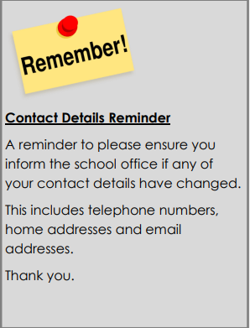
Plymouth Information Advice and Support for SEND

PIAS are delivering information sessions both in person at Jan Cutting Healthy living centre, and also online.

- Subjects are:
- Choosing a secondary school
- My child has special education needs.
- Choosing a secondary school
- My child has an EHCP

Follow the link to book: The Next Step: Primary To Secondary For Children With SEND

MYCLOTHING
Get great value school uniforms, complete with embroidered emblem.
• Extensive size and colour choices
• Outstanding products ethically sourced
• Embroidered in the UK
• FREE DELIVERY on all orders over £50
www.myclothing.com 0800 059 0594
Help and support

Dates for your diary  Monday 30th October 2023- NPD  Tuesday 31st October 2023- Children back to school  Wednesday 8th and Thursday 9th November- Parents evenings  Tuesday 21st November- Widening Horizons (Y5) trip to VW Murray  Friday 15th December- Carol Concert  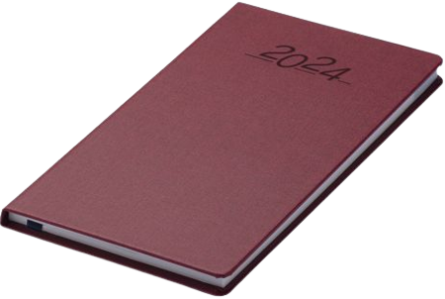  Tuesday 19th December- End of Term. |  | The uniform store Plymouth is a free service for families to kit out their children for school.  Through donations of good quality school uniform, we give the items to those in need, free of charge.  Our service is open to anyone to use- no referral is needed.  We are located at;  93 New George Street, Plymouth City Centre, PL1 1RQ  Opening hours:  Tuesday, Wednesday and Friday 10am-1pm.  Plymouth Uniform store

Is your child eligible for free school meals?

If you receive certain benefits then your child may be entitled to a free school meal and if so, their school receives extra funding. This means it’s important to apply, even if your child is in reception, year 1 or year 2 and already receives a free lunch.

Check the criteria and apply online: Free School Meals Plymouth

