The Cathedral School of St Mary Pen Licence Requirements
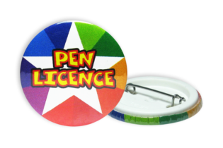
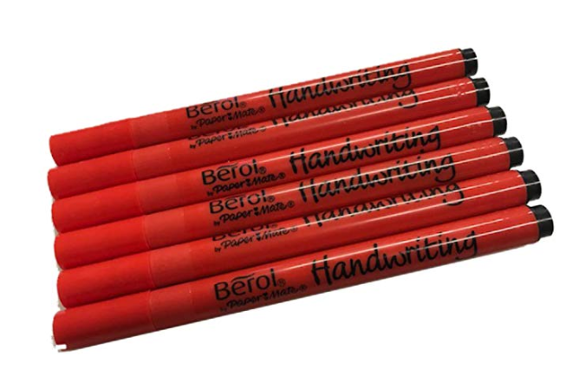
Silver
- As bronze requirements.
- Letters are consistent in size and direction.
- Writing is consistently joined.
- Letters are joined appropriately.
- There is a clear distinction in size of capital letters to lower case.
- Punctuation is the correct size in relation to the text.
- The writer writes with fluidity and at a good pace.

Gold
- As bronze and silver requirements.
- Writing has a consistent style which is neat, joined, legible and personal to them.

