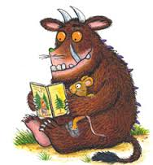

World Book Day

Please come and share a book with your child to celebrate World Book Day.
On Wednesday 4th March
Between 1.30-3pm
Friends Of School will be serving
Afternoon tea

