Curriculum Overview for ROALD DAHL CLASS 2019-2020
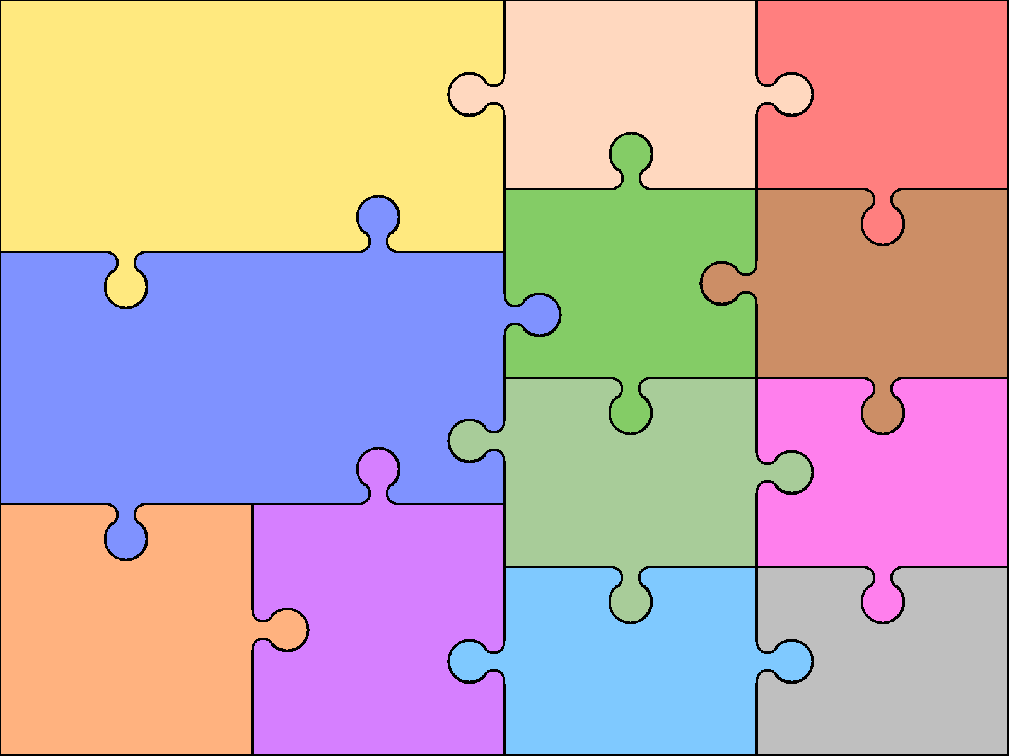  - Exploring and writing stories with familiar settings.  - Writing poetry  - Writing stories based on traditional tales | English  - Writing non-fiction information texts linked to geography, history and science.  - Exploring stories from other cultures.  - An author study and evaluation. |  | - Writing a recount about The Gunpowder Plot  - Writing postcards and letters.  - Writing instructions for Design and Technology. | Art & Design  - Use pencils and pastels to make observational drawings.  - Use paints to create paintings of lighthouses. | Computing  - Understand what algorithms are.  - Create and debug simple computer programs.  - Use technology purposefully to create and store information by creating a fact file.  - Use logical reasoning to predict the behaviour of simple programs.
 |  |  |  | Design & Technology  - Design, make and evaluate a firework in a jar.  - Design, make and evaluate new packaging for Traction Man.  - Design, make and evaluate a healthy sandwich. | Geography  - develop geographical skills through a local area study.  - understand geographical similarities and differences through studying the human and physical geography of Plymouth and a small area of Kenya.  - study the key physical and human features of seaside locations  PHSE
- Counting, partitioning and calculation.  - Children to use the symbols +, - x, ÷ and =.  - Children to present solutions to puzzles and problems in an organized way. | Mathematics  - Securing number facts.  - Children to describe patterns and relationships involving shapes.  - They predict and test with examples. |  | - Understanding shape.  - Children to identify reflective symmetry in patterns and 2-D shapes and find lines of symmetry in shapes.
 |  |  |  | Modern Foreign Languages  - Children will be introduced to learning French through songs.  - They will begin to learn how to say greetings, numbers and colours in French.  Physical Education  - Functional Movement  - Movement Concepts  - Aesthetic Movement  - Manipulative Skills  - Gymnastics  - Team Games | - Getting on and falling out  - Going for goals  - Being good to me  - Changes  - Relationships  - RTime  Religious Education  - Creation and New Beginnings  - Prayer, Feasts and Saints  - Advent  - Christmas  - Epiphany  - Revelation  - Lent  - Holy Week  - Easter  - Pentecost and Mission  - Other Fait
Science  - Children will learn about seasonal changes.  - Children will explore and investigate the environment and their impact on it.  - Children will explore the uses of everyday materials  - Children will learn about animals including humans and animal habitats and simple food chains. |  | History  - The Gunpowder Plot – what happened?  Who was involved?  - Explore and investigate the history of toys  - Compare and contrast the lives of Charles Darwin and David Attenborough

