

Autumn Term 2019

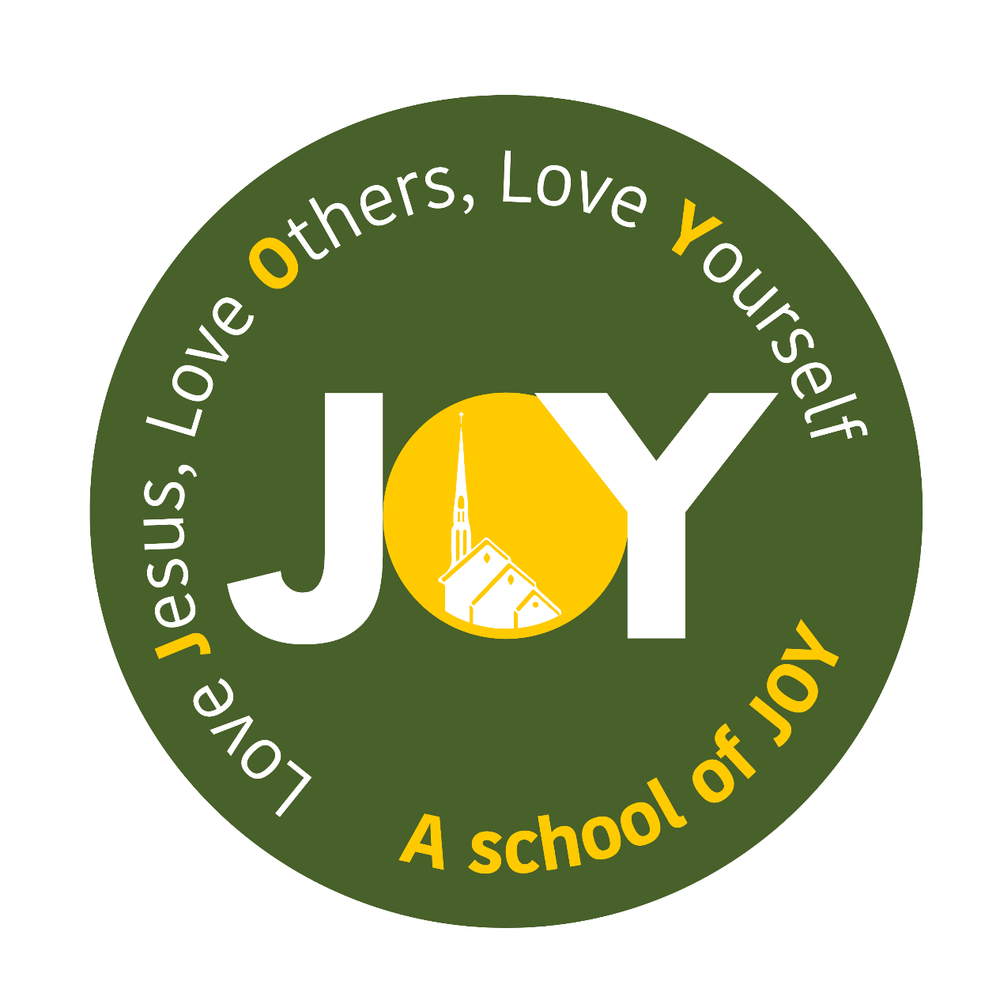

**Dear Parents**

**Welcome back for another year!**

I hope that you have enjoyed the extended break with your lovely children and appreciated the sunshine!

This newsletter is designed to help you settle as quickly as possible into life in Class 3.

**Organisation**

**We are focusing on encouraging children to become more independent in their learning and for those children in year 4 to take responsibility for their learning in preparation for upper key stage 2.**

They need to ensure they bring in and take home their reading books daily and that they have the correct PE kit in school at all times – especially on Mondays and Wednesdays. Children need to ensure they have their homework on the stated days. If there are exceptional circumstances meaning that homework is not completed, please send a note in with your child so I can be clear about the reasons.

**Homework**

Homework will be sent home on a Monday to be returned on a Thursday. The homework will be in line with the learning we are doing in school.

Whilst homework is not compulsory, it is recommended. Reading at home is a requirement of our home – school agreement. It is compulsory that your child reads at least three times a week and this is recorded and signed for in their reading record.

**PE/Games**

**PE sessions will be held weekly on Monday and Wednesday afternoons. All children will be expected to take part in all lessons. If your child is injured and cannot take part in PE then you will need to send in a note with your child.**

All PE kits need to be in school from the start of the term and then taken home at regular intervals to be washed. Please make sure that all kit is labelled so that missing kits are easily returned to their owners. We expect all kits to be in school at all times as there are occasions where PE days can change. As our sessions will mix indoor and outdoor activities a full kit is required.

**Trips**

There will be trips organised this school year and I am in the middle of planning something that I hope the children will enjoy.

**Working in partnership**

As a school, we believe passionately that your child’s learning best benefits from a positive relationship between us as a school and you as parents and guardians.

With this in mind, please take time to say hello or raise any issues at the end of the school day when the children exit school. I am also contactable through email or Class Dojo or, if you need to speak with me at greater length or in private, I will naturally be happy to arrange a time to do that.

*A*ny support is always welcomed so please do not hesitate to catchme if you are interested in coming into the classroom to help any time throughout the week.



Our Learning This Term

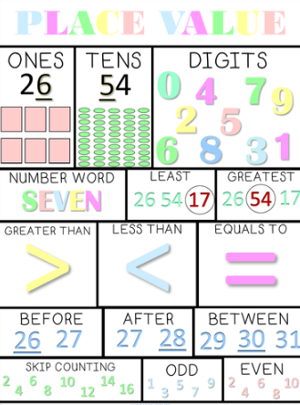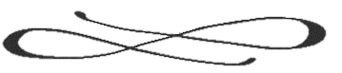

Mrs Berry

Our **Science** investigations for the Autumn term will focus on ‘States of Matter’ where the children will explore the states of different materials and how they can change. After half term we will be exploring Electricity and creating simple circuits.

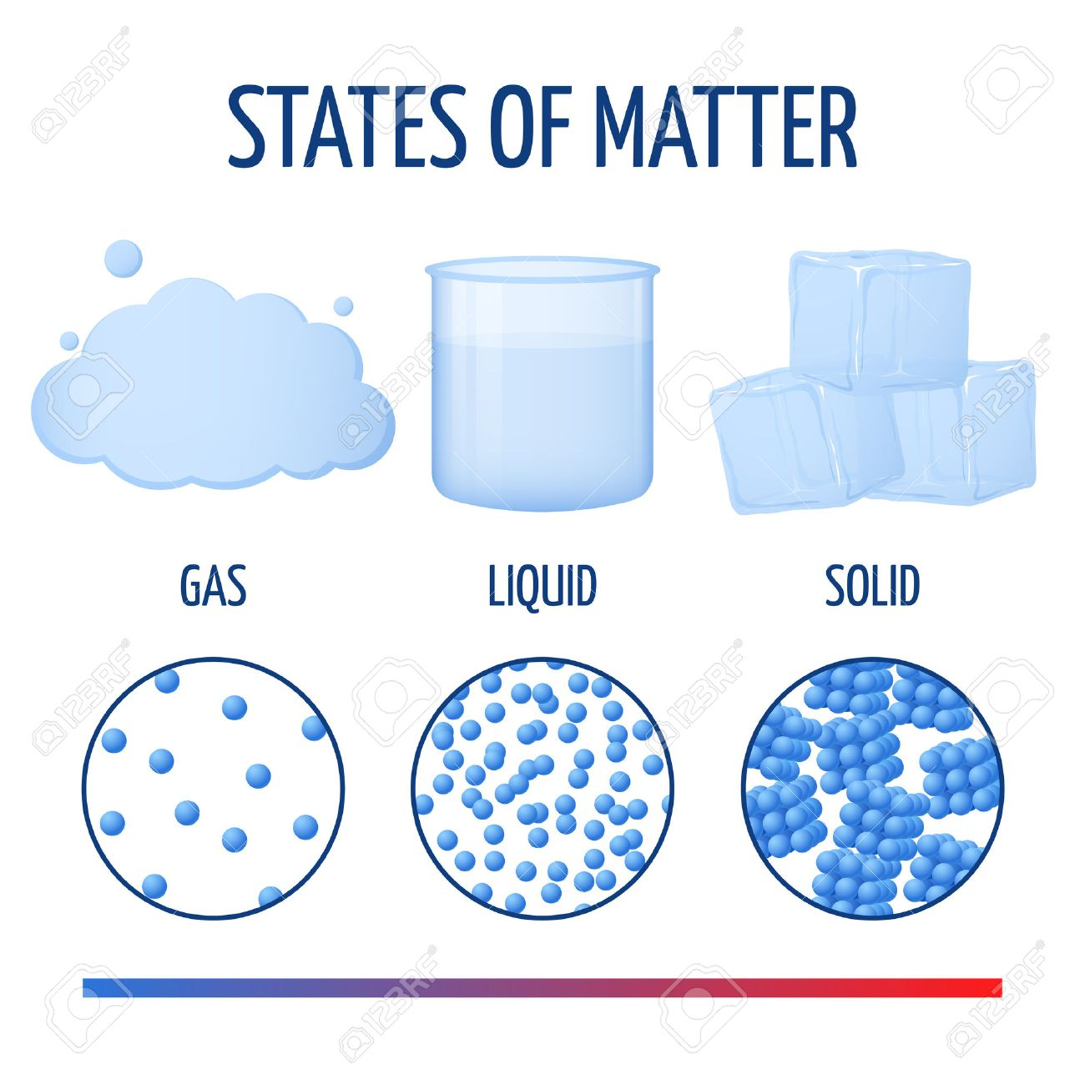

Our **Topic** this term is water where we will explore the water cycle, water conservation and flooding.

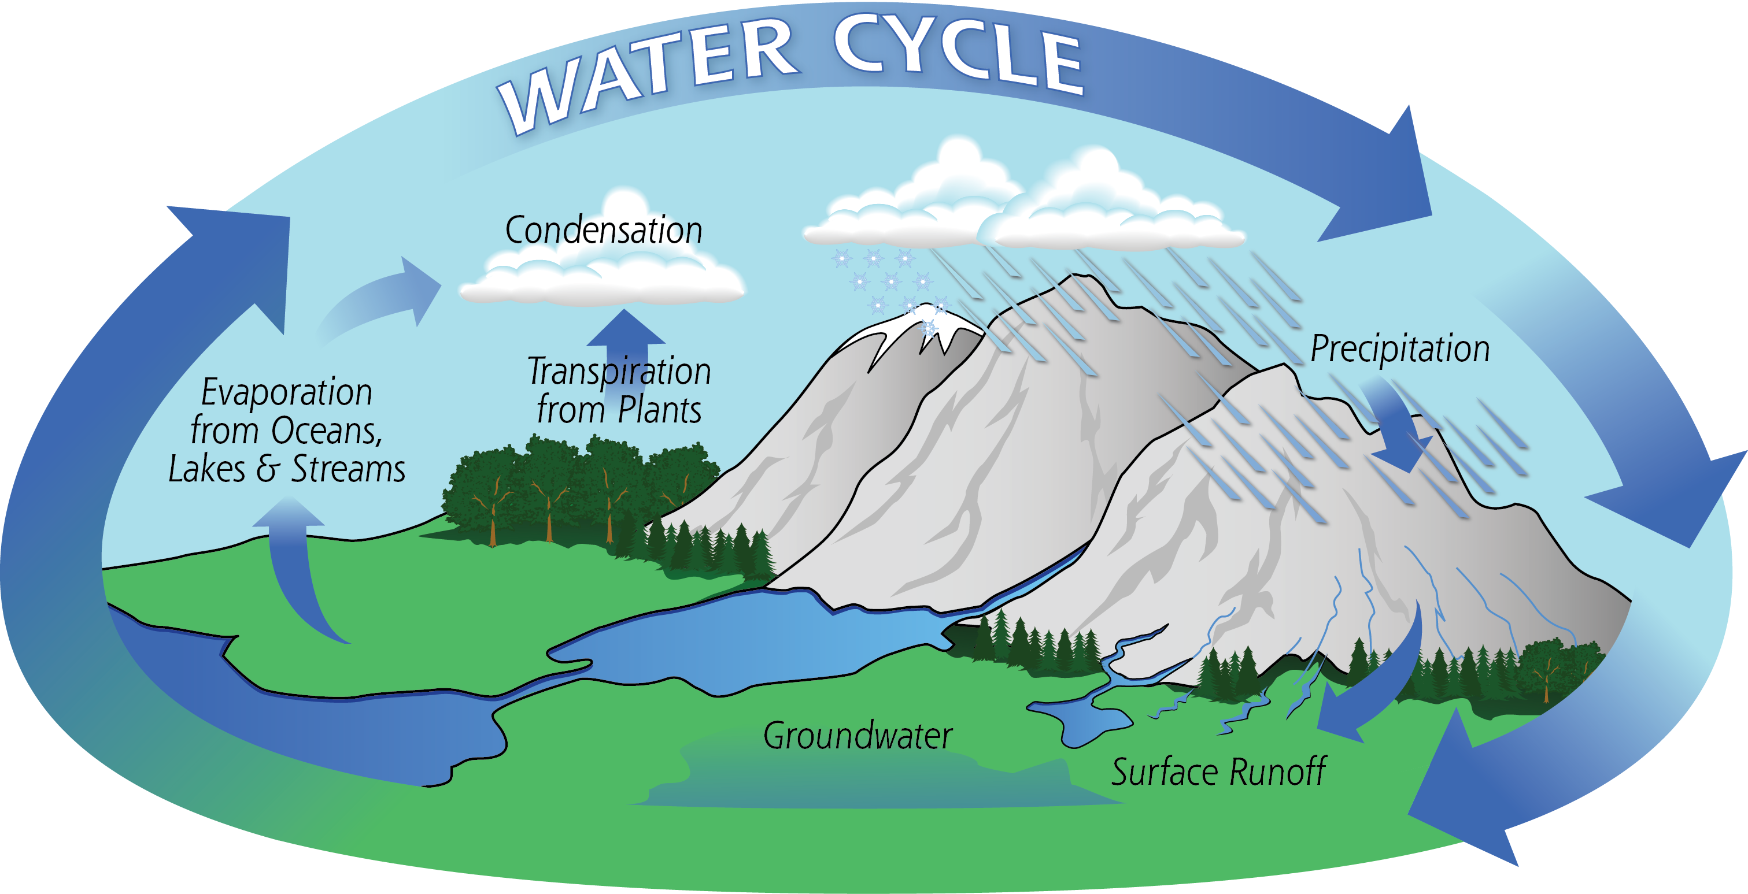

All of our learning is underpinned by our **Social and** **Emotional Aspects of Learning** work the pupilsengage in.

I am really looking forward to getting to know you and your family over the year and am very much looking forward to a wonderful year of learning with the new ‘Year 3/4’.

With every good wish,

In **English** we will begin with a poetry unit to tie in with our water topic. Children will be writing their own acrostic, haiku, list or rhyming poems after exploring a range of poems. Following this unit, the children will be exploring and writing an explanation text.

We will be working on understanding place value of whole numbers. All this work will be put into practice in our problem solving and reasoning morning tasks and our mental arithmetic sessions.

There will also be a strong focus on times tables. This will be enhanced by our class game of ‘Times Table Ladders’. We will be showing them a range of ways in which to practice and learn their times tables, including BBC Supermovers.

Our **RE** work will begin with our Creation unit of work. We will be considering our roles as co-creators in our ‘Creation’ unit, moving on to ‘Sacraments’. Finally we will enter our ‘Advent’ unit as we move towards Christmas.