Mrs Wright’s Update!

Dear Parents, Carers and Pupils,

As we reach the midpoint of the academic year and prepare to enjoy a well-deserved break, I am delighted to share some updates and highlights from our vibrant school community, Cathedral School of St Mary.

Celebrating Achievements: It has been a short but very busy half term for our School of Joy. In early January our year 6 and year 6 from St Joseph’s travelled to London and back, in a day, for a visit and tour of the Houses of Parliament. It was an early start and late finish but an excellent trip and a unique experience for them all. Their conduct on the day was fantastic and they were a credit to our schools.

Our running club has started in preparation for the Ocean City Run in April. The children taking part are from year 3 up to 6 and they run around Victoria Park every Monday lunchtime with a dedicated group of fit staff. One day soon I hope to join them, or maybe watch and cheer them on!
Plymouth Argyle and Devon/ Somerset Fire and Rescue have led workshops with pupils across the school and we are grateful for their support and proud of our links with them.
Our CSOSM football team represented the school at its first football tournament for many years. Their conduct both on and off the pitch was impeccable and they thoroughly enjoyed the experience. We were all very proud to watch them go off to the tournament in their green and yellow kit. We look forward to their next fixtures.
Our KS1 Indoor athletics team put on a magnificent performance and I’m sure they will have great success this year as they are a talented bunch.

Nurturing Faith and Values: At the Cathedral School of St Mary our faith is the cornerstone of everything we do. Throughout this half term, we have deepened our understanding of Catholic values and teachings through prayer, reflection, and acts of service. Our students have embraced opportunities to deliver the weekly Liturgy and Sr Navya, with the help of the GIFT chaplains, has started Prayer and Reflection time at the Cathedral during a lunchtime every week. This has proved to be very popular.
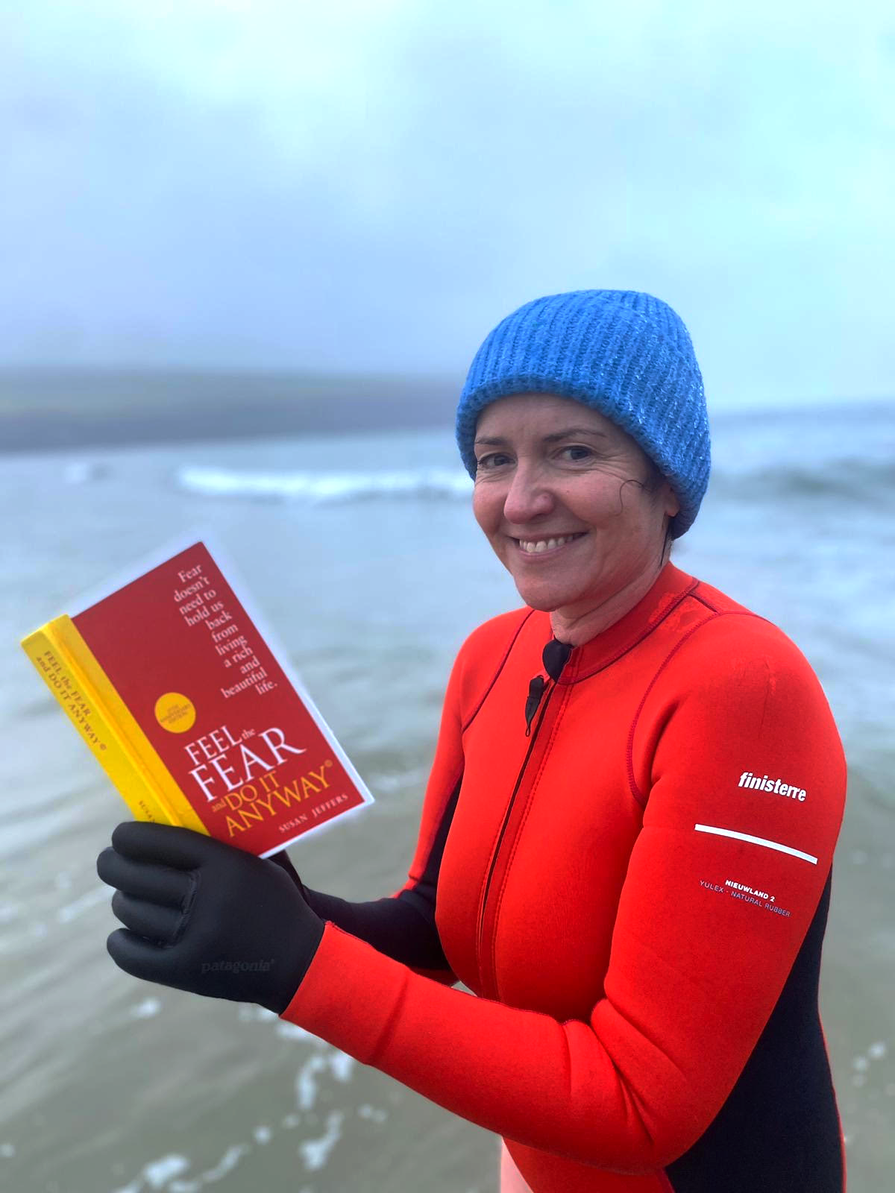
Parental Engagement and Support: I have had the pleasure of teaching some lessons and it has been great to have the opportunity to learn more names. Over the February break please encourage your children in years 4, 5 and 6 to continue to learn times tables up to 12 fluently and to speed. This will help them to understand and make rapid progress in the maths they are being taught. Please encourage all pupils to read at home for pleasure and enjoyment. They also love to have adults reading to them the odd time. We would love them to bring in a photo or send via Dojo, a picture of them reading in ‘extreme places’ to add to our display by the office - extreme but safe! Here is mine as an example.We are grateful for the ongoing support and partnership of our parents and carers. Your involvement in your child's education is invaluable, and we appreciate the time and effort you invest in their learning journey.

Looking Ahead:
As we look ahead to the second half of the year, we do so with optimism, enthusiasm, and a sense of purpose. There are many exciting opportunities and challenges on the horizon. As a school community, we will all rise to the forthcoming challenges of KS2 SATs, Year 4 Statutory MTCs (Multiplication Tables Check), Phonics and our due Ofsted inspection.
Thank you for your continued support and partnership. Wishing you all a restful and enjoyable half term break filled with love, laughter, and cherished moments with family and friends.

Take care,
Mrs Wright
‘For nothing will be impossible with God’ Luke 1:37
Catholic Life and Events

Catholic Life  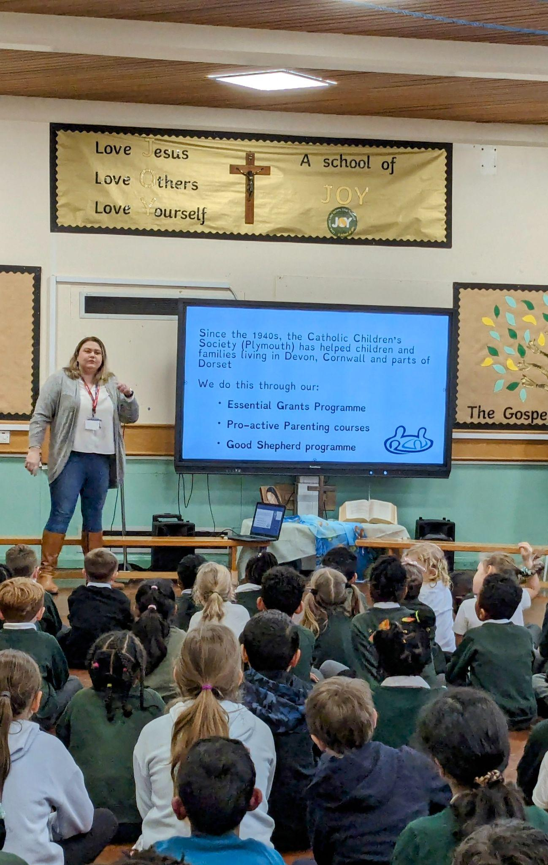  This has been another busy term for the Catholic Life of our school.  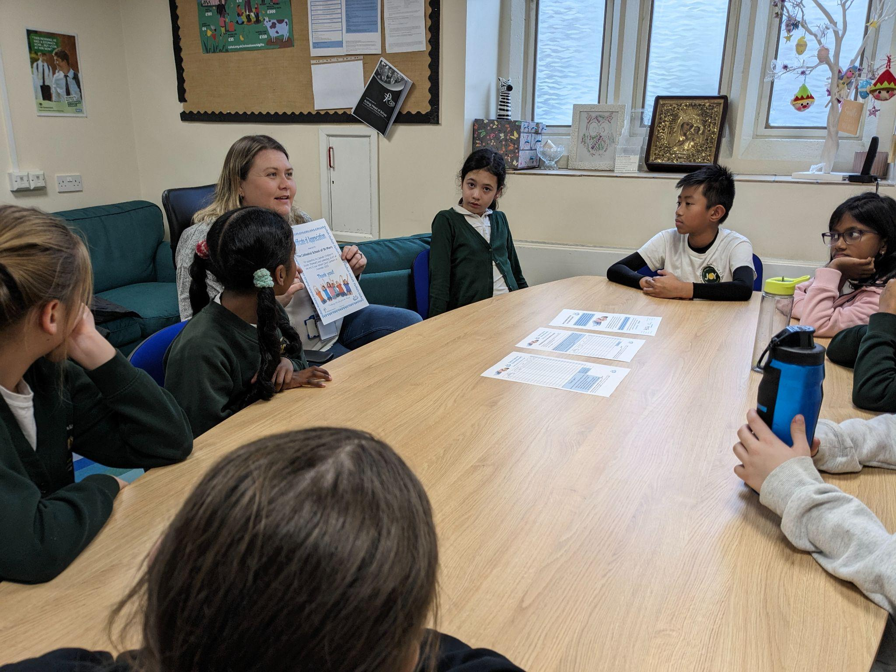  With the help of Sarah from the Catholic Children's Society Plymouth, the GIFT team have planned a fantastic fundraising plan that will take place over Lent. They aim to raise awareness of, and money for the homeless through holding a sponsored sleepover in the school.  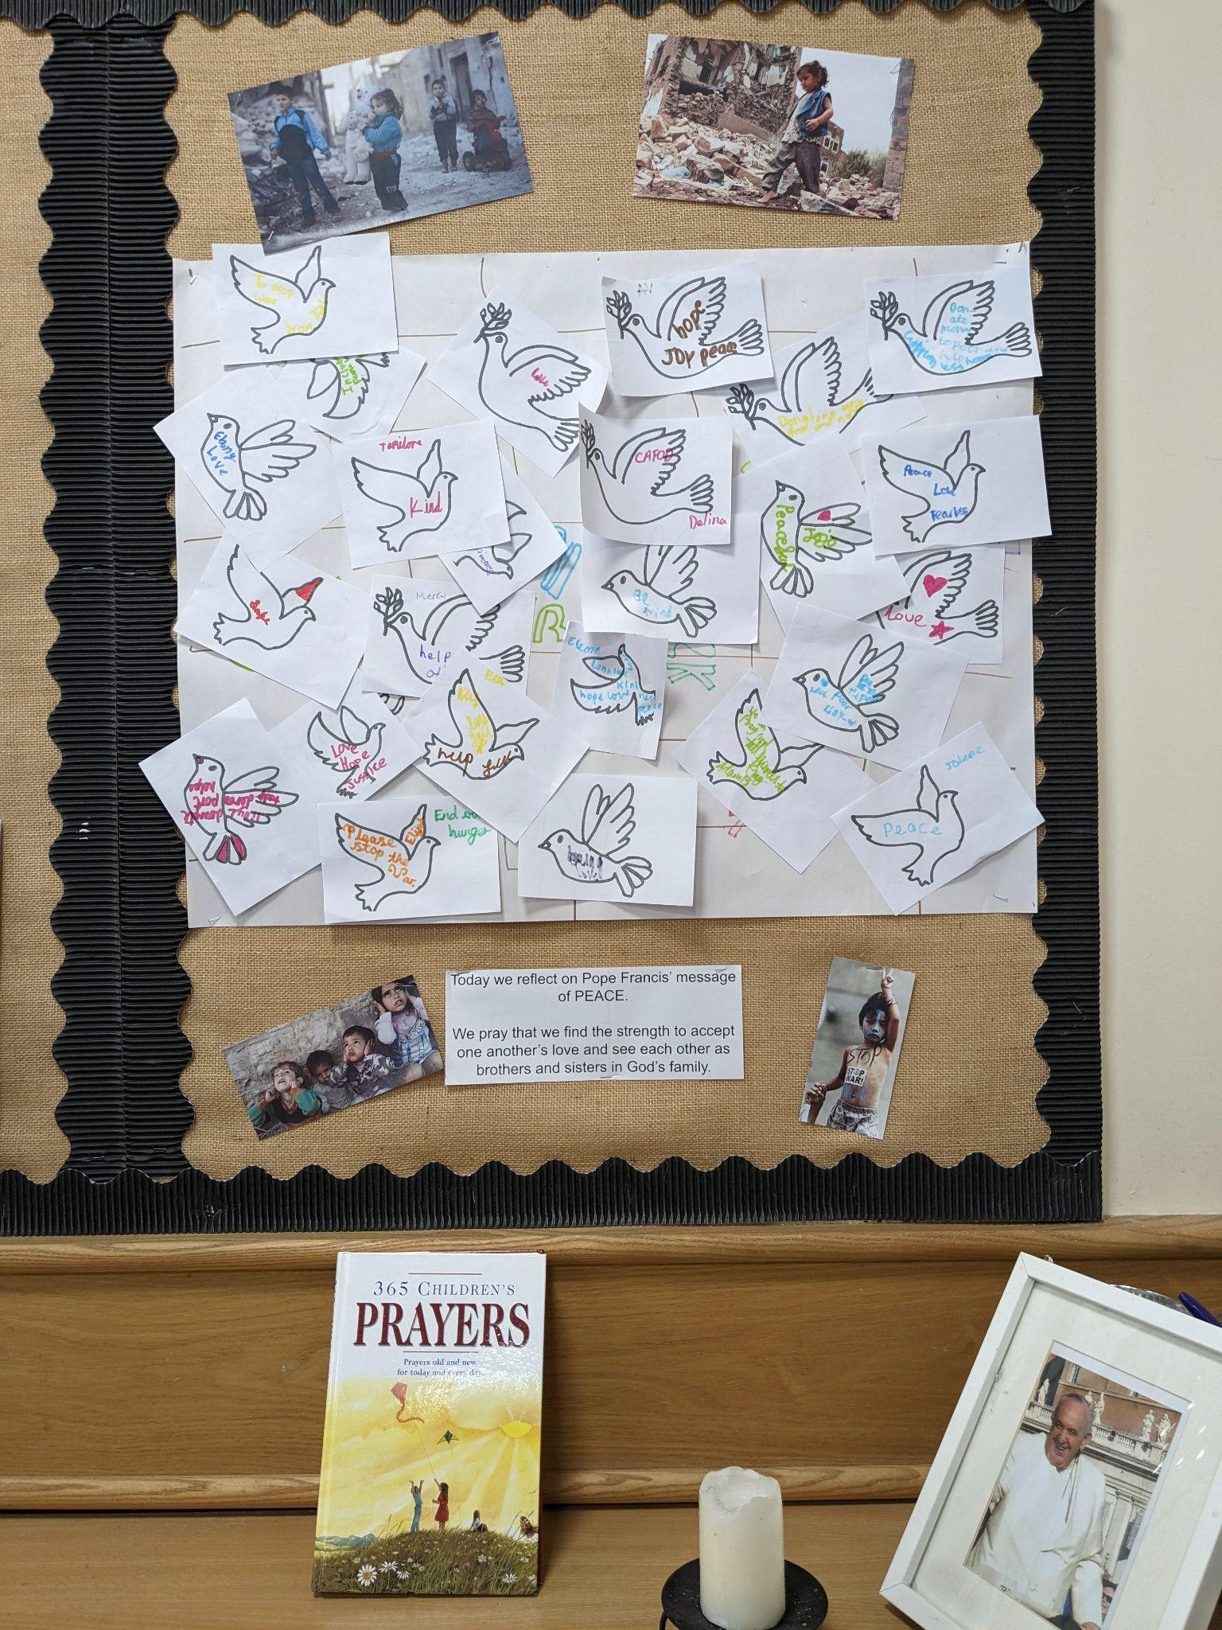  The GIFT team also worked with Sister Navya to launch our first Prayer Space. The children were invited to the Cathedral to focus on Pope Francis’ message of peace. It was a beautiful opportunity for them to focus on their own relationship with God and our global brothers and sisters. |  | Regular events in The Cathedral Centre  Ecumenical Bible Study Group:  Thursdays -10.00am coffee/tea, 10.30-11.30am.  Legion of Mary:  Thursday, 6.00pm to 7.30pm  Union of Catholic Mothers:  Tuesdays 1.30pm-3.30pm.  St Pio Prayer Group:  On the first Friday of every month after 7.00pm Mass, all are welcome. Contact: Rev. Deacon Tony Irwin, Tel. 01548 853413.  Society for the Protection of Unborn Children:  Meet in the Cathedral Centre, third Wednesday of every month at 7.30pm. Contact Christine Hudson Tel. 01752 224018.  Knights of St Columba:  Every second Monday of the month at 6.30pm.  The Cathedral Centre Events

Congratulations!

We have high expectations for all of our pupils to arrive at school each day and on time. Thank you for your continued support.  Miss Grosch 88.73  Miss Galloghly 91.67%  Miss Toms 86.76%  Mr Driscoll 90.43%  Mrs Berry 90.56%  The highest attendance this half term goes to…  Mrs Galloghly’s Class  As a ‘well done’ for winning this half term’s attendance, your class have earnt an extra 20 minutes playtime- keep up the excellent work! |  | Heart of Gold Awards  Miss Grosch’s Class  The heart of gold this week goes to Rafael. This is for both a love of learning and for being a loving member of our class. He is consistently a positive role model and when it comes to engaging in our learning, he always puts in a huge amount of effort. Thank you for all your hard work Rafael!  Miss Galloghly’s Class-  This week we are awarding Rosie with the Heart of Gold award. It is a sad day today, as we say a farewell to Rosie as she sets off in her new adventures! Rosie has demonstrated a heart of gold during her time at our school with continuous kindness and laughter. Well done Rosie!  Miss Toms’ Class-  The Heart of Gold award this week goes to Dawid.  Dawid is such a caring member of our class. He is always there to support his peers and will always offer to help others. He is an excellent role model and a pleasure to have in class.  Well done Dawid.  Mr Driscoll’s class-  Jolene has been awarded the Heart of Gold this week for courage. She has settled in very well into the classroom and has tried incredibly hard to show just what a capable, hardworking and kind member she can be. Well done Jolene.  Mrs Berry’s Class-  Loza is a wonderful and valued member of our class and the school community. She is a model student who always tries her best and she is a fantastic role model for her peers and the younger pupils in the school. Great job Loza!
News and Events

Meet the Governors  Lyn McLoughlin- Foundation Governor  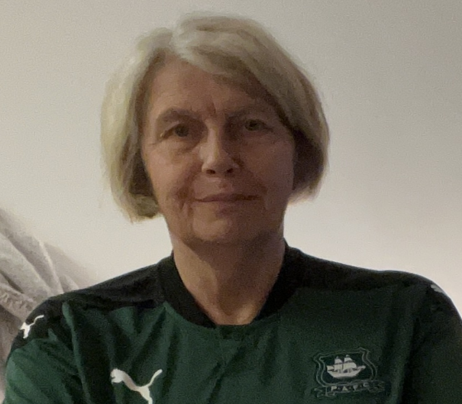  I am currently employed as the Pastoral Assistant and safeguarding Rep for Plymouth Cathedral having previously spent 20 years in education as a teacher- (10 of these in Catholic Education)- this followed a successful career in banking prior to me starting a family.  My hobbies:- When I am not spending time with my 2 grandchildren, I enjoy singing with Plymouth Philharmonic Choir and Phoenix Chorale, together with my other passion-football, which I have recently resumed after a lengthy break. My role as a Foundation Governor is to oversee the spending of Pupil Premium and Sports Premium budgets for both schools and to support the schools in other ways whenever possible. | Mental Health Week 2024  Developed with the help of children and young people in PLace2Be partner schools, MY VOICE MATTERS is about empowering young people to use their voices and share what matters to them- while encouraging those around them to hear their voices. We want all children and young people, whoever they are, and wherever they are in the world, to be able to say- and believe- MY VOICE MATTERS.  Useful links below for anyone wanting support for their child.  https://www.place2be.org.uk/  https://healthinnovationsouthwest.com/  https://www.nhs.uk/mental-health/children-and-young-adults/mental-health-support/
Let’s get talking at home
Things to talk about at home...
• Do you enjoy reading? If so, what type of books?
• Talk to someone at home about the types of books they like to read?

We Love Learning!

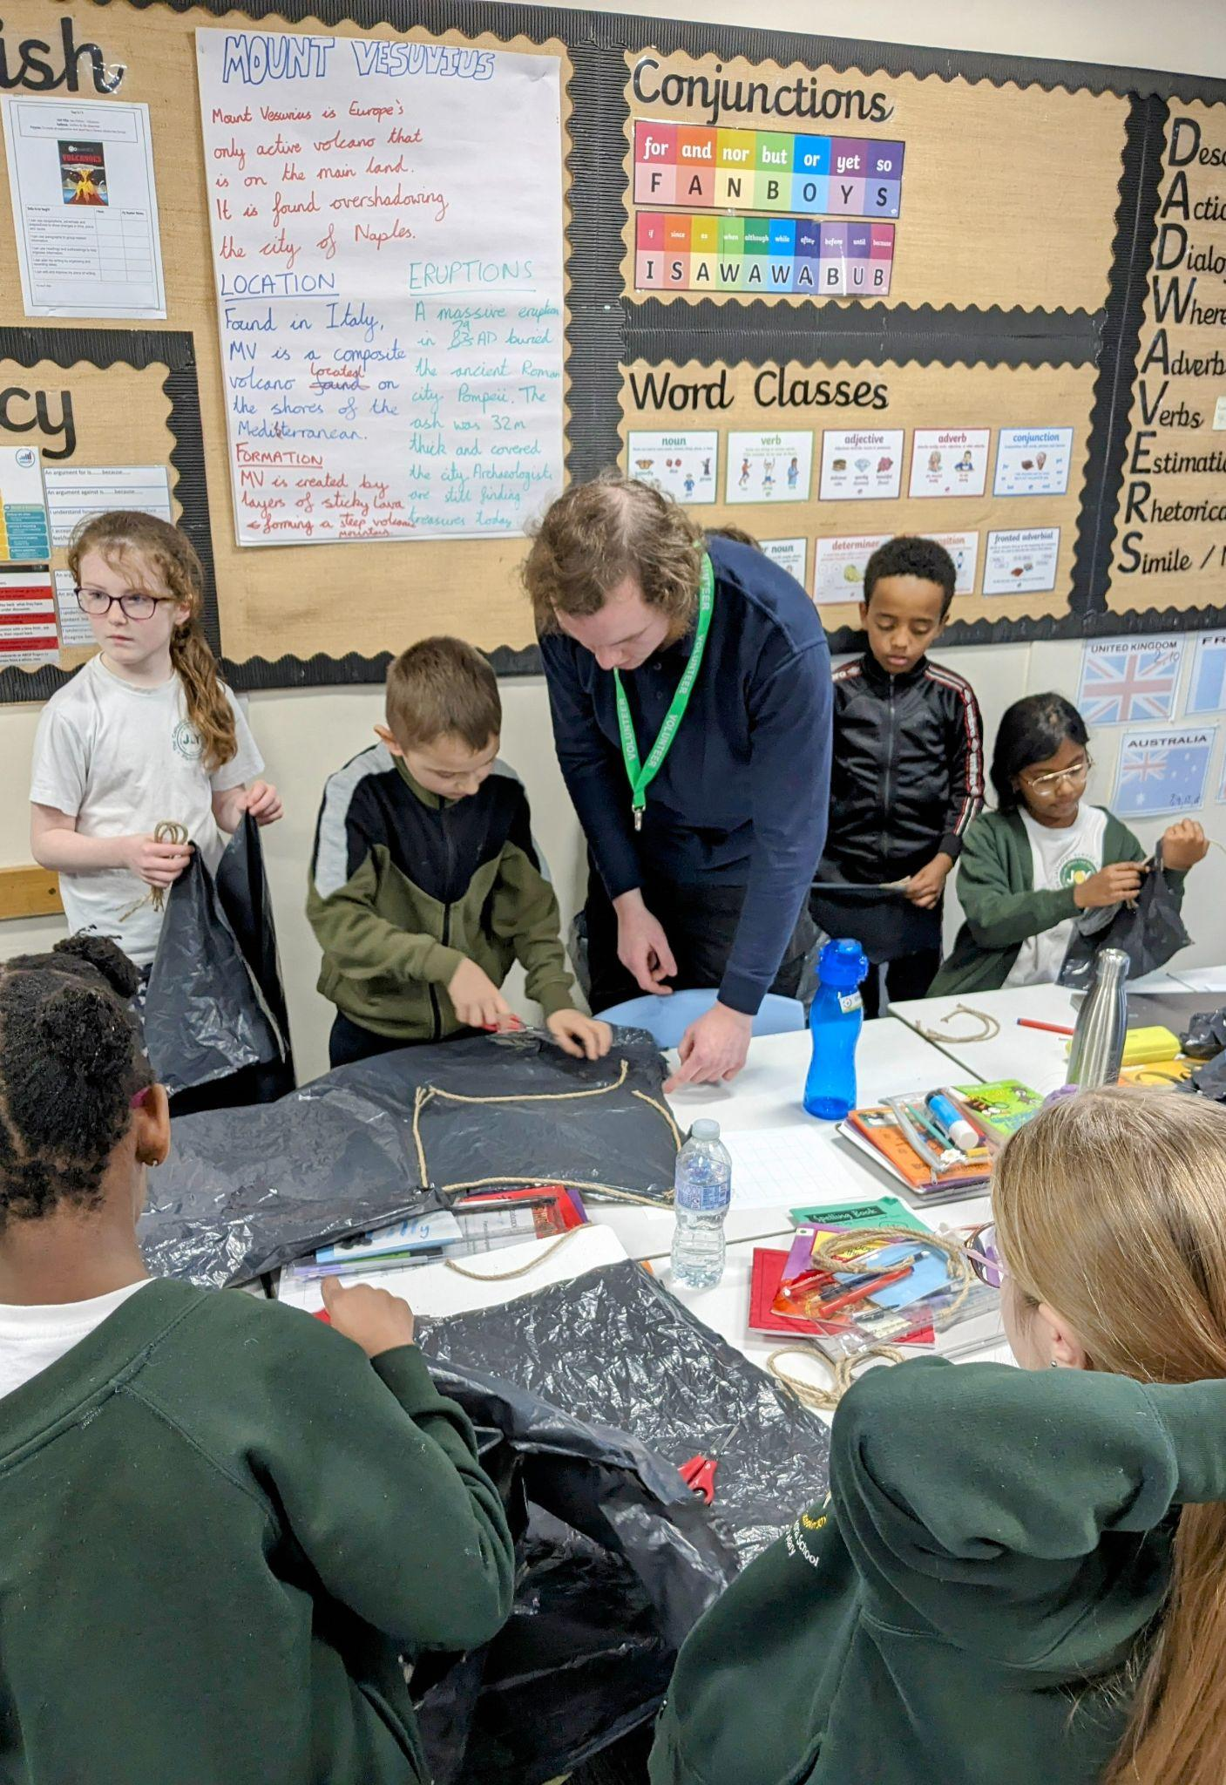
Ther Year 3/4 children enjoyed a STEM workshop with the Babcock Ambassadors this term. They explored the effects of gravity and air resistance by designing and building a parachute for an egg |  | Our KS1 children took part in their indoor athletics event. They performed fantastically coming in 5th place overall. Well done children!
 |  | 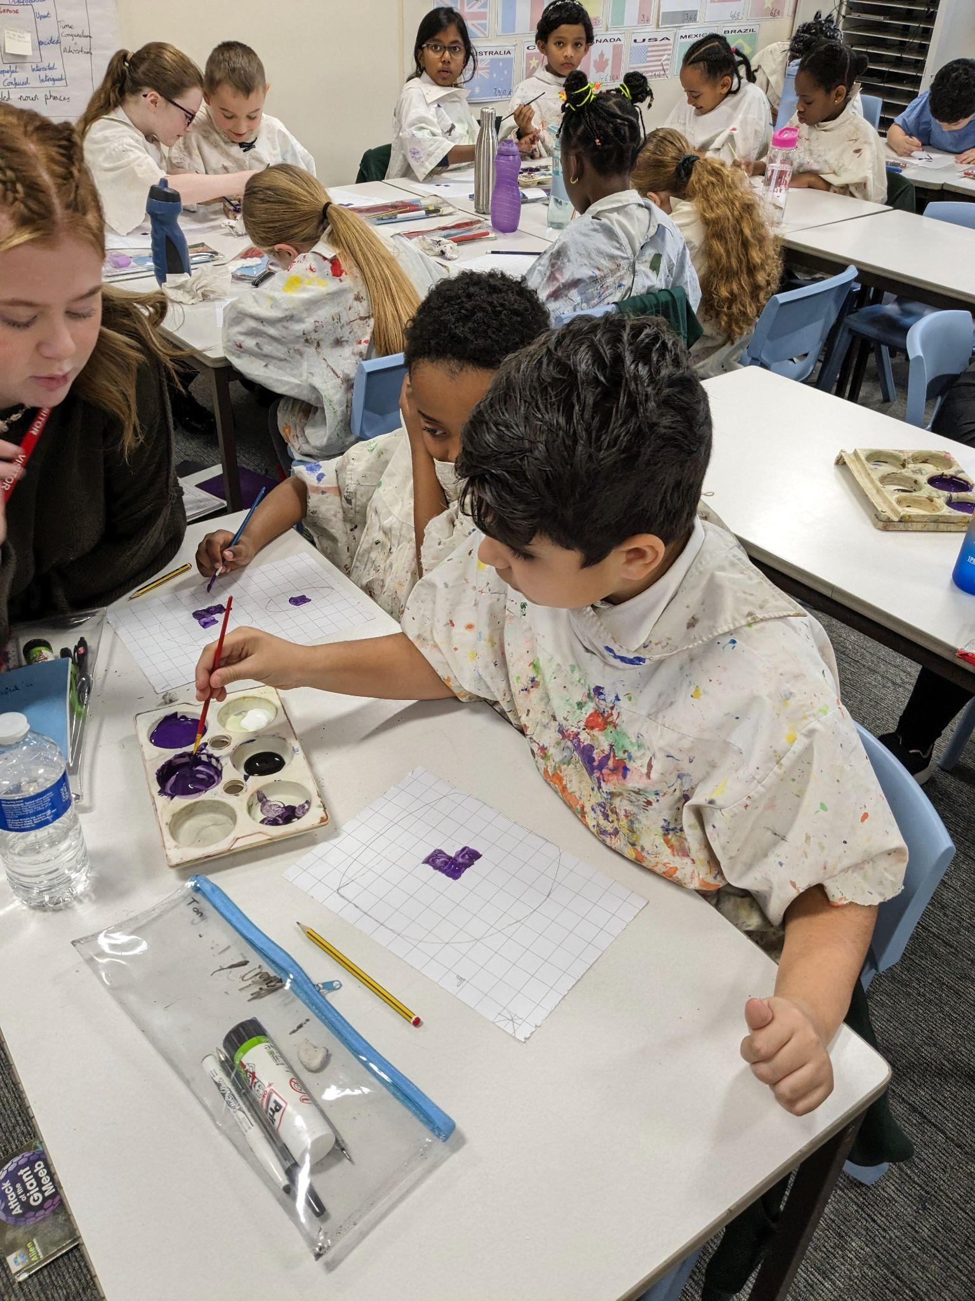
Well done to the UKS2 football team. They took part in their first competitive event and showed some brilliant skill. Great work children. |  | The Year 3 / 4 children have been learning about creating realistic images using light and shade. They used the grid method to help create depth.
 |  | 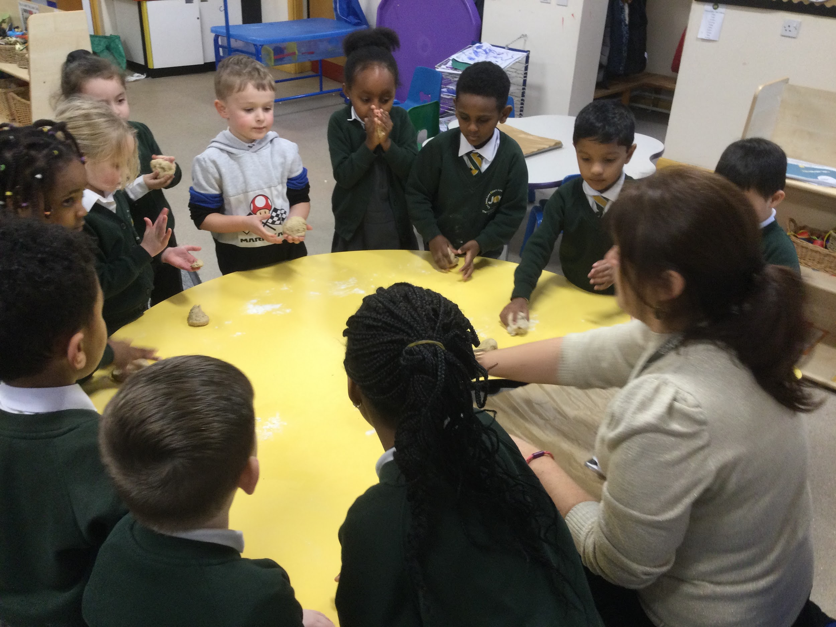
The GIFT Chaplains met with Sarah from the Catholic Children's Society to discuss out next big fundraiser. They also received a certificate of thanks for the money raised during the carol concert. |  | In RE in EYFS, we have been learning about Jesus’ miracles, focusing on the feeding of the 5000. We talked about how Jesus was always caring for others and we made our own loaves. It was messy, fun and tasty!
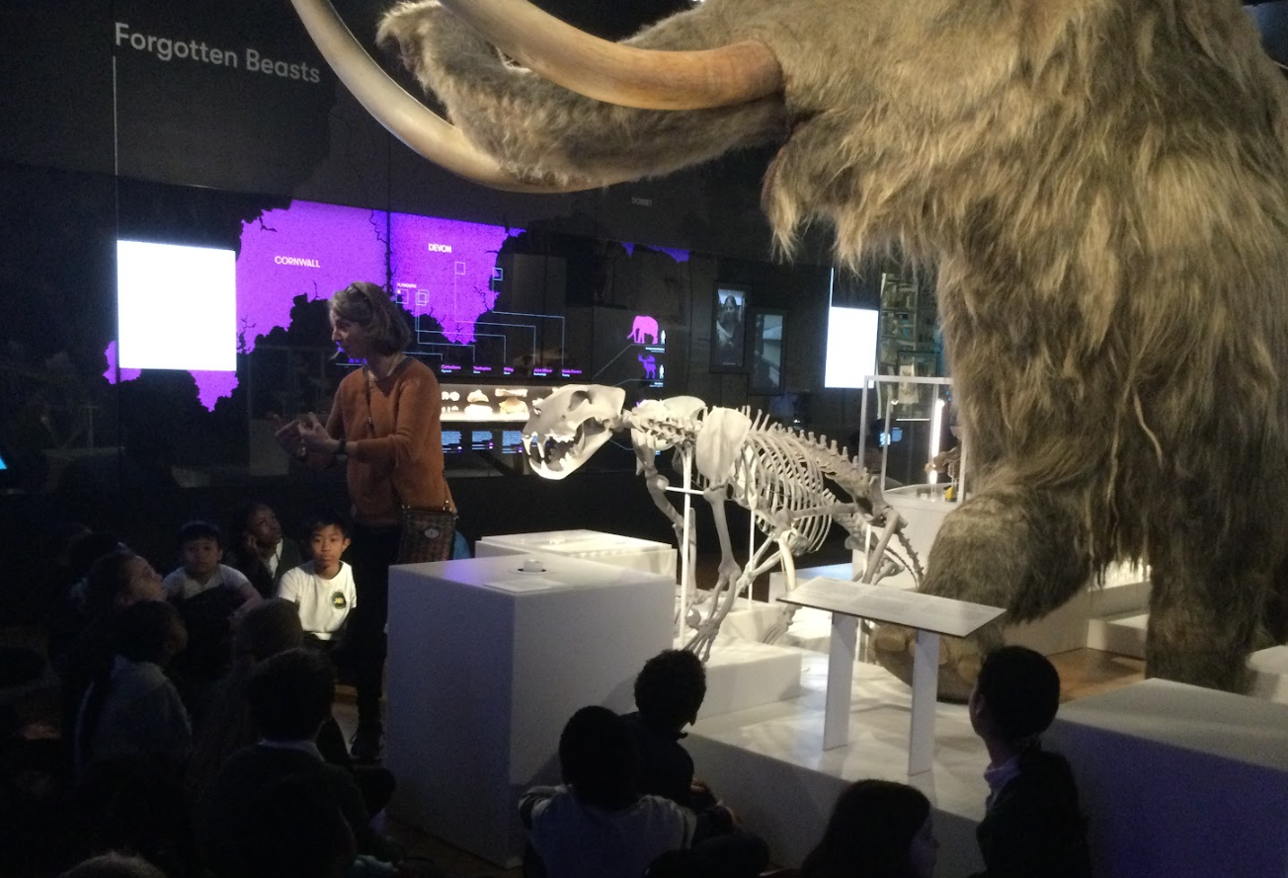 |  | 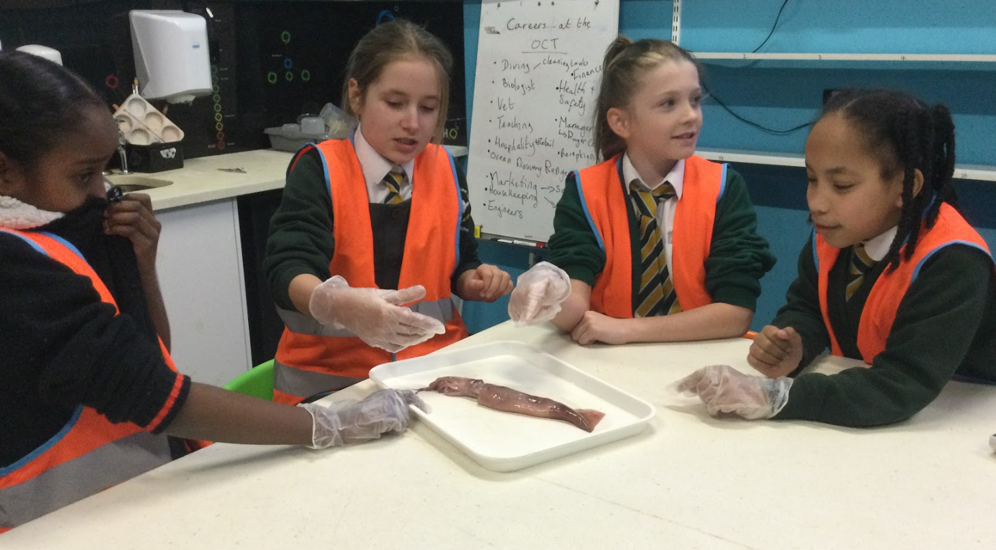
Mrs Berry’s class visited The Box as part of their learning about Evolution and Inheritance in science. The staff at The Box were so impressed by the children’s curiosity, politeness and behaviour they sent a special email. |  | As part of the Widening Horizons project, our year 5 children were treated to a behind the scenes visit to The National Marine Aquarium,

Half Term Events

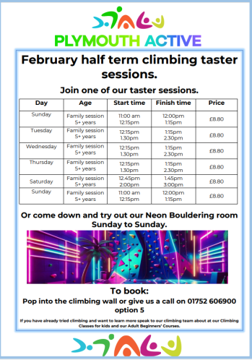
Advice and Support

We are Readers

Mrs Berry’s Class have been reading Matt Goodfellow’s The Final Year in
whole class guided reading lessons this half term. The Final Year is written
in prose and is about Nathan and his transition from year 5 to year 6.
The story follows Nathan through his own mental health issues, tricky home
situation and the usual upper key stage 2 trials. The class (and Mrs Berry)
have loved this book and have voted to read Skellig by David Almond next half term as it is referenced throughout the narrative. We would highly recommend it.
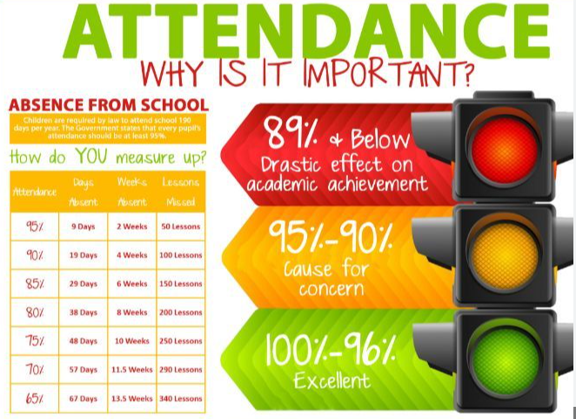
Attendance update

This term, we have introduced messaging parents to share updates on children’s attendance as a way of improving our communication. In most cases, parents were thankful for us making them aware if their child’s attendance was lower than our 96% target and we have already started to see the school’s overall attendance improve. In the first week of implementing this strategy, we saw our whole school attendance rise from;

89.9% to 91.8%.

I would like to say a heartfelt ‘thank you’ to you all for your ongoing support around improving attendance. Together,

Mr Moore

Advice and Support

Dates for your diary  12-16th February- Half term  19th February- Non-Pupil day  20th February- Children return to school.  7th March- World Book Day  28th March- Last day of term.  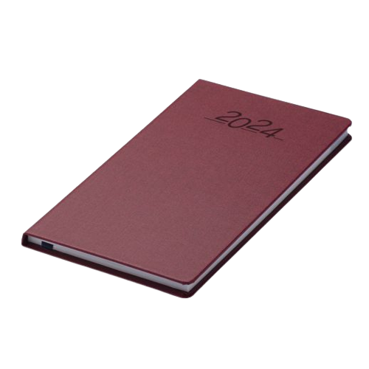  29th March- Monday 15th April Easter Holidays. |  | The uniform store Plymouth is a free service for families to kit out their children for school.  Through donations of good quality school uniform, we give the items to those in need, free of charge.  Our service is open to anyone to use- no referral is needed.  We are located at;  93 New George Street, Plymouth City Centre, PL1 1RQ  Opening hours:  Tuesday, Wednesday and Friday 10am-1pm.  Plymouth Uniform store

Is your child eligible for free school meals?

If you receive certain benefits then your child may be entitled to a free school meal and if so, their school receives extra funding. This means it’s important to apply, even if your child is in reception, year 1 or year 2 and already receives a free lunch.

Check the criteria and apply online: Free School Meals Plymouth

FOOD REQUEST

The Cathedral School of St Mary

have teamed up with

Love in action group -

The Cathedral Church of St Mary and St Boniface
If you email Marianne our School PSA, by Tuesday 2pm of the week you require help with food, you will be able to collect from School on The Wednesday/Thursday

t.cook@plymouthcast.com

SPACES AVAILABLE !
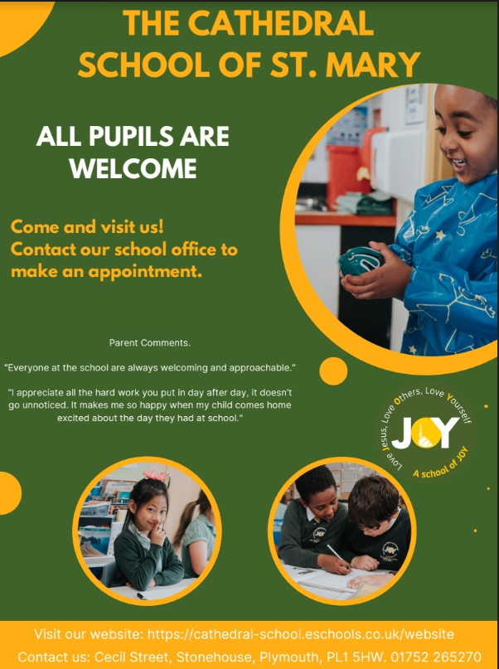
Phonics parents meeting
Learning to read is the most important thing your child will learn at school. Everything else depends on it, so we do all we can to make sure every child learns to read as soon as possible. We want your child to love reading – and to want to read for themselves. Therefore, we are inviting you to a meeting for parents to find out how we are teaching your children to read and to provide support for parents/ carers when hearing your child read at home..
This meeting will give you an overview of the Read Write Inc phonics scheme we use with the children in order to teach them how to read. We want to help you understand the phonics programme that we use and share information about how to support your child to read their Read Write Inc. Phonics decodable storybook that they bring home.
The meeting will take place on Tuesday 20th February at 2:45. Younger siblings are welcome to attend.
Thank you for your continued support.

