Roald Dahl Class
Mrs Futcher and Mrs Holloway

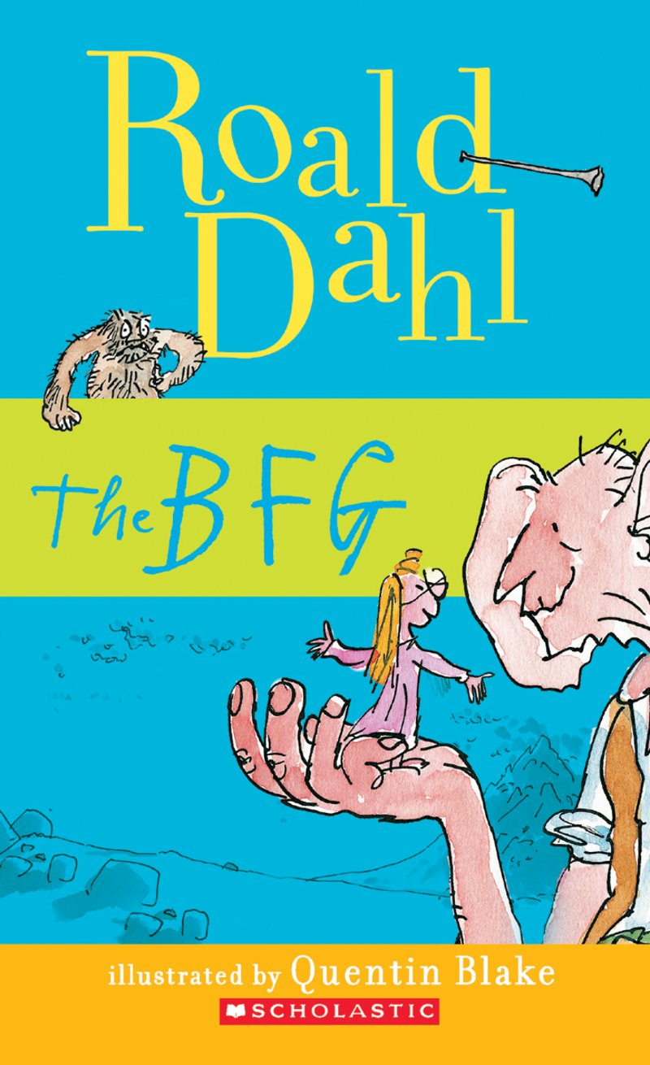

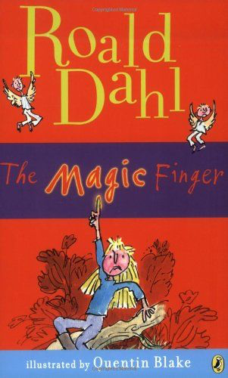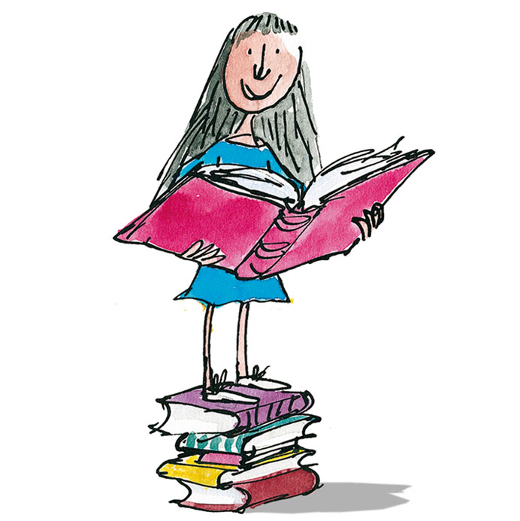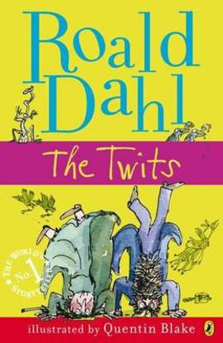

Autumn Term 2019
Newsletter

Welcome back to a new school year. We have a wonderful term planned and can’t wait to get going!

Things to remember for school…

- Children are welcome to come into school from 8:30am. This allows the children time to put away their belongings, change their reading books, settle in and begin the school day promptly at 8:50am.

- Please collect your child at 3:15pm from the playground by the main entrance.

- We have PE throughout the week so please ensure that your child’s full kit (named) is in school every day in a gym bag. (green school t–shirt with school logo or plain white t-shirt, black shorts, black plimsolls).

- Reading folders must be in school every day. We will check them every morning for any letters or reply slips being returned. Letters for you will be put in here so please check it every evening for any communications.

- Please listen to your child read as often as you can and make a comment in their reading diary. Books will be changed once you indicate in the reading diary that the book has been read twice.
We track the children’s reading journey and reward each child with a small prize every time they complete their sticker chart. Please support your child by providing some quiet time to read every day and record their achievements in the reading diary.

- We are outside in all weathers so please provide your child with a waterproof coat every day.
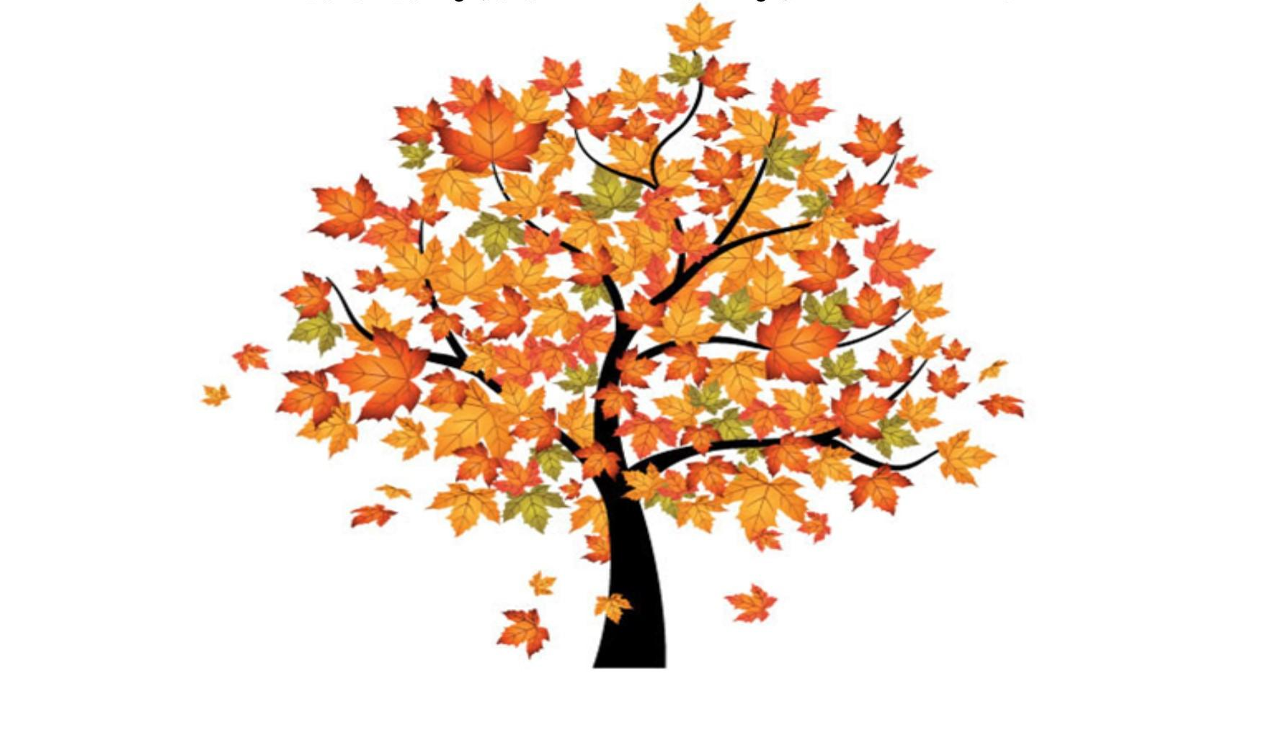Autumn Term Learning
Autumn 1: Our Local Area

Mathematics
Our first half term’s learning will be based around number and place value. We will be counting, sorting, writing, representing and spotting patterns when working with numbers 0-100. Once children are secure in their place value understanding we will focus on addition and subtraction.

English
In class we will develop our reading and writing skills through the book, ‘The Lighthouse Keeper’s Lunch’ by Ronda and David Armitage. They will then learn to write instructions linked to DT.

Topic
Our geography topic is Our Local Area. Children will learn about their locality beyond the school gate. Children will explore their local area using first hand observation to enhance their locational awareness along with developing essential map and fieldwork skills.

Science
This term the children will learn about Seasonal Changes (autumn and winter). In this the children will learn about the four seasons, with a particular focus on autumn and winter. Children will learn what the word weather means and find out how different types of weather can be measured. Children will observe, measure and record the weather by exploring the signs of autumn and winter through nature and wildlife.

RE
Our first unit is Creation, during which the children will learn about God as Creator and our role in protecting His universe. Following that, we will begin a unit on the Sacraments where we will explore what happens during Baptism, Marriage and the Eucharist and their importance in the life of the Church.

PE
We will be developing games skills through a unit on net and wall games.
Autumn Term Learning
Autumn 2: The Gunpowder Plot

Mathematics
In Autumn 2 we will begin by continuing to focus on addition and subtraction. Then we will then move back to place value and explore multiplication.

English
We will be developing our reading and writing skills through recounts of the Gunpowder Plot using the book, ‘Mr Fawkes, The King and the Gunpowder Plot’ by Tom and Tony Bradman. The children will also learn to write poetry based on their senses and fireworks.

Topic
In our history topic, we will learn about some of the key events and people involved in the Gunpowder Plot.

Science
In science children will learn about the Environment and the ecological challenges that face the modern world. The children will undertake a range of activities that challenge them to engage with environmental issues and to understand the simple changes we can make to live more sustainable lives. Throughout the unit, learning is closely focused on the Working Scientifically strand of learning objectives, that will provide a range of opportunities for the children to apply practical scientific methods and skills.

RE
After completing our Sacraments unit we will begin developing our understanding of Advent and Christmas.

PE
We will be developing movement and composition skills through dance and gymnastics.

Home Learning

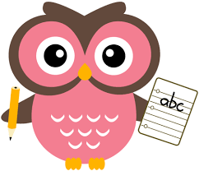

Each week children will be expected to:

- Read at least 4 times each week
Please sign the reading log book so this may be monitored.

- Weekly spellings
Children will receive a set of spellings to learn. These will be handed out each Monday or Tuesday (depending on what group your child is in) and should be learnt by the following Monday.

- Monday Maths
New homework sheets will be given out on Monday and should be returned by the following Monday.

Useful Information

Keep in Touch
Don’t forget to check our class webpage. Each term we will let you know what to expect in the following term. You may wish to use this to support work you are doing with them at home.

We recommend that you connect to our class Dojo site where you can keep a daily check on your child’s effort in school and see what they have been learning through our class story.

Adult Helpers
We are always looking for parents to help us stick work in books and support children’s learning! If you think you could spare some time to help please let us know. You will be asked to complete a DBS check before coming in – the children’s safety is always our priority.

And finally…
We recognise that children learn best when home and school work together and are always happy to talk to you. Please contact us in the way which suits you best: catch us at the end of the school day, make an appointment via the office, leave a letter in the home school records, message us via the class Dojo or email us. Our door is always open.

Many Thanks,
Mrs Futcher and Mrs Holloway

kfutcher@maryofthecross.co.uk

