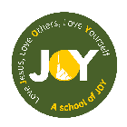

Class 2
Afternoon Activities

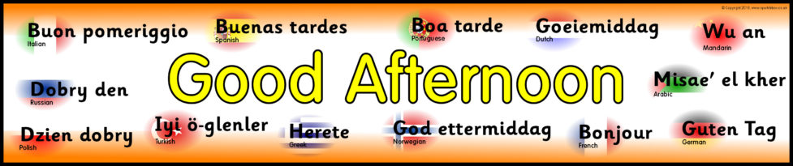

Tuesday
PE – As we are looking at mythical creatures and thinking about myths and legends, have a go at this Moana inspired yoga. It’s one of my favourites!
https://www.youtube.com/watch?v=5y3gCrL_XIM
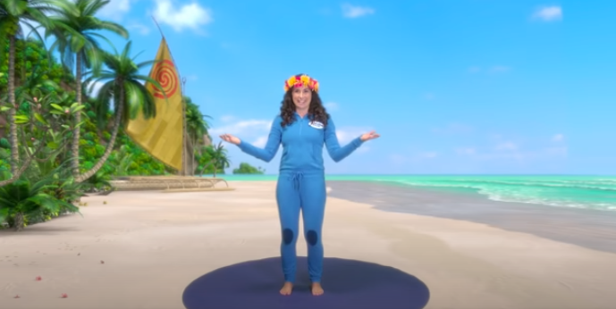

Wednesday - Art
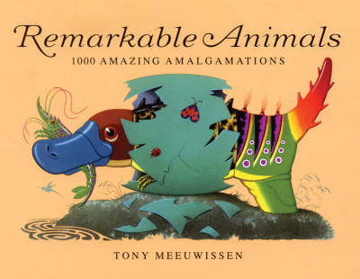
I want you to have a go at making up your own mythical creature. A lot of mythical creatures are made up of different parts of different animals. Have a look at a book like this to give you ideas – I will put it onto class dojo for you to have a look through.
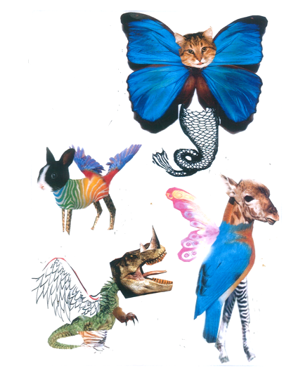

You could even make a collage like these.

Thursday
Geography – where in the world does your mythical creature come from? Maybe it lives on a mountain, or underwater, or in a cave? Why does it live there? Place it on the map and then maybe draw it’s habitat.
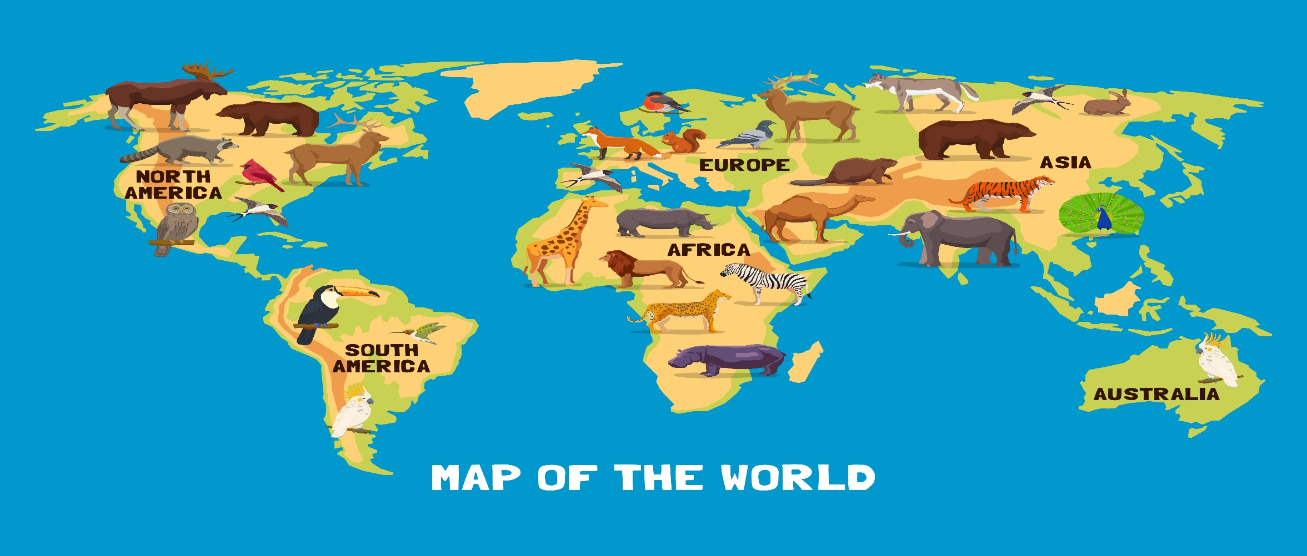

Friday
Cooking! I thought that this might be a fun Friday treat to have a go at. Can you bake some unicorn cookies? I have given it a go (and will post pictures and videos on dojo!) Or you could just decorate a normal biscuit using icing and sprinkles!
Alternatively, can you design a cake with a mythical creature as the main design? What are the ingredients you using? What flavour is your cake?
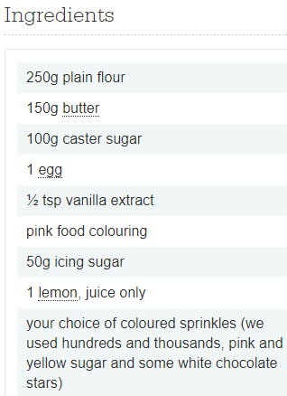
Here is the recipe for what I made. https://www.bbcgoodfood.com/recipes/unicorn-party-cookies
