Julia Donaldson Class
Mrs Gleed, Mrs Sheikh, Mrs Brooks & Mrs Nankivell

Autumn Term 2018

Welcome back to a new school year. The children have come back with great enthusiasm and are settling well into Julia Donaldson Class! We have a wonderful term planned and can’t wait to get going.

Things to remember for school…

- Children are welcome to come into school from 8:30am. This allows the children time to put away their belongings, change their reading books, settle in and begin the school day promptly at 8:50am.

- Please collect your child at 3:10pm from the playground by the main entrance.

- Reading folders must be in school every day. We will check them every morning for any letters or reply slips being returned. Letters for you will be put in here so please check it every evening for any communications.

- Please listen to your child read as often as you can and make a comment in their reading diary. Books will be changed once you indicate in the reading diary that the book has been completed.

Mrs Sheikh tracks the children’s reading journey and rewards each child with a small prize and certificate each time they reach 10 reads. Please support your child by providing some quiet time to read every day and record their achievements in the reading log.

- We are outside in all weathers so please provide your child with a waterproof coat every day.

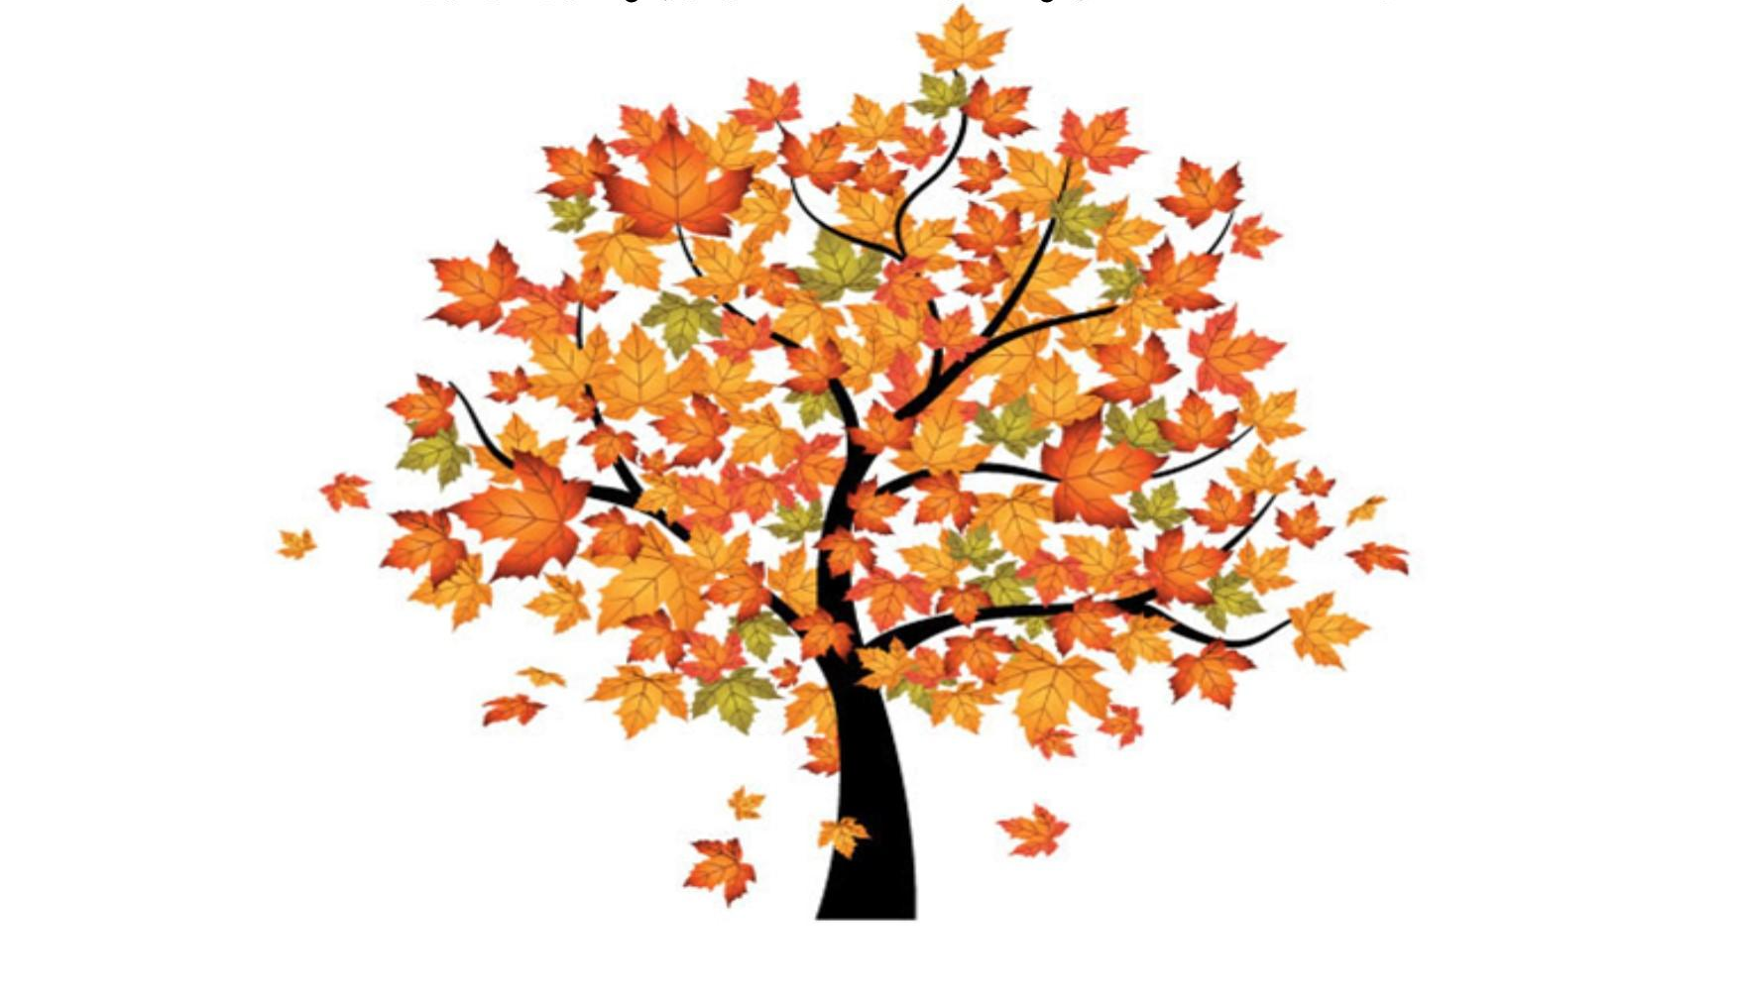Autumn Term Learning
Autumn 1
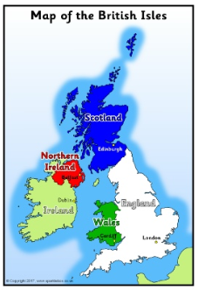
Mathematics
Our first half term’s learning will be based around number and place value. We will be writing, representing and spotting patterns when working with numbers 0-100.

English
In class we will develop our reading and writing skills through units based on Barnaby Bear and We’re Going on a Bear Hunt.

Topic
Our geography based topic this term is ‘Where is Barnaby Bear?’. We will learn about the countries of the UK developing learning beyond children’s immediate environment and own locality to the UK. We will explore the UK by looking at individual countries, capital cities and look at the human and physical features found in each locality.

Science
We will focus our learning this term on plants. They will be taught about the structure of plants and trees and what they need to grow well. The children will identify plants and trees at Victoria Park and sort deciduous and evergreen leaves. We will plant beans in lesson 1 and observe it closely over the coming weeks by measuring and recording its growth.

RE
In RE will be developing our appreciation of ourselves and the world around us as part of God’s creation. Following that, we will begin a unit on Sacraments where we will explore what happens during Baptism, Matrimony and the Eucharist.

PE
We will be developing team work skills by playing lots of games involving working together as a team.

Autumn Term Learning
Autumn 2
Mathematics
In Autumn 2 we will focus on addition and subtraction. We will develop our mental calculation strategies, learn to use a 100 square more efficiently and begin to develop informal and formal written methods. We will end with a unit of statistics where we will learn to read and interpret tables, charts and graphs.

English
In English, we will develop our reading and writing skills through recounts of the Great Fire of London and the Nativity.

Topic
In this history topic, we will learn about some of the key events and people involved in the Great Fire of London. We will also bake bread and explain how the Great Fire of London began in Thomas Farriner's bakery in Pudding Lane.

Science
We will focus on living things and their habitats. In this unit children will learn about a variety of habitats and the plants and animals that live there. They learn to tell the difference between things that are living, dead and things that have never been alive, and apply this in a range of contexts. They make observations of a woodland habitats and the creatures that live there, investigating conditions in local microhabitats and how they affect the minibeasts found within them. This unit allows children to research a range of global habitats and how the living things that live there are suited to their environments, and also provides an introduction to the idea of dependency between plant and animal species.

RE
After completing our Sacraments unit we will begin developing our understanding of Advent and Christmas.

PE
We will be developing movement and composition skills through dance.

Home Learning
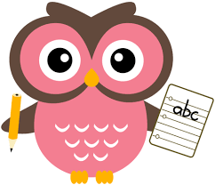

Each week children will be expected to:

- Read at least 4 times each week
Please sign the reading log book so this may be monitored.

- Weekly spellings
Children will receive a set of spellings to learn. These will be handed out each Monday and should be learnt by the following Monday.

- Monday Maths
New homework sheets will be given out on Monday and should be returned by the following Monday.

Children who complete all homework set will be rewarded at the end of each half term with a visit to the playground!

Useful Information

Keep in Touch
Don’t forget to check our class webpage. Each term we will let you know what to expect in the following term. You may wish to use this to support work you are doing with them at home.

We recommend that you connect to our class Dojo site where you can keep a daily check on your child’s effort in school and see what they have been learning through our class story.

Adult Helpers
We are always looking for parents to help us stick work in books and support children’s learning! If you think you could spare some time to help please let us know. You will be asked to complete a DBS check before coming in – the children’s safety is always our priority.

And finally…
We recognise that children learn best when home and school work together and are always happy to talk to you. Please contact us in the way which suits you best: catch us at the end of the school day, make an appointment via the office, leave a letter in the home school records, message us via the class Dojo or email us. Our door is always open.

Many Thanks,
Mrs Gleed, Mrs Sheikh, Mrs Brooks and Mrs Nankivell

b.gleed@cathedral.plymouth.sch.uk

