The Cathedral School of St Mary Pen Licence Requirements

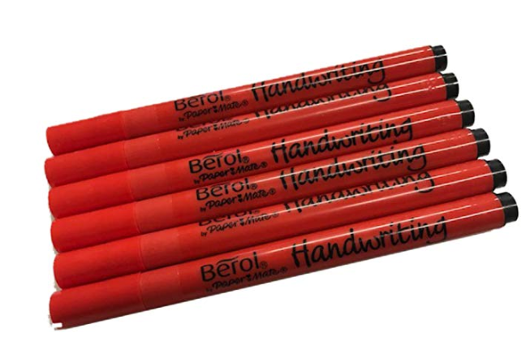

|  |
| --- |
| Bronze |
| Silver |
| Gold |