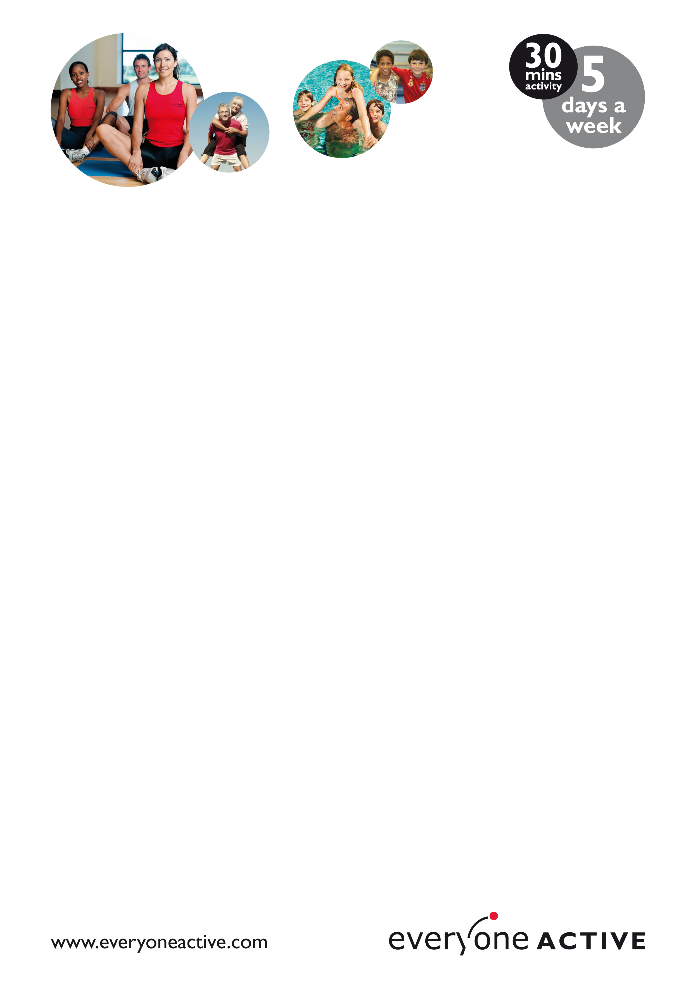

Dear Parent

Your child recently completed their school swimming lessons at Plymouth Life Centre. As part of the programme we offer every child 5 free family swims during the six weeks after completion.

The period for your free family swims is from 14/03/15 until 26/04/15.

To access the free swims you will need to come to the centre and give your childs name and school. The free swims will already be on the system to use.

Please do not hesitate to get in touch with any questions

Regards

Jessica Hogben
School Swimming Lesson Manager

jessicahogben@evweryoneactive.com
Tel 01752 606900 ext 2

