The Cathedral School of St Mary Pen Licence Requirements

Bronze
- All letters are formed correctly with clear descenders and ascenders which are mainly consistent and in a legible size
- All digits 0-9 are formed correctly.
- All capital letters are clear and used correctly.
- All letters are written on the one line with regular spaces between words.
- All work is dated, titled and underlined with a ruler.
- Titles use capital letters correctly.
- All written work starts from the margin.
- Any mistakes are crossed out with one neat line.
- Illustrations are drawn in pencil and coloured neatly too.
- Writing is beginning to be joined.
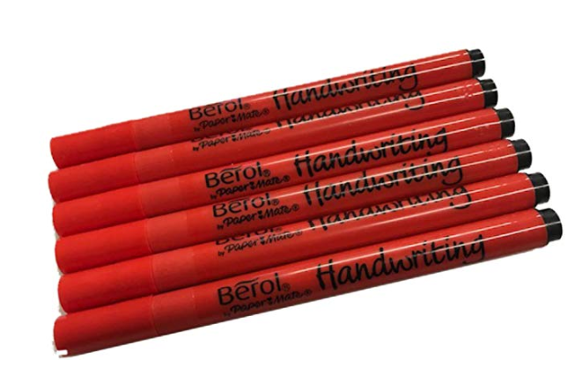
- Care in ALL books is consistently taken.

