Cathedral Life
winter 2016
newsletter

Dear Parents/Carers,

Just look at the things we have been up to this week in addition to all our usual hard work! We are buzzing!
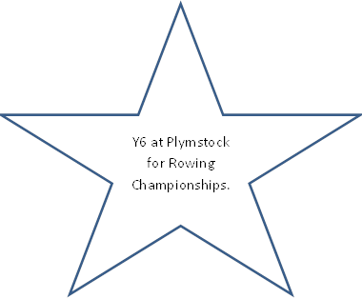
KS2 children at Goals for football Tournament.

Class One celebrate a marriage as part of their RE.
Y2 visit the Royal Albert Bridge as part of their topic work.
Governors share their findings see the website for more info!
Y6 visit to the STEM Centre.
Y5 visits the Aquarium.

