**Year 5 Homework – Friday 17th November 2016**

**Maths**

Please continue to practise your Times Tables on TT Rockstars. Next week in class we will be revising the 7 times table, so please get practising this weekend!

**r u**

**Reading**

Continue reading for pleasure and remember to get your reading records signed at least 3 times a week.



**English**

Write a paragraph, including 2A sentences, describing the picture below.

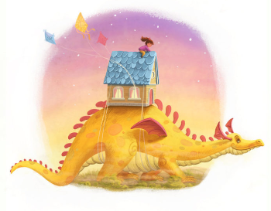

**Spelling**

Your spelling list will be provided by Mrs Ellard.

Don’t forget that you can also log on to Spellodrome to practise your spellings.