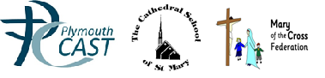

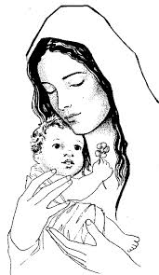
Whole School and Class Masses
Spring 2016

Theme | When | Who | Where
The Epiphany | Tuesday 6th January 2016 | Whole School | Cathedral
The Presentation of Our Lord | Tuesday 2nd February 2016 | Class 3 & 4 | Hall
Ash Wednesday | Wednesday 10th February 2016 | Whole School | Cathedral
St Peter | Tuesday 23rd February 2016 | Class 1 & 2 | Classroom
St Patrick | Thursday 17th March 2016 | Whole School | Cathedral
Everyone is welcome to any of our celebrations

