Cathedral Life
winter 2016
newsletter

Dear parents/carers,

Another busy week at The Cathedral School! Our Years 3, 4 and 5 have enjoyed swimming every day – this continues for the next two weeks and we look forward to sharing our children’s success.

Our school football team played their first ever match on grass this week and I think they enjoyed getting very muddy just as much as playing the game. They were great ambassadors for themselves and the school.

Next week is Parent Consultation Week. If you have not yet booked an appointment online please do so or contact the office who will be happy to help.

One of our friends has lost an ipod just like this. Could you please look to see if it has been taken home in error? Many of our children have such devices and there could easily have been a mix up.
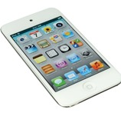
We have also recently had some money found in a cloakroom. This has proved very difficult to home and emphasises the need for ANY valuables to be handed in to the office where they can be kept safe. They must remain there until children are leaving – that means after school clubs etc. If we cannot ensure the money goes to the person it belongs to then we shall donate it to our Lenten CAFOD appeal – details of which will be with you shortly.
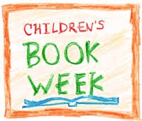
Look out for exciting news about book week coming today!

