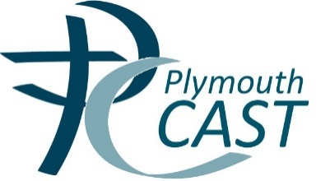 | 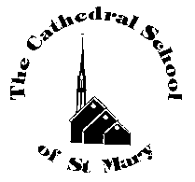
The Cathedral School of St. Mary
Cecil Street
Plymouth
PL1 5HW

18th March 2015

Dear Parents
I’m sure you will have heard that Friday is a special day!
‘On the morning of Friday 20 March the Sun will move into eclipse while people in the UK are heading to work or school.’
During a partial eclipse it will still be daylight, and while you are on your way to work or school you probably will not notice any difference in the lighting conditions. However, it will still be very dangerous to look directly at the sun, should you do so, you risk permanent blindness.
In order to try to ensure our children’s safety we will be inviting children to come into school for 8.30 where we will view the eclipse safely via the big screen in the hall. As always children are welcome to join breakfast club.
Please take great care when walking to school on that day!
Also on Friday, some of our children have been selected randomly to take part in another very special event so don’t be surprised if they come home with some exciting stories to tell! Please don’t ask me to tell you what it is as I have been sworn to secrecy!
As for the rest of us we are celebrating the end of the ‘Big Pedal’ with a Superhero day – children can dress up as their favourite Superhero or just wear mufti. Please DO NOT go out and buy an outfit. I feel that this totally detracts from the message that we can have fun, learn and help the environment without any cost to us. Thank you for your support.

Mrs Bernie Kennedy
Head of Learning

