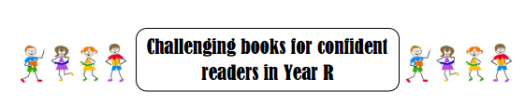
The following books have been chosen from the Centre for Literacy in Primary Education Core Books List to both challenge and engage Cathedral’s more able readers. We hope you enjoy them.

